# Description of Flight Tests

| Date | Index | Config. | | Azimuth | | Elevation | Comments | Test Point # |
| --- | --- | --- | --- | --- | --- | --- | --- | --- |
| Nov 28 2007  Vibration test to evaluate platform shake | No Video | | | | | | Ground Idle | 1 |
| IGE Hover | 2 |
| OGE Hover | 3 |
| Slow accel thru translational lift | 4 |
| Quickstop | 5 |
| Sidestep | 6 |
| Translational Lift | 7 |
| Max Pwr Climb | 8 |
| 60 knots straight & level | 9 |
| 70 knots straight & level | 10 |
| 80 knots straight & level | 11 |
| 90 knots straight & level | 12 |
| 100 knots straight & level | 13 |
| 110 knots straight & level | 14 |
| Rate 1 turn 80 knots | 15 |
| Rate 2 turn 80 knots | 16 |
| 45 deg bank turn 80 knots | 17 |
| 1000 fpm descent | 18 |
| Vh | 19 |
| Approach to hover | 20 |
| Landing at FRL | 21 |
| Feb 3 2009 | No Video | | | | | | Flarm, ADS-B Shakedown | 22 |
| Feb 6 2009 Flarn, ADS-B Shakedown 2 Formation depart and rejoins | No Video | | | | | | Co altitude 0 degree | 23 |
| Co altitude 15 degr | 24 |
| Co altitude -30 deg | 25 |
| Co altitude -45 deg | 26 |
| Co altitude -60 deg | 27 |
| PTP +500 ft 0 deg | 28 |
| PTP +500 ft -15 deg | 29 |
| PTP +500 ft -30 deg | 30 |
| PTP +500 ft -45 deg | 31 |
| PTP -500 ft 0 deg | 32 |
| Feb 13 2009  - no intruder data  - cam 3 non functional  - aperture full open | 1 | 1 | N/A | | N/A | | Formation, Extra 300 to B205 port | 33 |
| 2 | 1 | N/A | | N/A | | Formation, Extra 300 to B205 front and port | 34 |
| 3 | 1 | N/A | | N/A | | Formation, Extra 300 direct in front of B205 | 35 |
| 4 | 1 | N/A | | N/A | | Formation, Extra 300 direct in front, increasing separation | 36 |
| 5 | 1 | N/A | | N/A | | Extra 300 maneuvering toward B205 | 37 |
| 6 | 1 | N/A | | N/A | | Formation, Extra 300 increasing separation | 38 |
| 7 | 1 | N/A | | N/A | | Formation, Extra 300 left passing ahead, turns 90 degrees, and crosses over right to left | 39 |
| 8 | 1 | N/A | | N/A | | Extra 300 cross over left to right | 40 |
| 9 | 1 | N/A | | N/A | | Return to base | 41 |
| 10 | 1 | N/A | | N/A | | Commercial aircraft on approach to runway 25 CYOW | 42 |
| 11 | 1 | N/A | | N/A | | Landing | 43 |
| May 12 2009  Test of height/heading hold | No video | | | | | | Low yaw gain oscillation | 44 |
| Airspeed hold test | 45 |
| Poor airspeed tracking | 46 |
| Track error increased as gain increased (sign error?) | 47 |
| June 4 2009  -F/4  -Haze filters  -Cam 1 non functional | 1 | 1 | N/A | | N/A | | Taxi | 48 |
| 2 | 1 | N/A | | N/A | | Taxi with commercial aircraft approaching runway 25 | 49 |
| 3 | 1 | N/A | | N/A | | Takeoff | 50 |
| 4 | 1 | N/A | | N/A | | Formation | 51 |
| 5 | 1 | N/A | | N/A | | Formation, slow break | 52 |
| 6 | 1 | N/A | | N/A | | Formation, re-join | 53 |
| 7 | 1 | N/A | | N/A | | Long formation break out to 5 nm separation | 54 |
| 8 | 1 | N/A | | N/A | | 25 degree azimuth approach | 55 |
| 9 | 1 | N/A | | N/A | | Landing formation, runway 25 CYOW | 56 |
| July 6 2009  -ADS-B data recording not working | 1 | 1 | 0 | | 0 | |  | 57 |
| 2 | 1 | -10 | | 0 | | Landing lights on | 58 |
| 3 | 1 | -30 | | 0 | | Visual contact switch left in ‘up’ position. > 1000m CPA | 59 |
| 4 | 1 | -50 | | 0 | | 250 m CPA (out of FOV cam2 at 3:09, and into FOV cam3 at 3:20) | 60 |
| 5 | 1 | -70 | | 0 | | Harvard passed well behind B205, PTP display turns off | 61 |
| 6 | 1 | -90 | | 0 | | Aborted | 62 |
| 7 | N/A | N/A | | N/A | | Flight into rain cloud | 63 |
| July 8 2009 | 1 | N/A | N/A | | N/A | | Flight in cloud | 64 |
| 2 | 1 | 0 | | 0 | |  | 65 |
| 3 | 1 | -10 | | 0 | |  | 66 |
| 4 | 1 | -30 | | 0 | |  | 67 |
| 5 | 1 | -50 | | 0 | | Azimuth falls off at end of run | 68 |
| 6 | 1 | -70 | | 0 | | Azimuth falls off at end of run | 69 |
| 7 | 1 | -90 | | 0 | |  | 70 |
| 8 | 1 | N/A | | N/A | | Landing | 71 |
| April 20 2010 | No Video | | | | | | Radar shakedown | 72 |
| April 23 2010 | 1 | N/A | N/A | | N/A | | Formation, Harvard at -90 deg to -45 deg | 73 |
| 2 | N/A | N/A | | N/A | | Formation, Harvard at -90 deg to -45 deg | 74 |
| 3 | N/A | N/A | | N/A | | Break away at -30 deg | 75 |
| 4 | N/A | N/A | | N/A | | Break away at -10 deg | 76 |
| 5 | N/A | N/A | | N/A | | Break away from -90 to -30 | 77 |
| 6 | N/A | N/A | | N/A | | Break away from -90 to - 10 | 78 |
| Sept 1 2010  B206 Shakedown/Training  Poor Vis (Hazy) | 1 | 1 | -5 | | 0 | | 3 nm separation azimuth -5 deg | 79 |
| 2 | 1 | N/A | | N/A | | Aircraft on approach to CYOW RW 32 | 80 |
| Oct 20 2010 | 1 | 1 | 0 | | 0 | | 0 degree – point failed (no video data for cam 1) | 81 |
| 2 | 1 | 0 | | 0 | | Repeat of prev point | 82 |
| 3 | 1 | -10 | | 0 | |  | 83 |
| 4 | 1 | -30 | | 0 | | Failed | 84 |
| 5 | 1 | -30 | | 0 | | Not visible in Cam 1, Cam 2 overexposed in full sunlight | 85 |
| 6 | 1 | -50 | | 0 | | Slightly overexposed, but useable | 86 |
| 7 | 1 | -70 | | 0 | | Cam 3 | 87 |
| 8 | 1 | -90 | | 0 | | Often outside of FOV | 88 |
| Oct 22 2010 | 1 | 1 | 0 | | 0 | | Low cloud deck | 89 |
| 2 | 1 | -10 | | 0 | | Appear from cloud approx 2:47 | 90 |
| 3 | 1 | -30 | | 0 | | Upper cloud deck washed out | 91 |
| 4 | 1 | -50 | | 0 | | Just outside of cam 2 FOV | 92 |
| 5 | 1 | -70 | | 0 | | Closer to 90 deg from YZV hdg reference | 93 |
| 6 | 1 | -90 | | 0 | | Abandoned at 1 nm separation (FCC failed) | 94 |
| Nov 19 2010 | 1 | 1 | -30 | | 0 | | Cam 1 had failed so started at -30 deg | 95 |
|  | 2 | 1 | -50 | | 0 | | Cam2 points into sun, but ZUQ appears below this area | 96 |
|  | 3 | 1 | -70 | | 0 | | Azimuth falls off near end | 97 |
|  | 4 | 1 | -90 | | 0 | | Out of frame | 98 |
|  | 5 | 1 | -90 | | 0 | | Out of frame | 99 |
| Dec 17 2010  Cams overexposed | 2 | 2 | 0 | | 0 | | Cam 1 slightly overexposed | 100 |
| 3 | 2 | -10 | | 0 | |  | 101 |
| 4 | 2 | -30 | | 0 | |  | 102 |
| 5 | 2 | -50 | | 0 | | Approximately 10 deg out. Test Point failed | 103 |
| 6 | 2 | -50 | | 0 | | Repeat of -50 deg | 104 |
| 7 | 2 | -70 | | 0 | |  | 105 |
| 8 | 2 | -90 | | 0 | |  | 106 |
| Jan 20 2011  Filters installed | 1 | 2 | 0 | | 0 | |  | 107 |
| 2 | 2 | -10 | | 0 | | In camera 2 | 108 |
| 3 | 2 | -30 | | 0 | | Starts in cam to moves to cam 3 by 2:45 | 109 |
| 4 | 2 | -50 | | 0 | |  | 110 |
| 5 | 2 | -70 | | 0 | | Nice | 111 |
| 6 | 2 | -90 | | 0 | | Often out of frame | 112 |

# Flight Test Results

## Data Processing

In this section, add some notes on what sort of data post-processing was performed:

* Re-selection of time range to correspond with Aligned INS
* Interpolation to a common time-base (Harvard rate of 60 Hz chosen)
* Double precision time and lat/lon, and demonstration of effect on accuracy

|  |  |  |  |  |
| --- | --- | --- | --- | --- |
| Name | Description | Units/Sign | Source | Rate |
|  |  |  |  |  |
| flarm_own_lat | Ownship (B205) Latitude as reported by FLARM | Decimal Degrees +ve North | FLARM, via CA DRP | 1 Hz |
| flarm_own_lon | Ownship (B205) Longitude as reported by FLARM | Decimal Degrees +ve East | FLARM, via CA DRP | 1 Hz |
| flarm_press_alt | Pressure altitude as recorded by FLARM | Feet, +ve up | FLARM via CA DRP | 1 Hz |
| flarm_targ_bearing | Bearing to target from own (B205) position and ground track | Degrees (-180 to 180), +ve clockwise | FLARM via CA DRP | 1 Hz |
| flarm_targ_dist | Distance to target | Meters (VERIFY), always positive | FLARM via CA DRP | 1 Hz |
| flarm_targ_rel_e | Eastward distance to target | Meters, +ve east | FLARM via CA DRP | 1 Hz |
| flarm_targ_rel_n | Northward distance to target | Meters, +ve north | FLARM via CA DRP | 1 Hz |
| flarm_targ_rel_vert | Vertical distance to the target (unknown if pressure or GPS) | Meters (VERIFY), +ve means intruder is above ownship | FLARM via CA DRP | 1 Hz |
| ptp_alt | Harvard GPS/INS Altitude | Feet | Harvard HG1700 DRP | 60 Hz |
| ptp_alt_adsb_h | Altitude of Harvard as reported by B205 ADS-B, interpolated to 60 Hz | ???? |  |  |
| ptp_hdg | Harvard True heading | Degrees +/- 180 | Harvard HG1700 DRP | 60 Hz |
| ptp_lat | Harvard Latitude | Decimal Degrees +ve North | Harvard HG1700 DRP | 60 Hz |
| ptp_lon | Harvard Longitude | Decimal Degrees +ve East | Harvard HG1700 DRP | 60 Hz |
| ptp_pitch | Harvard Pitch Attitude | Degrees +ve Nose Up | Harvard HG1700 DRP | 60 Hz |
| ptp_roll | Harvard Roll Attitude | Degrees +ve Right Wing Down | Harvard HG1700 DRP | 60 Hz |
| ptp_time | Harvard GPS Time | Seconds since Sunday midnight (GMT) | Harvard HG1700 DRP | 60 Hz |
| ptp_time_fix | Harvard GPS Time Linear fit/Interpolated to prevent repeated samples/quantization | Seconds since Sunday midnight (GMT) | Harvard HG1700 DRP | 60 Hz |
| ptp_utmx_adsb | Harvard UTM Easting as reported by B205 ADS-B | Meters +ve east | B205 ADS-B | Nominal 1 Hz update, but recorded at 133 Hz |
| ptp_utmx_adsb_h | Harvard UTM easting as reported by the B205 ADS-B, interpolated at ptp_time_fix time intervals | Meters +ve east | B205 ADS-B | Nominal 1 Hz update, but recorded at 133 Hz, and interpolated to 60 Hz |
| ptp_utmx_hg1700 | Harvard UTM easting as converted from HG1700 lat/lon | Meters +ve east | Harvard HG1700 DRP | 60 Hz |
| ptp_utmy_adsb | Harvard UTM Northing as reported by B205 ADS-B | Meters +ve North | B205 ADS-B | Nominal 1 Hz update, but recorded at 133 Hz |
| ptp_utmy_adsb_h | Harvard UTM Northing as reported by the B205 ADS-B, interpolated at ptp_time_fix time intervals | Meters +ve North | B205 ADS-B | Nominal 1 Hz update, but recorded at 133 Hz, and interpolated to 60 Hz |
| ptp_utmy_hg1700 | Harvard UTM Northing as converted from HG1700 lat/lon | Meters +ve North | Harvard HG1700 DRP | 60 Hz |
| yzv_alt | B205 GPS/INS Altitude | Feet | B205 LN200 DRP | 133 Hz |
| yzv_alt_ln200_ptime | B205 GPS/INS Altitude interpolated at ptp_time_fix (60Hz) intervals | Feet | B205 LN200 DRP | Nominally 133 Hz, interpolated to 60 Hz |
| yzv_hdg | B205 true heading | Degrees +/- 180 | B205 LN200 DRP | 133 Hz |
| yzv_lat | B205 Latitude | Degrees +ve North | B205 LN200 DRP | 133 Hz |
| yzv_lon | B205 Longitude | Degrees +ve East | B205 LN200 DRP | 133 Hz |
| yzv_pitch | B205 Pitch attitude | Degrees +ve nose up | B205 LN200 DRP | 133 Hz |
| yzv_roll | B205 Roll attitude | Degrees +ve right skid down | B205 LN200 DRP | 133 Hz |
| yzv_time | B205 GPS/INS time | Seconds since Sunday midnight GMT | B205 LN200 DRP | 133 Hz |
| yzv_time_fix | B205 GPS Time Linear fit/Interpolated to prevent repeated samples/quantization | Seconds since Sunday midnight GMT | B205 LN200 DRP | 133 Hz |
| yzv_utmx_adsb | B205 ownship UTM easting as reported by the B205 ADS-B | Meters, positive north | B205 ADS-B | Nominally 1 Hz, interpolated to 133 Hz |
| yzv_utmx_flarm | B205 ownship UTM northing as reported by the B205 FLARM | Meters, positive north | B205 FLARM | Nominally 1 Hz, interpolated to 133 Hz |
| yzv_utmx_ln200 | B205 ownship UTM easting as reported by the B205 LN200 INS | Meters, positive north | B205 LN200 DRP | 133 Hz |
| yzv_utmx_ln200_ptime | B205 ownship UTM easting as reported by the B205 ADS-B resampled to the Harvard INS timebase | Meters, positive north | B205 LN200 DRP | 133 Hz |
| yzv_utmy_adsb | B205 ownship UTM northing as reported by the B205 ADS-B | Meters, positive east | B205 ADS-B | Nominally 1 Hz, interpolated to 133 Hz |
| yzv_utmy_flarm | B205 ownship UTM northing as reported by the B205 FLARM | Meters, positive east | B205 FLARM | Nominally 1 Hz, interpolated to 133 Hz |
| yzv_utmy_ln200 | B205 ownship UTM northing as reported by the B205 LN200 INS | Meters, positive east | B205 LN200 DRP | 133 Hz |
| yzv_utmy_ln200_ptime | B205 ownship UTM northing as reported by the B205 LN200 INS resampled to the Harvard INS timebase | Meters, positive east | B205 LN200 DRP | Nominally 133 Hz, resampled to 60 Hz |



Figure : Test point #57, 0 deg azimuth



Figure : Test point #57, 0 deg azimuth, final 30 seconds



Figure : Test point #57, 0 deg azimuth, plan view (UTM coordinates)

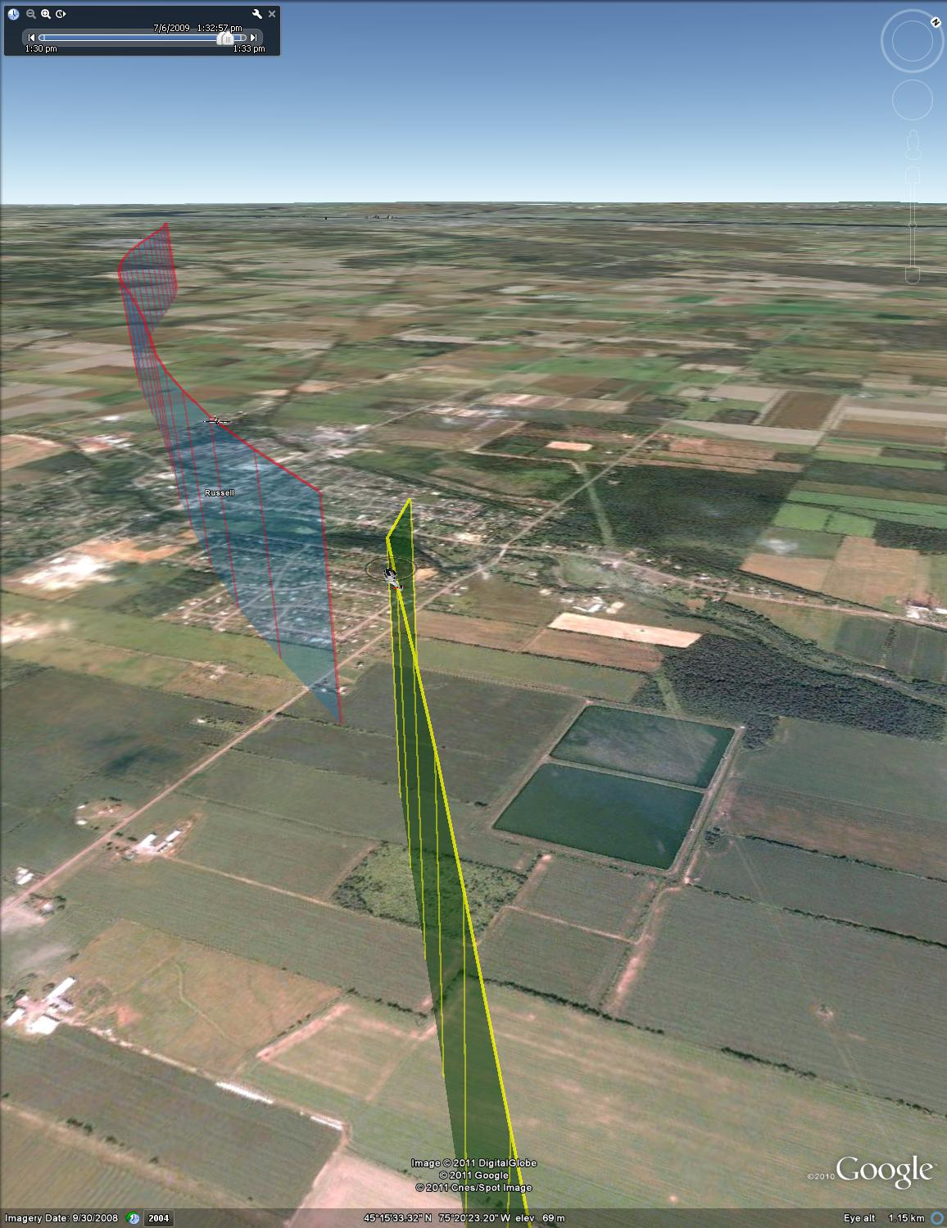

Figure : Test point #57, 0 deg azimuth, isometric view



Figure : Test point #58, -10 deg azimuth



Figure : Test point #58, -10 deg azimuth, final 30 seconds



Figure : Test Point #58, -10 deg azimuth, plan view (UTM coordinates)

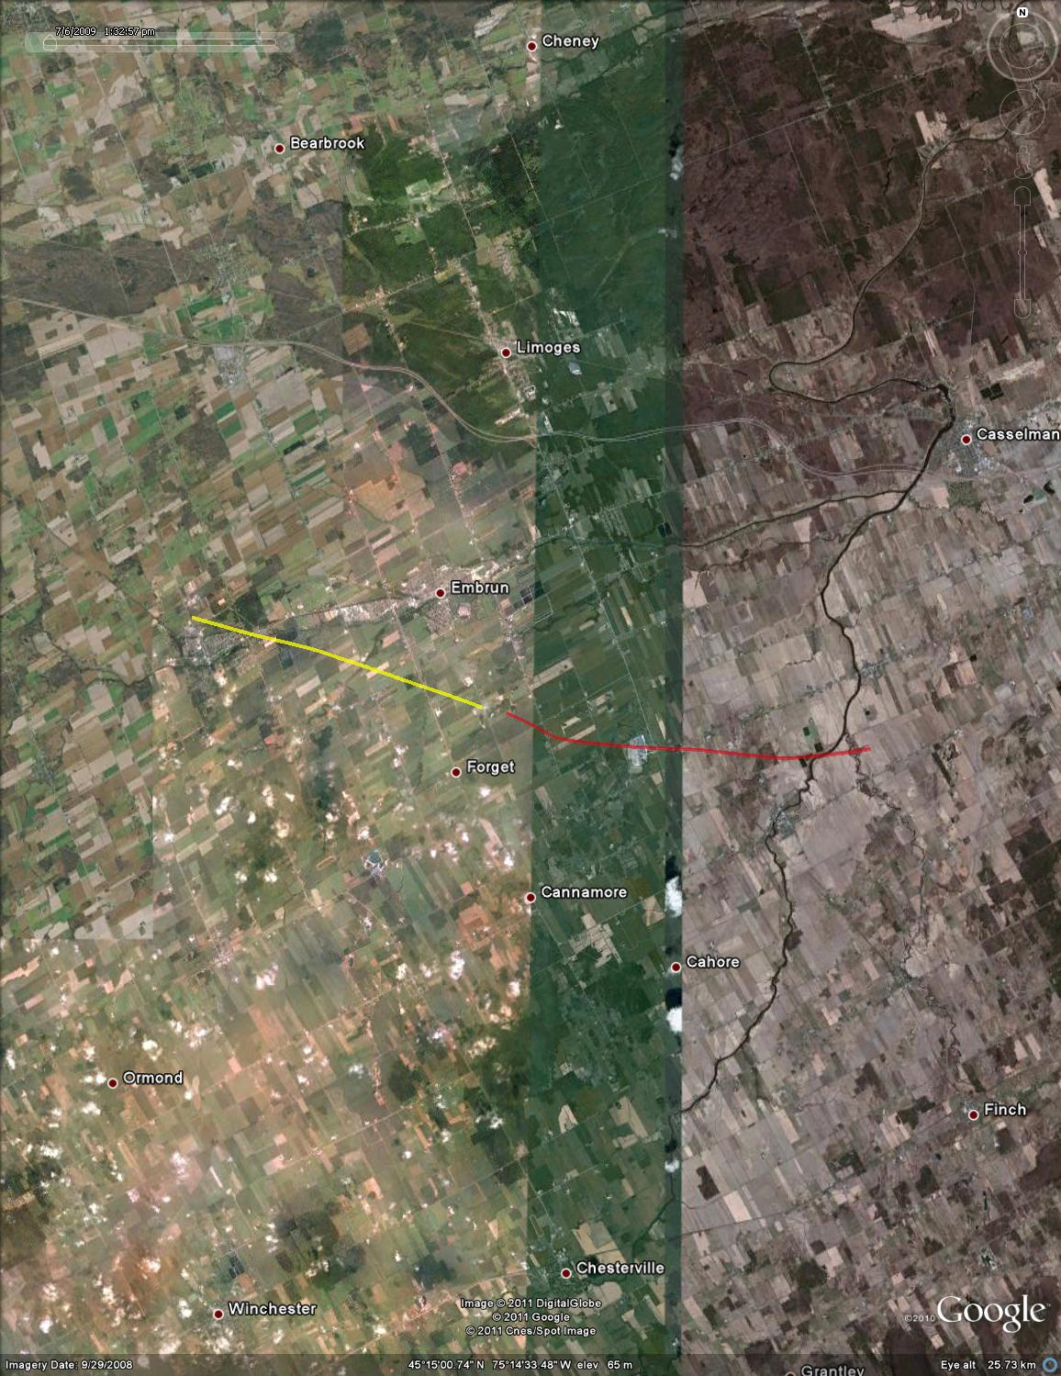

Figure : Test point #58, - 10 deg azimuth, plan view (satellite overlay)

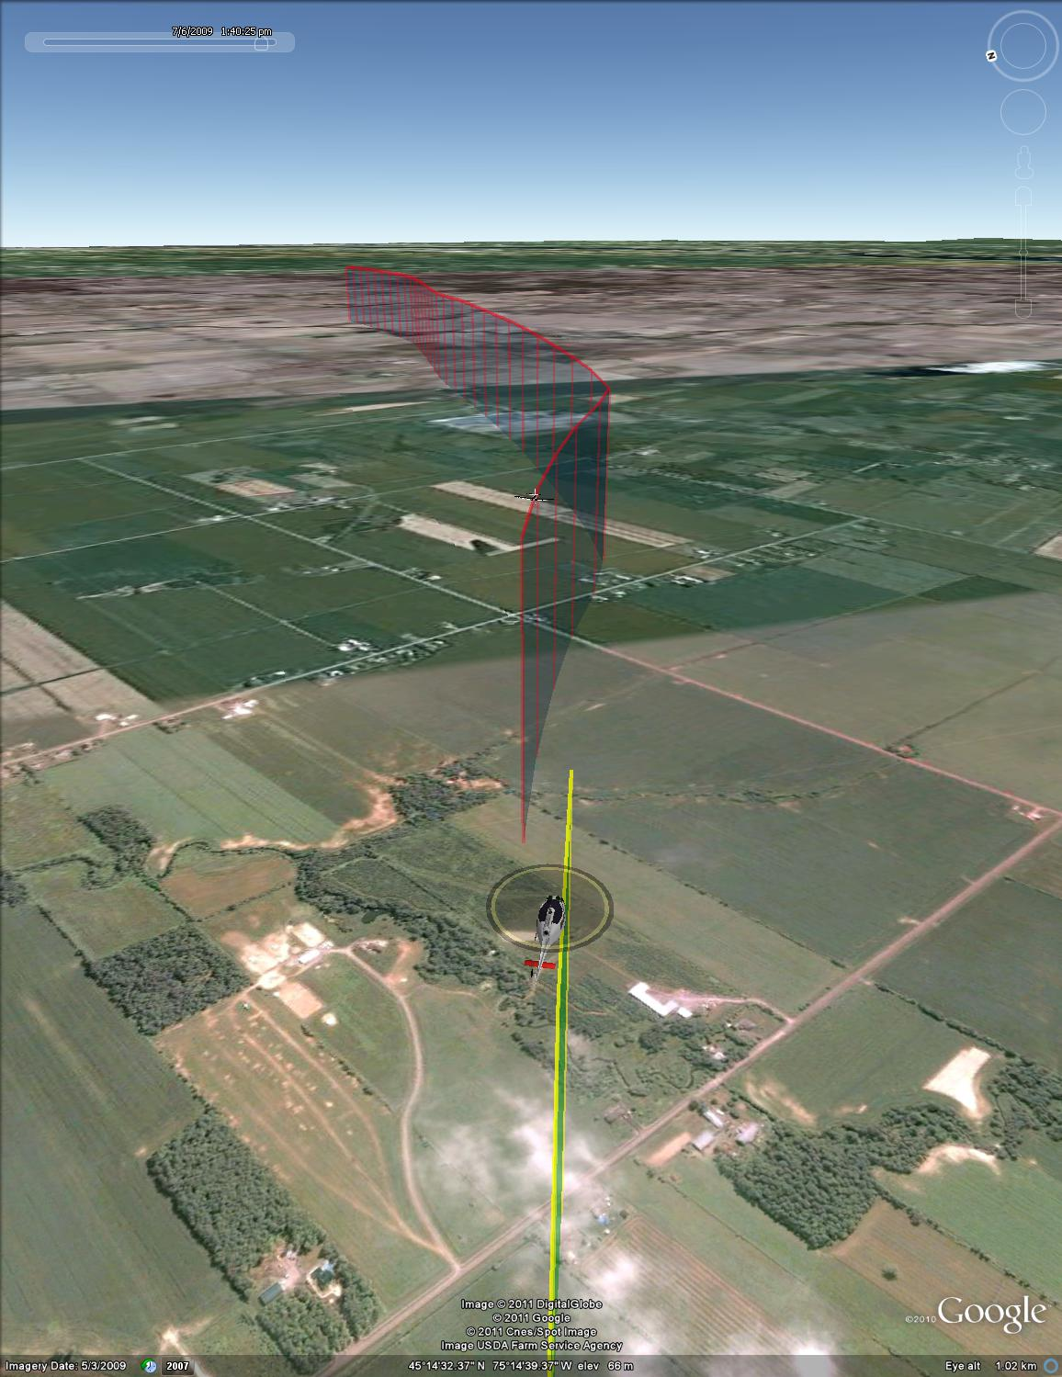

Figure : Test point #58, -10 deg azimuth, isometric view



Figure : Test point #59, -30 deg azimuth



Figure : Test point #59, -30 deg azimuth, final 30 seconds



Figure : Test point #59, -30 deg azimuth, plan view (UTM coordinates)

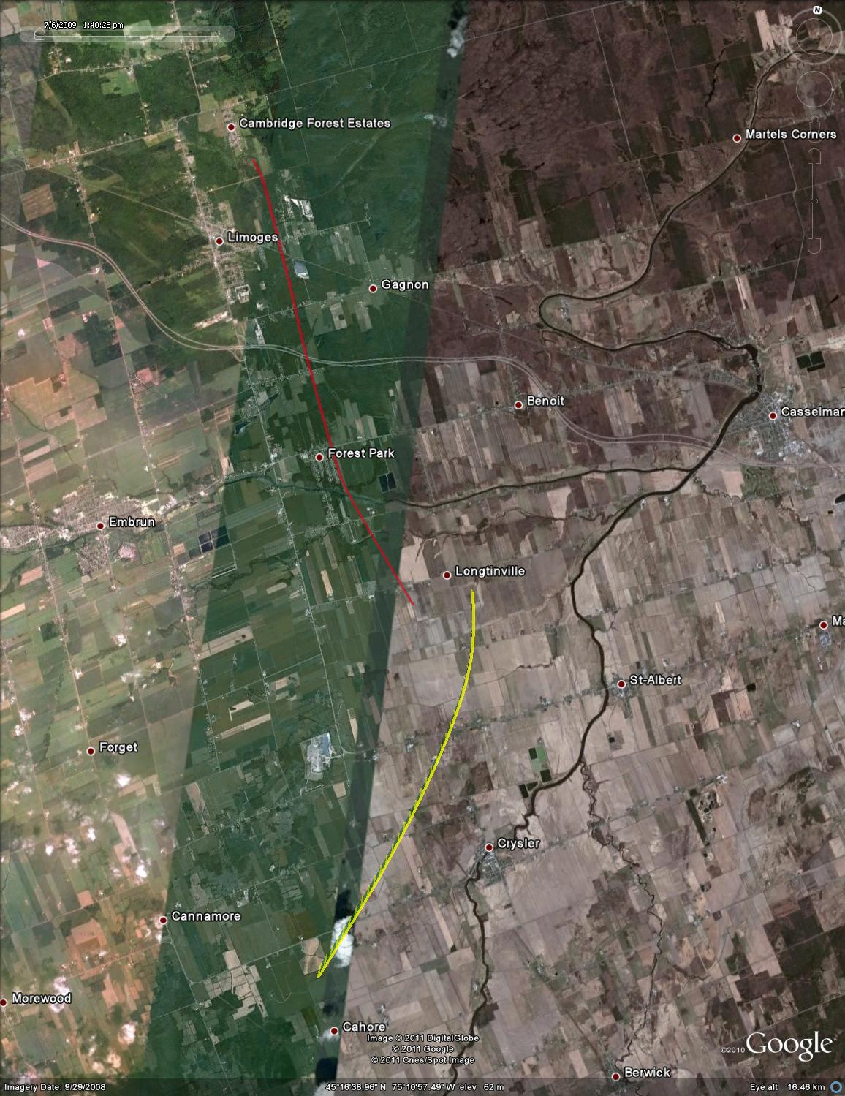

Figure : Test point #59, -30 deg azimuth, plan view (satellite overlay)

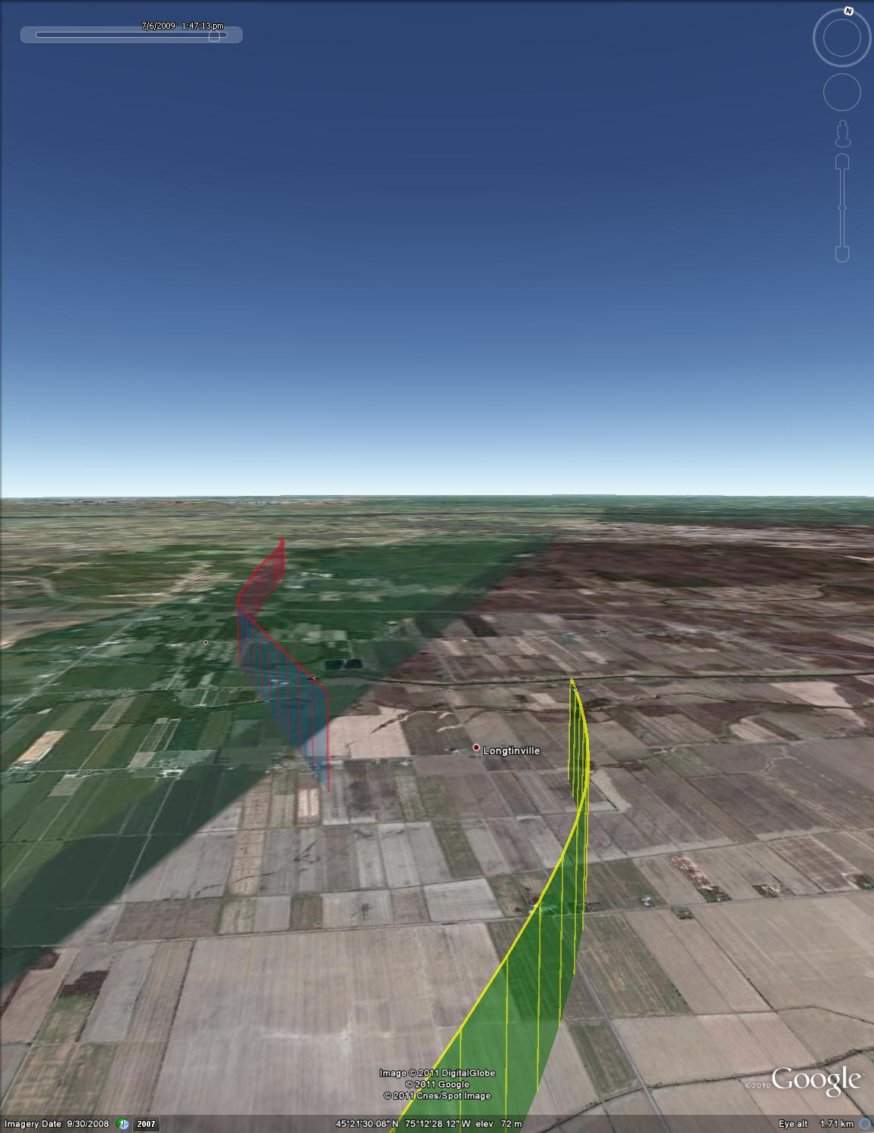

Figure : Test point #59, -30 deg azimuth, isometric view



Figure : Test point #60, -50 deg azimuth



Figure : Test point #60, -50 deg azimuth, final 30 seconds



Figure : Test point #60, -50 deg azimuth, plan view (UTM coordinates)

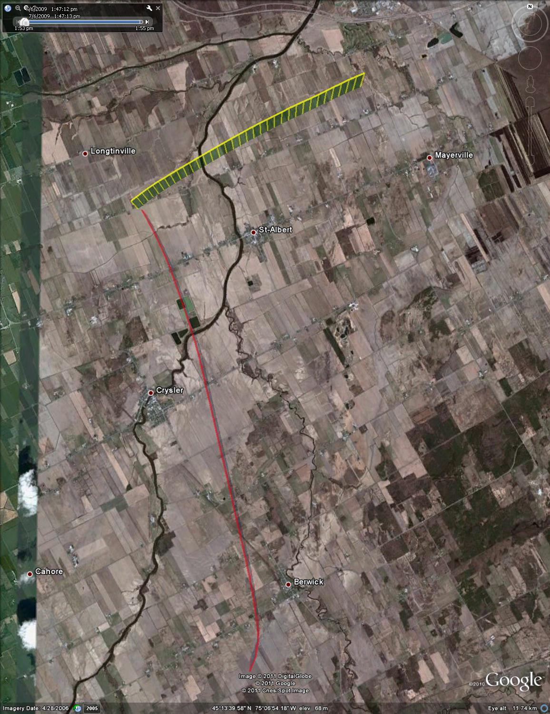

Figure : Test point #60, -50 deg azimuth, plan view (satellite overlay)

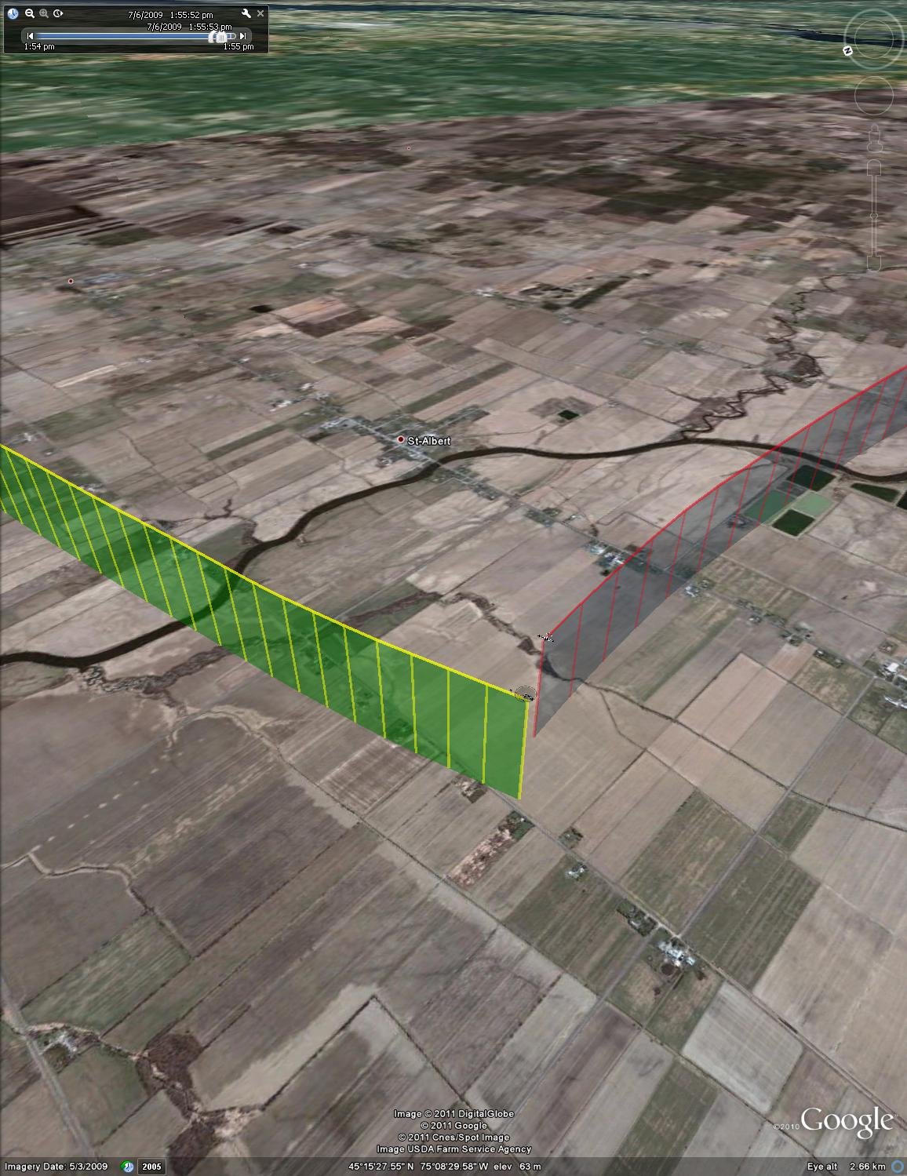

Figure : Test point #60, -50 deg azimuth, isometric view



Figure :Test point #61, -70 deg azimuth



Figure : Test point #61, -70 deg azimuth, final 30 seconds



Figure : Test point #61, -70 deg azimuth, plan view (UTM coordinates)

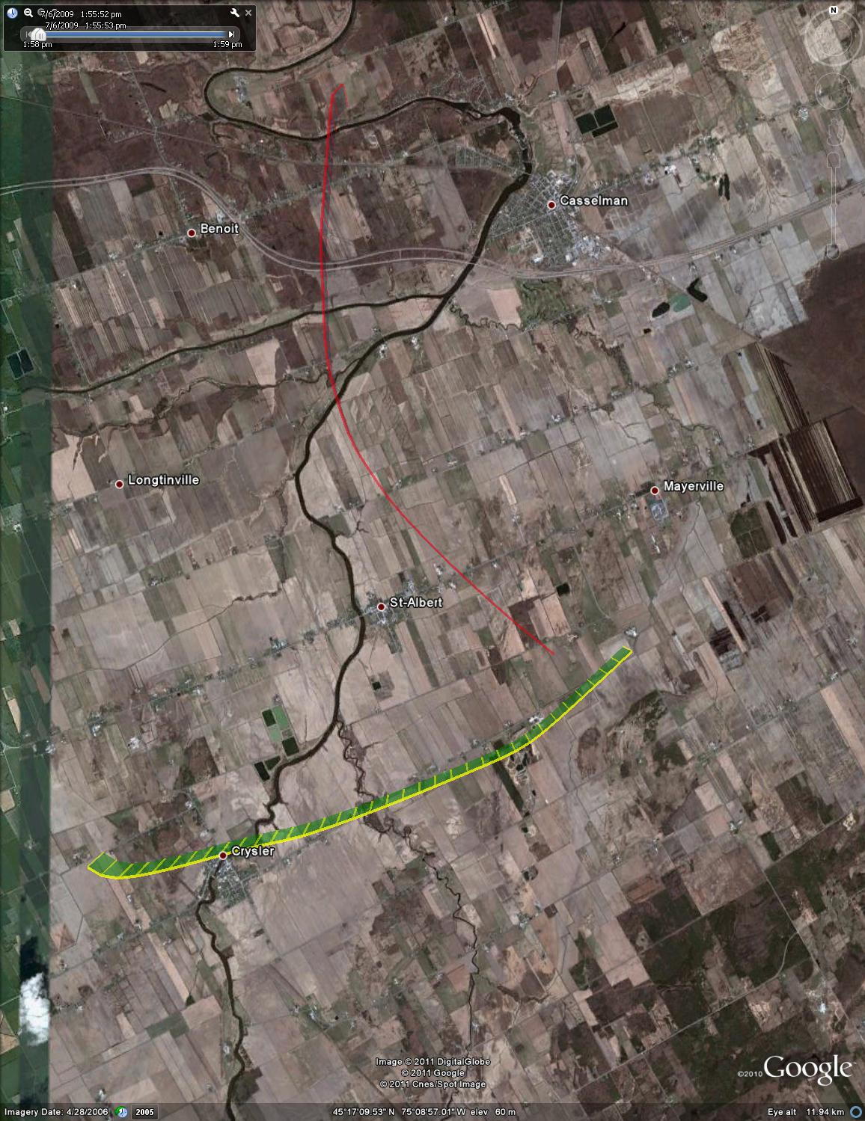

Figure : Test point #61, -70 deg azimuth, plan view (satellite overlay)

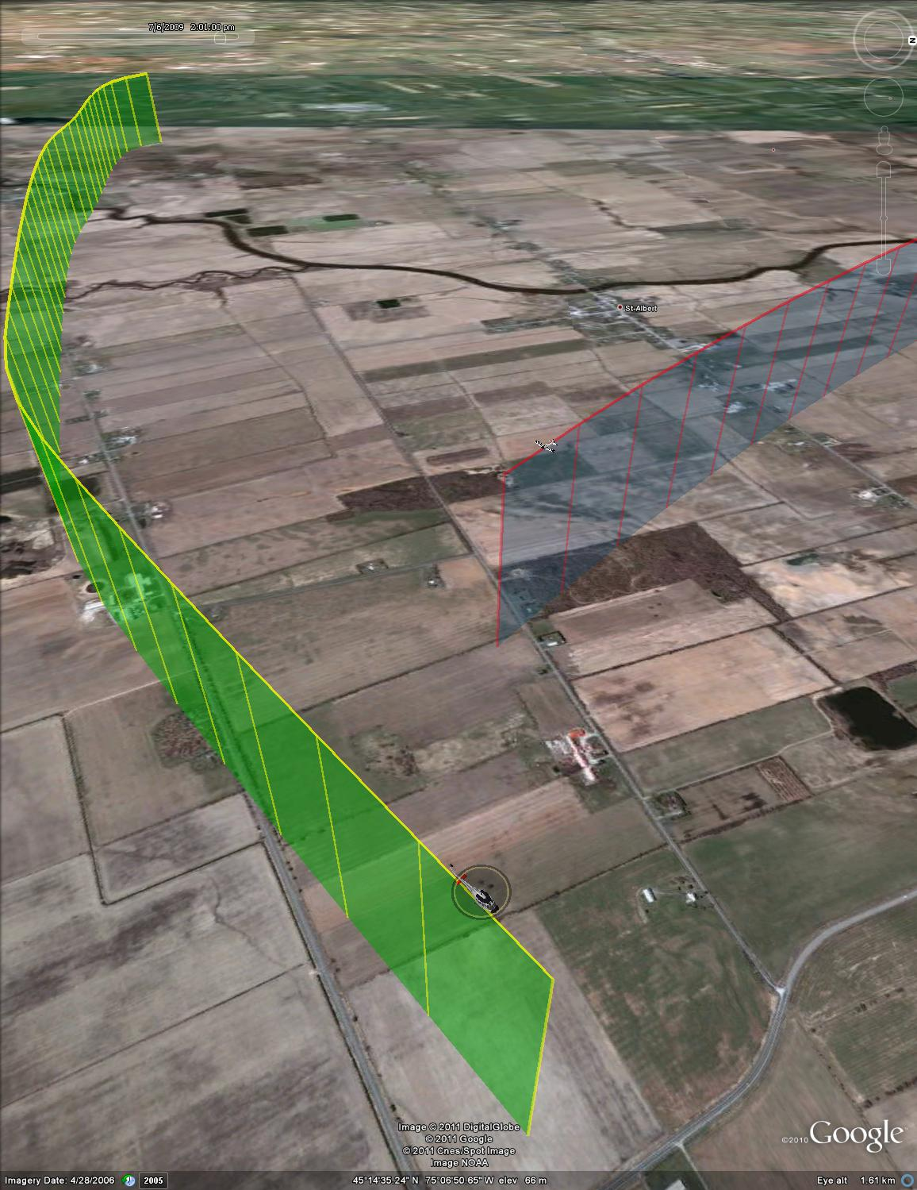

Figure : Test point #61, -70 deg azimuth, isometric view



Figure : Test point #62, -90 deg azimuth (aborted)



Figure : Test point #62, - 90 deg azimuth (aborted), plan view (UTM coordinates)

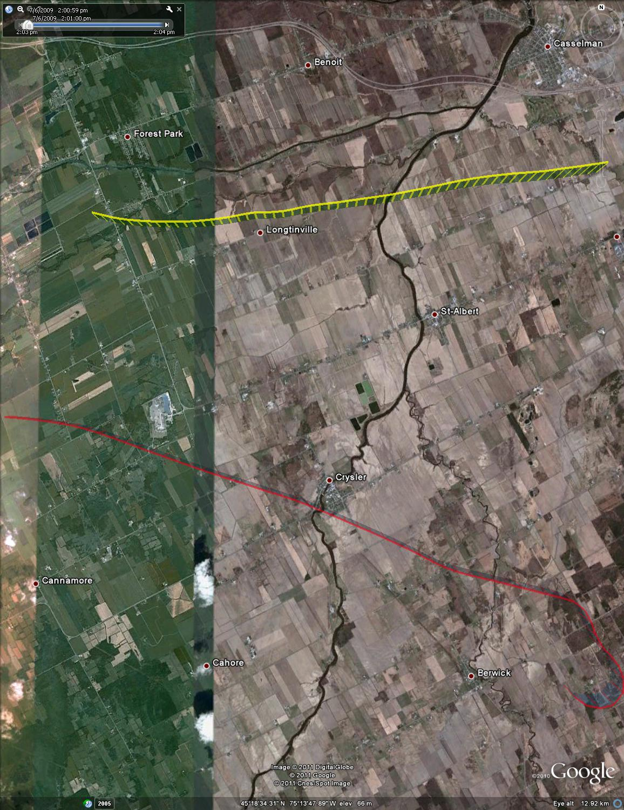

Figure : Test point #62, -90 deg azimuth (aborted), plan view (satellite overlay)



Figure : Test point #65, 0 deg azimuth



Figure : Test point #65, 0 deg azimuth, final 30 seconds



Figure : Test point #65, 0 deg azimuth, plan view (UTM coordinates)

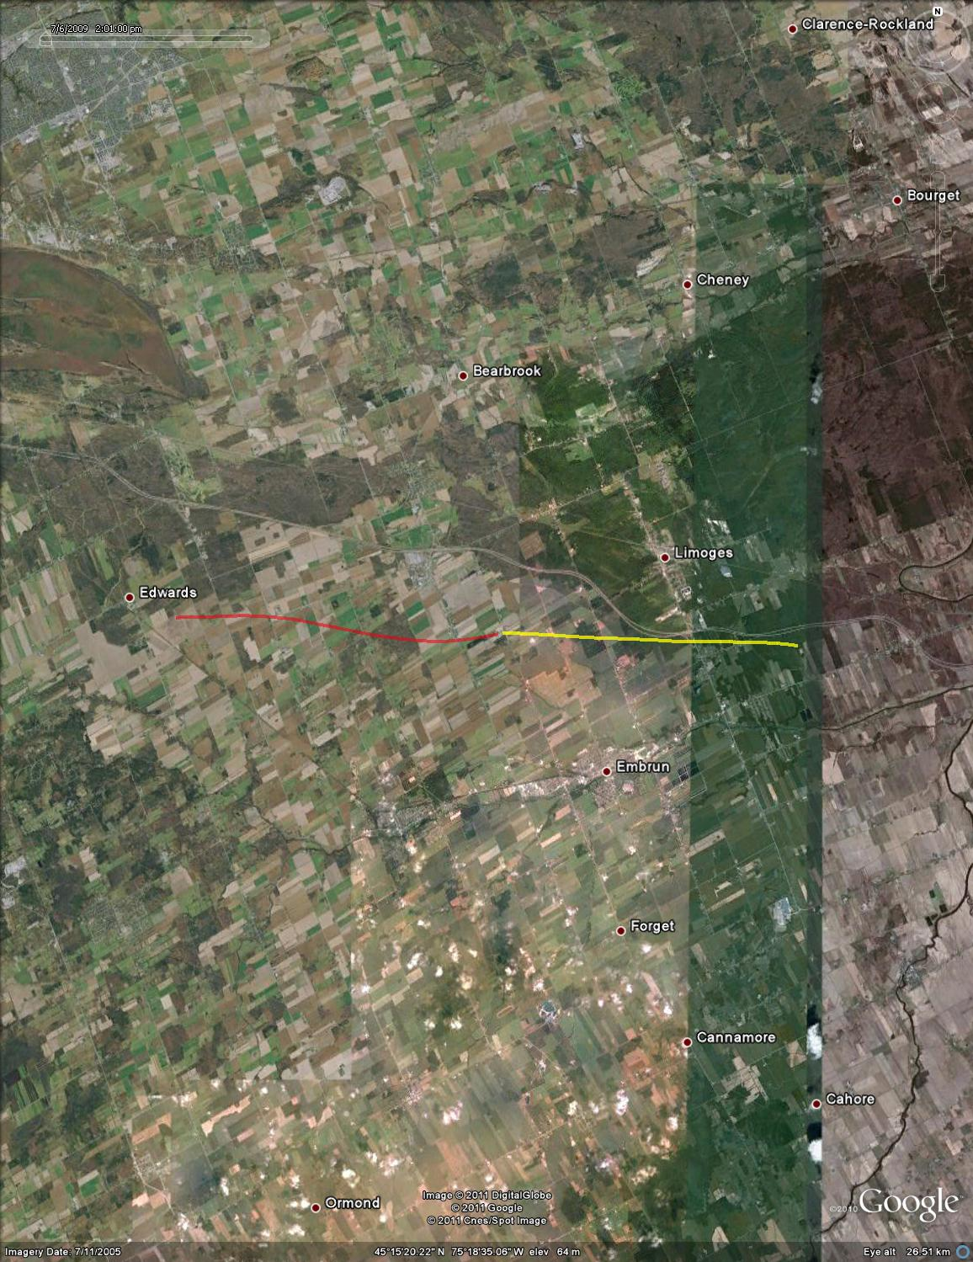

Figure : Test point #65, 0 deg azimuth, plan view (satellite overlay)

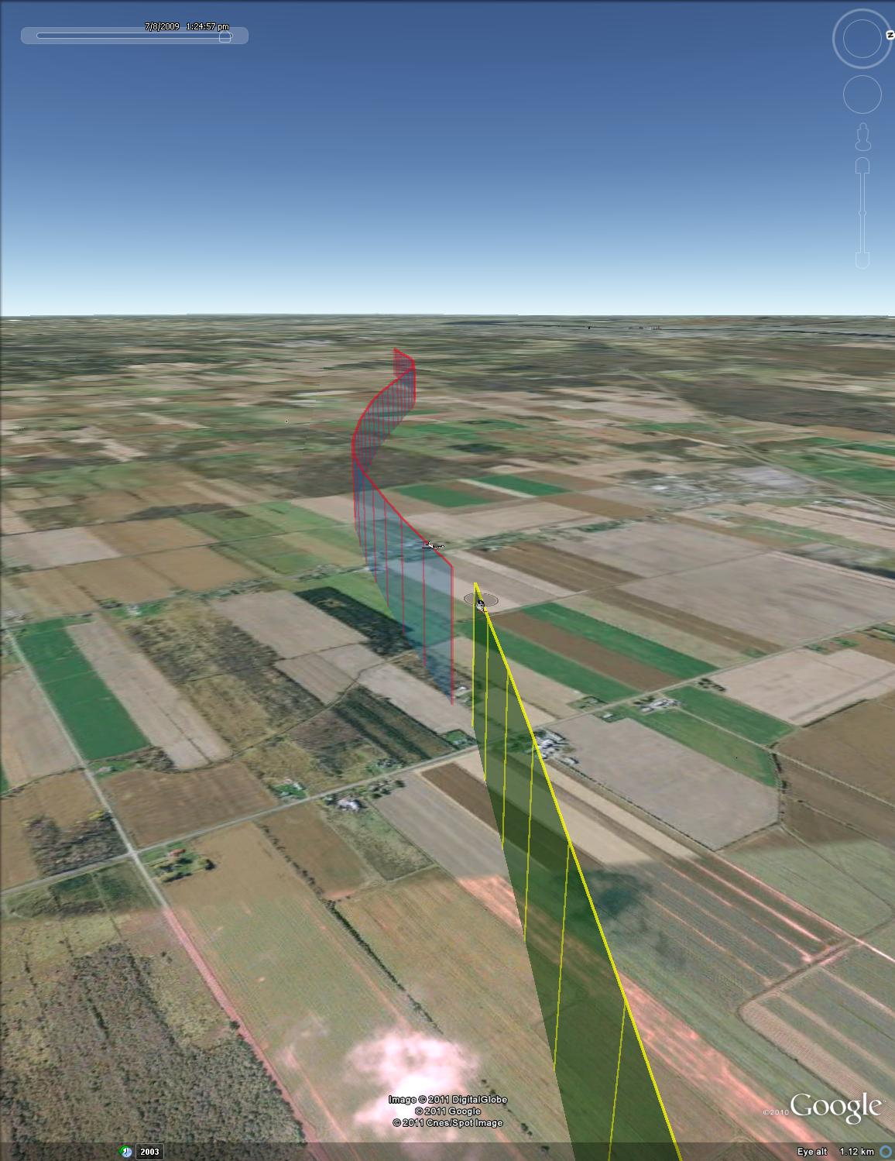

Figure : Test point #65, 0 deg azimuth, isometric view



Figure : Test point #66, - 10 deg azimuth



Figure : Test point #66, -10 deg azimuth, final 30 seconds



Figure : Test point #66, -10 deg azimuth, plan view (UTM coordinates)

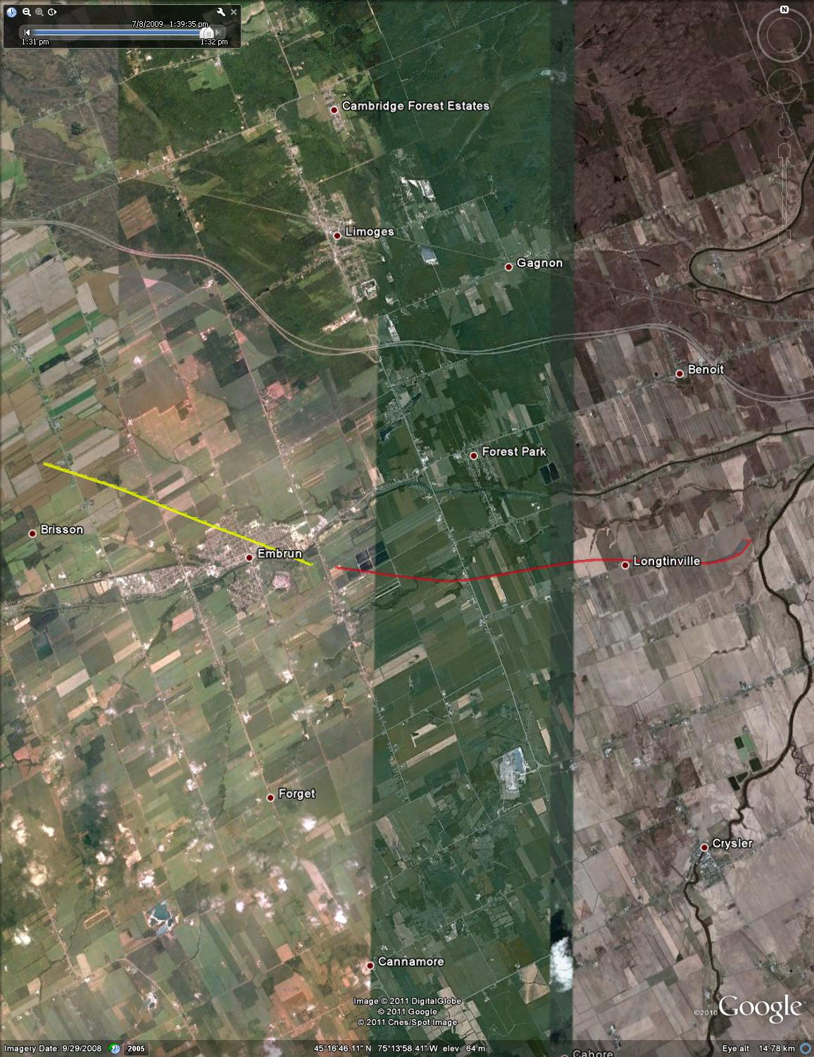

Figure : Test point #66, - 10 deg azimuth, plan view (satellite overlay)

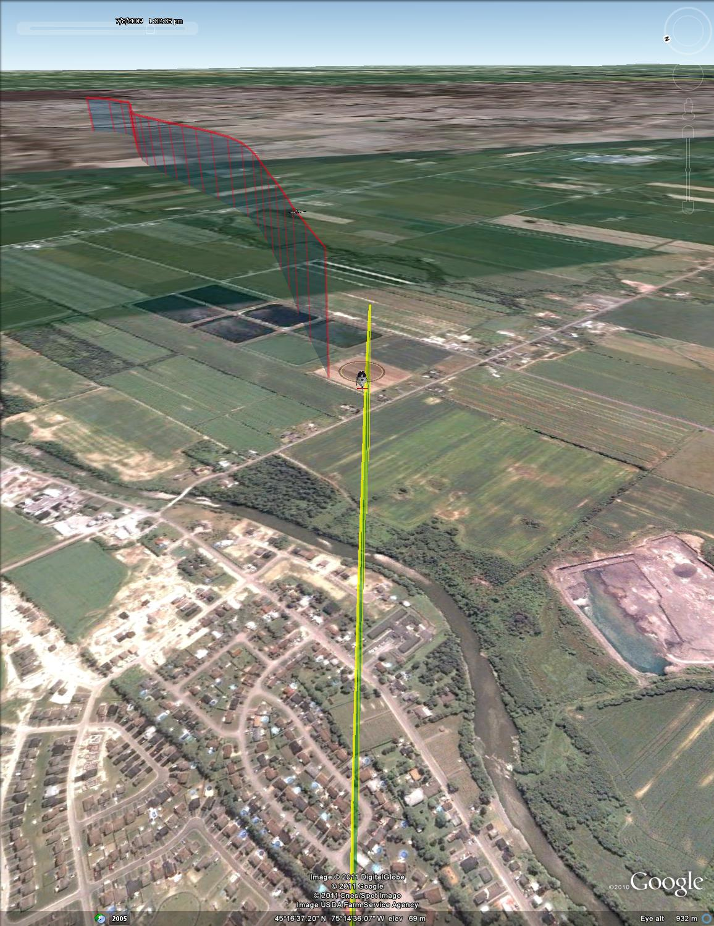

Figure : Test point #66, -10 deg azimuth, isometric view



Figure : Test point #67, -30 deg azimuth



Figure : Test point #67, - 30 deg azimuth, final 30 seconds



Figure : Test point #67, -30 deg azimuth, plan view (UTM coordinates)

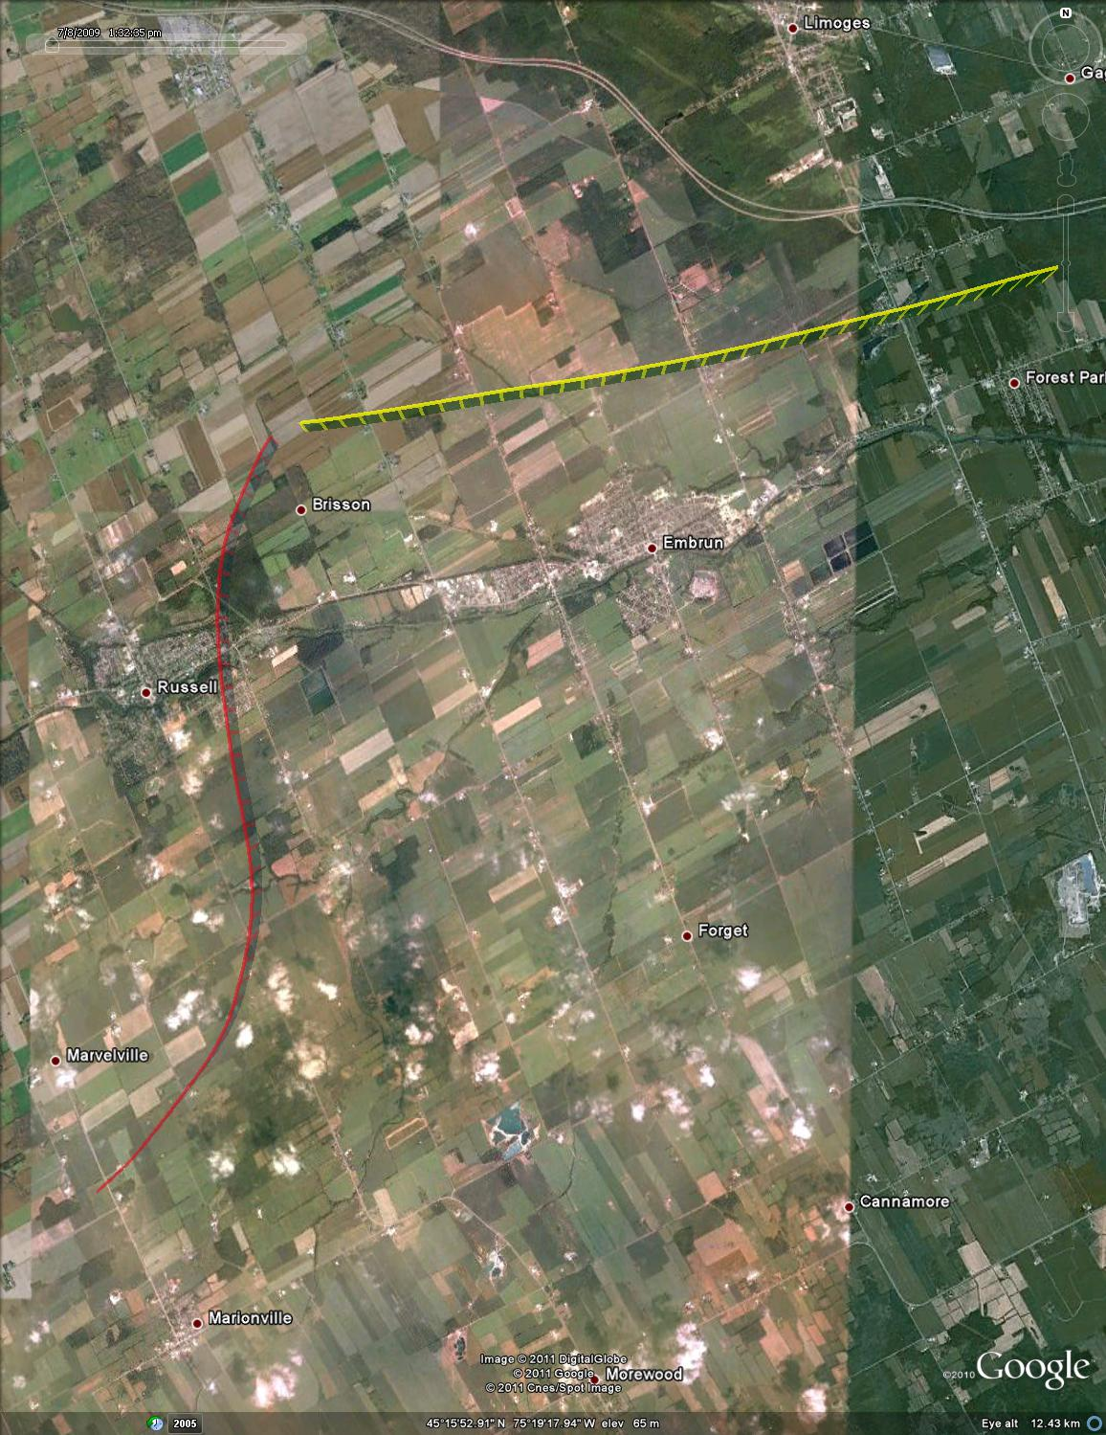

Figure : Test point #67, -30 deg azimuth, plan view (satellite overlay)

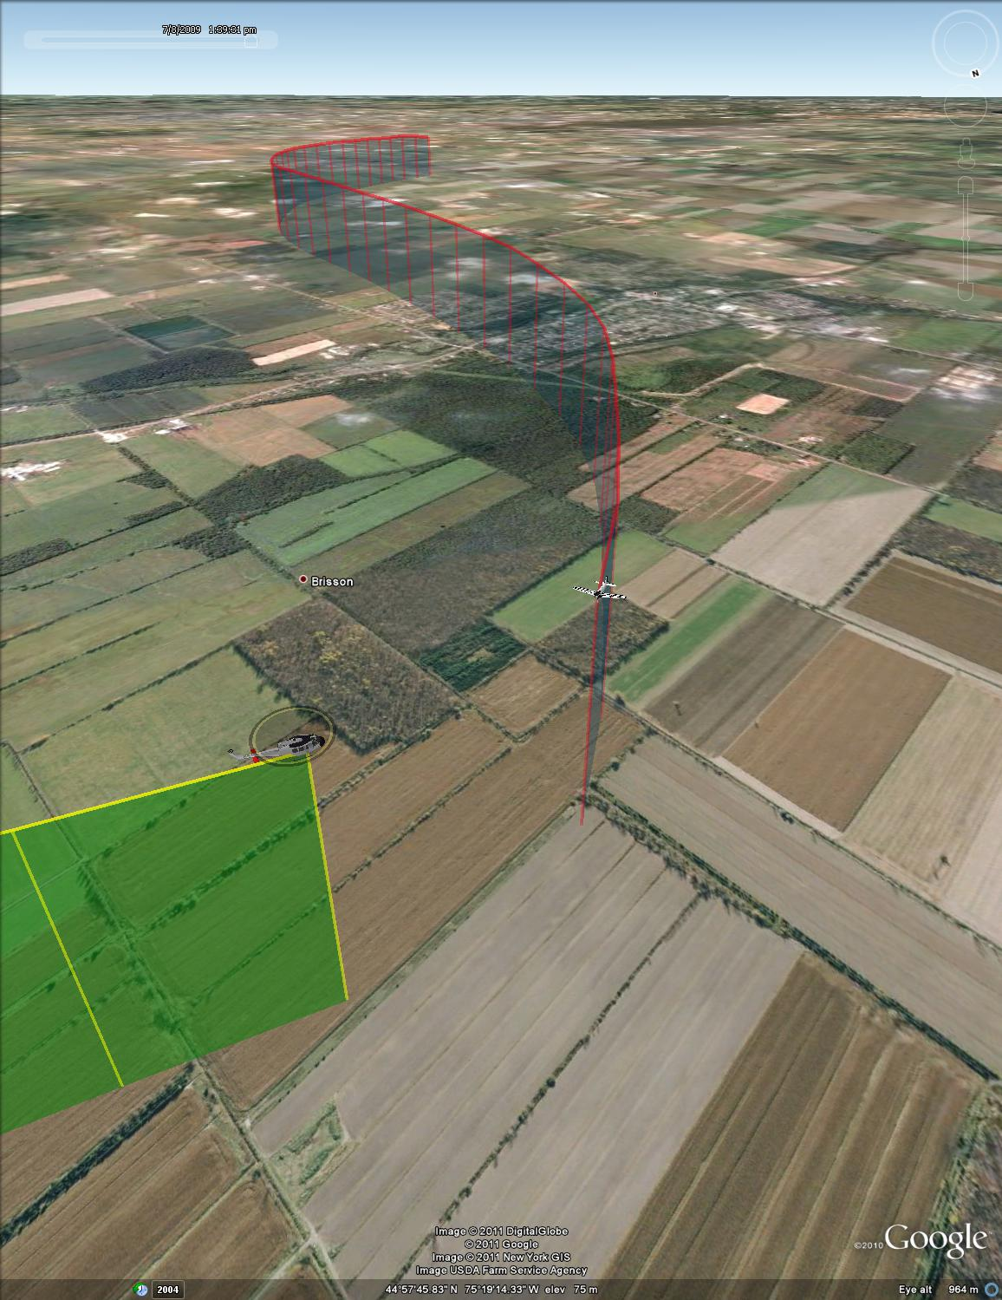

Figure : Test point #67, -30 deg, isometric view



Figure : Test point #68, -50 deg azimuth



Figure : test point #68, - 50 deg azimuth, final 30 seconds



Figure : Test point #68, -50 deg azimuth, plan view (UTM coordinates)

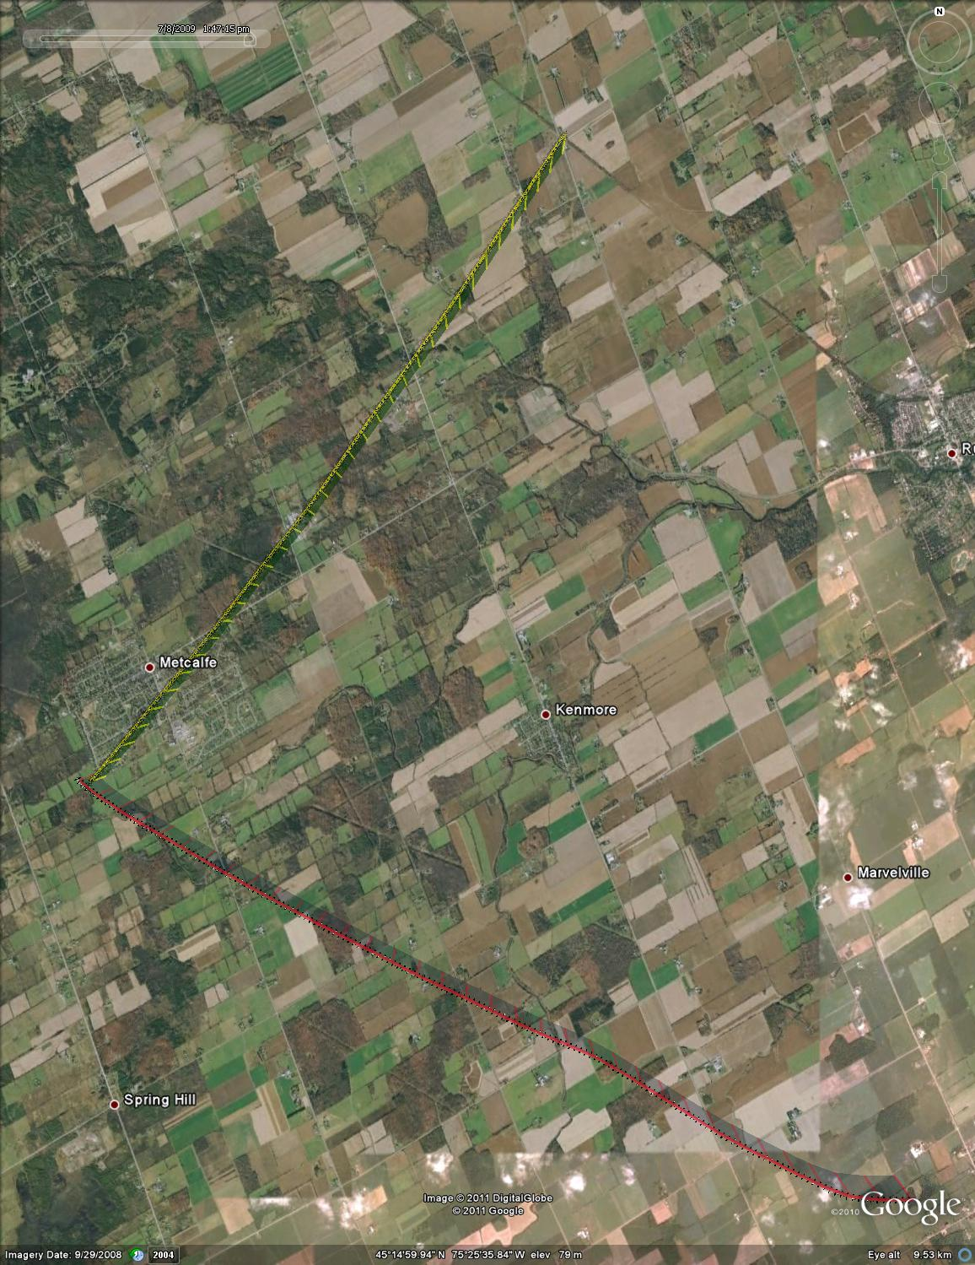

Figure : Test point #68, -50 deg azimuth, plan view (satellite overlay)

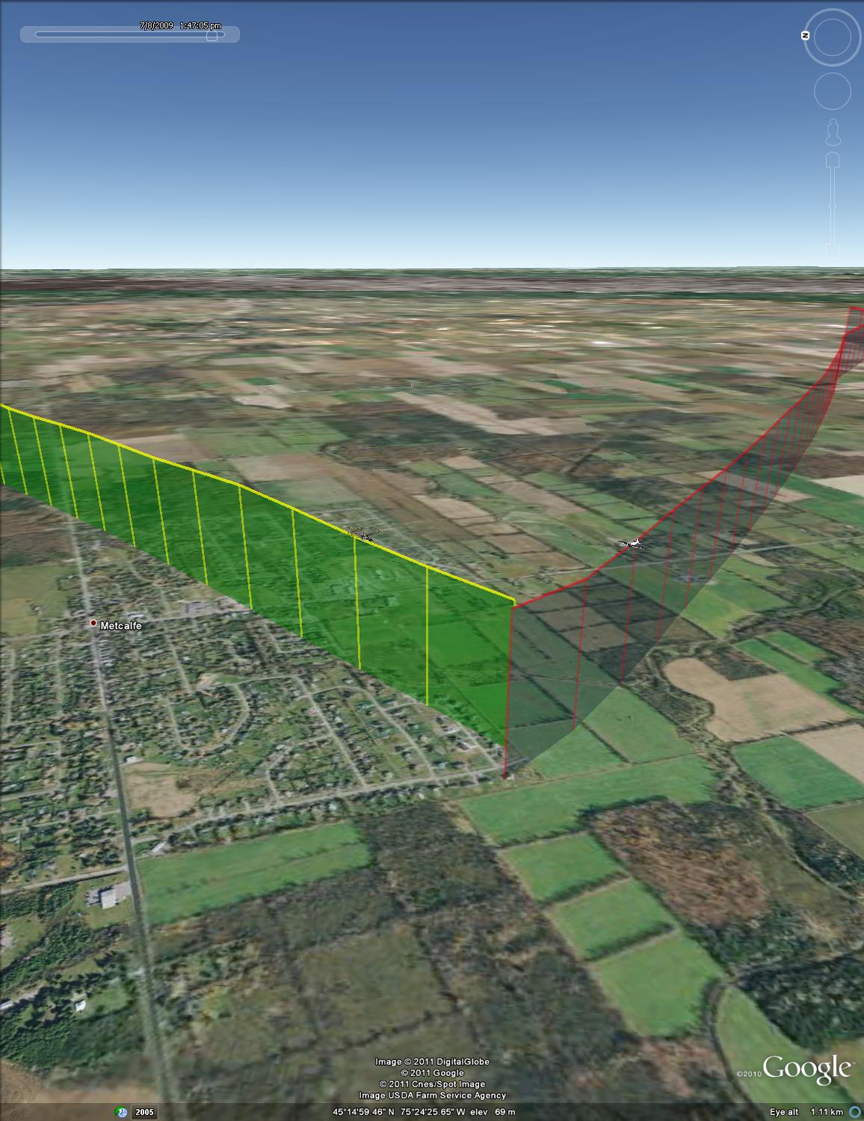

Figure : Test point #68, -50 deg azimuth, isometric view



Figure : Test point #69, -70 deg azimuth



Figure : Test point #69, -70 deg azimuth, final 30 seconds



Figure : Test point #69, -70 deg azimuth, plan view (UTM coordinates)

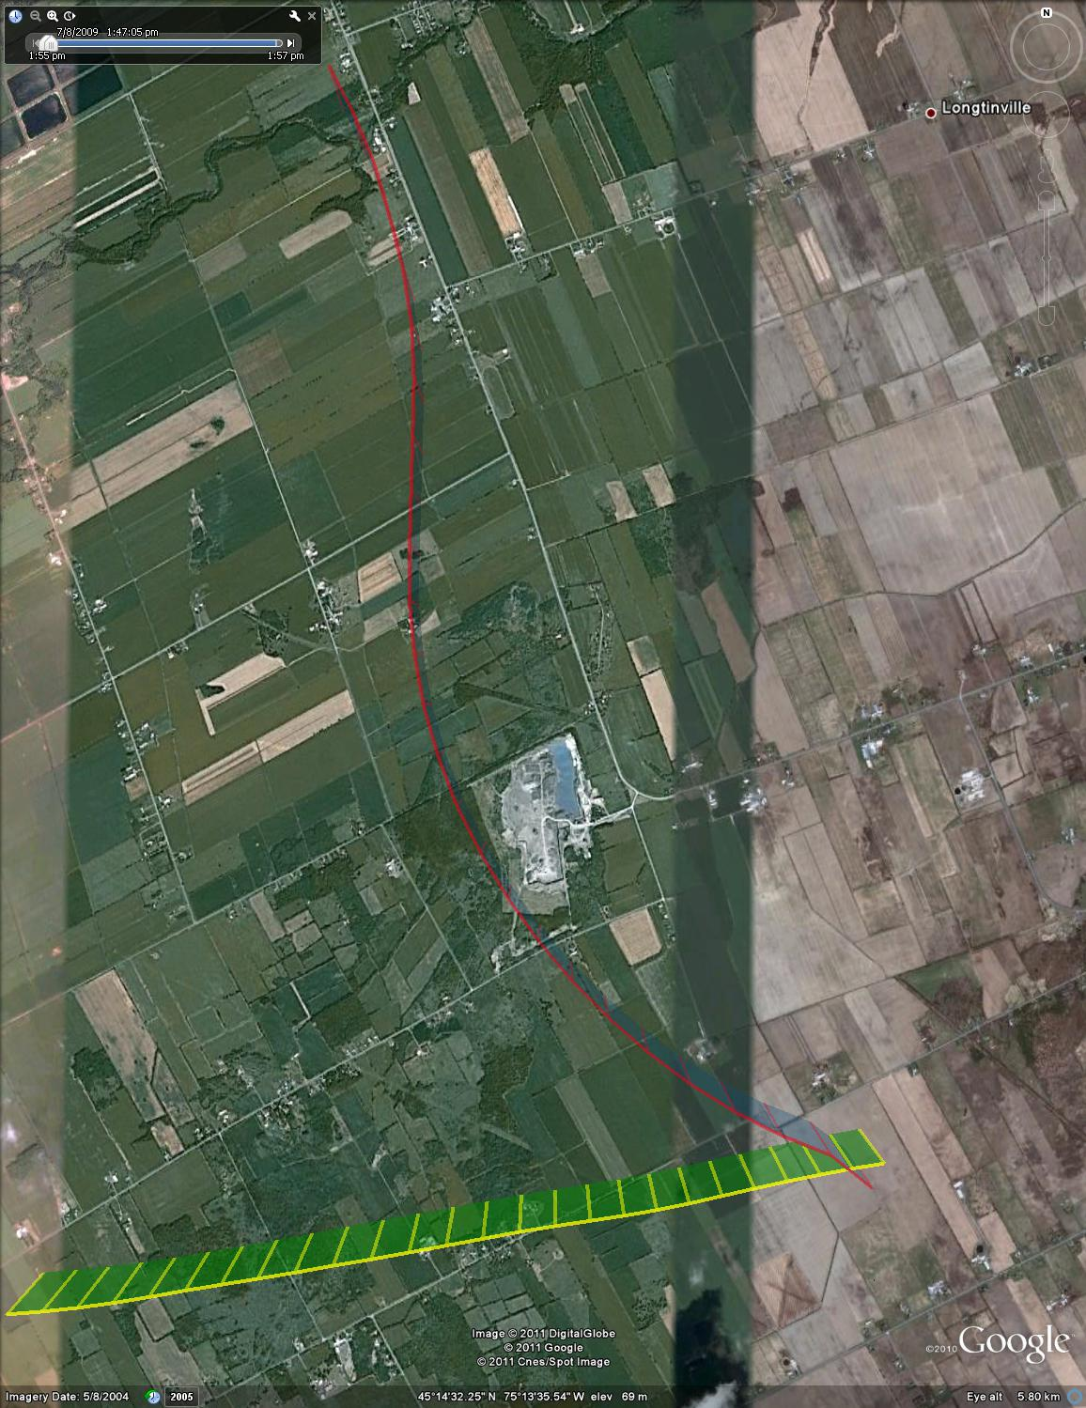

Figure : Test point #69. -70 deg azimuth, plan view (satellite overlay)

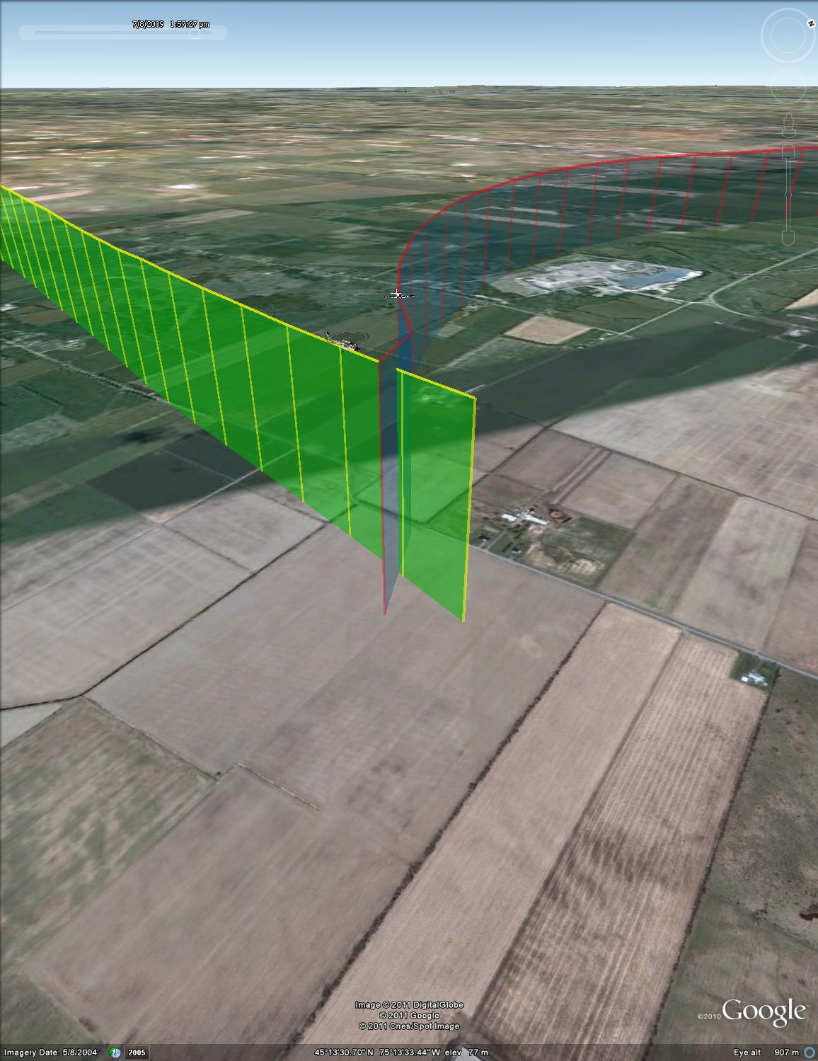

Figure : Test point #69, -70 deg azimuth, isometric view



Figure : Test point #70, - 90 deg azimuth



Figure : Test point #71, -90 deg azimuth, final 30 seconds



Figure : Test point #70, -90 deg azimuth, plan view (UTM coordinates)

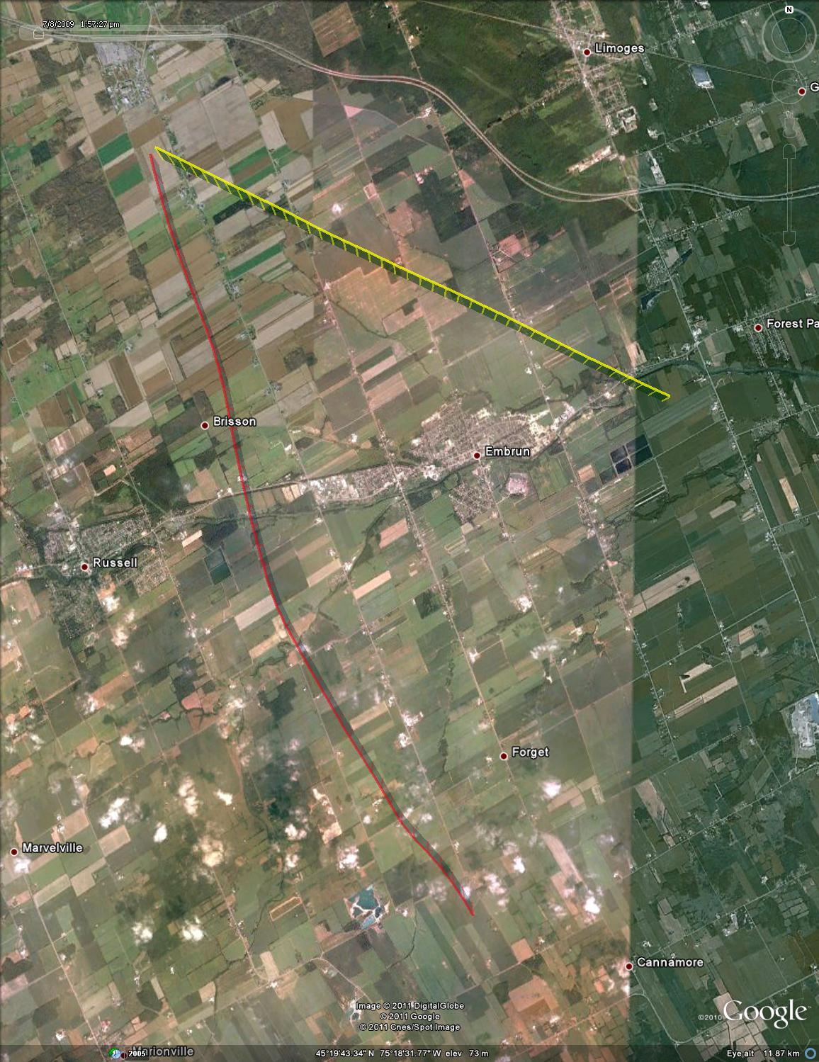

Figure : Test point #70, - 90deg azimuth, plan view (satellite overlay)

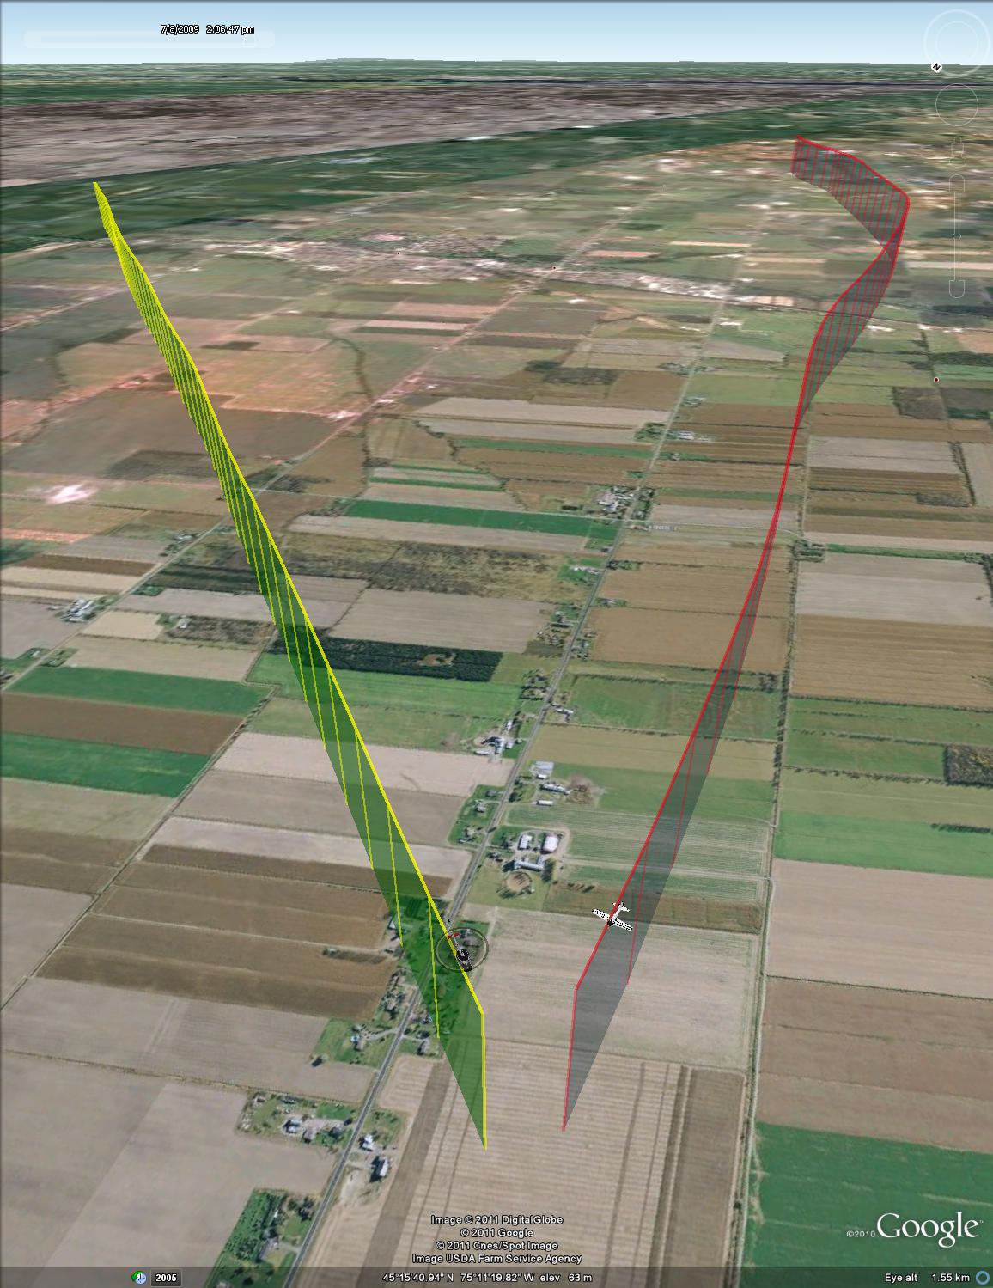

Figure : Test point #70, -90 deg azimuth, isometric view



Figure : Test point #81, 0 deg azimuth



Figure : test point #81, 0 deg azimuth, final 30 seconds



Figure : Test point #81, 0 deg azimuth, plan view (UTM coordinates)

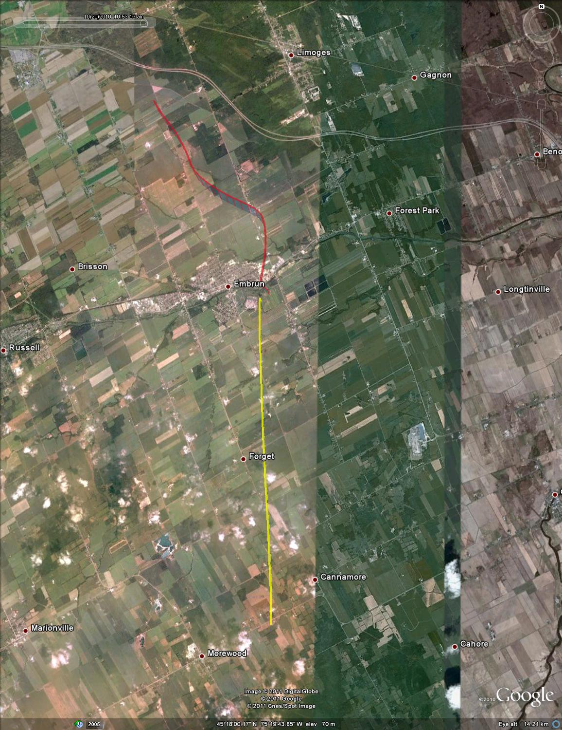

Figure : Test point #81, 0 deg azimuth, plan view (satellite overlay)

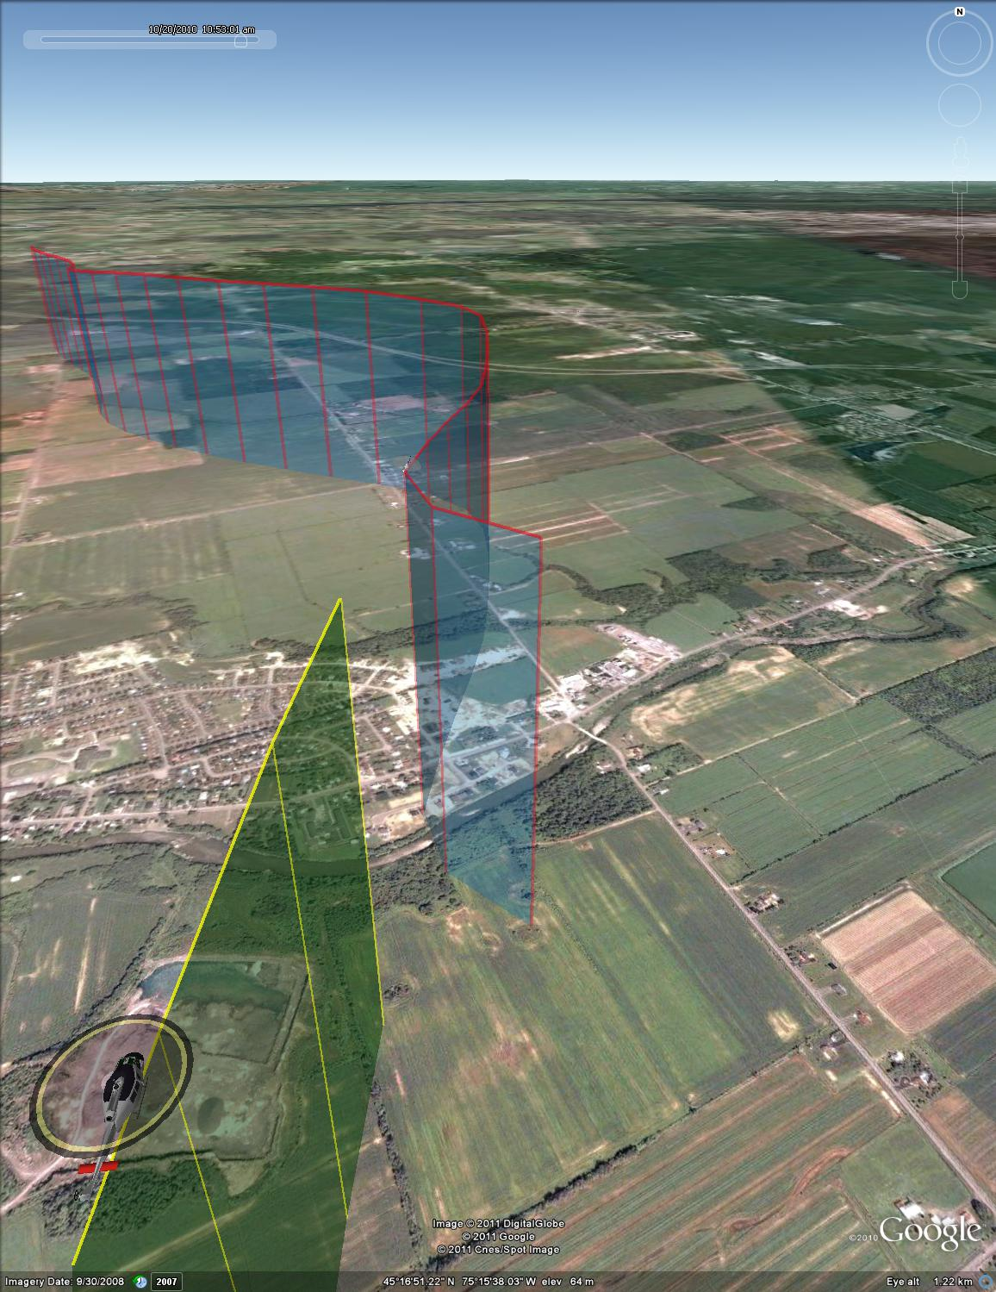

Figure : Test point #81, 0 deg azimuth, isometric view



Figure : Test point #82, 0 deg azimuth



Figure : Test point #82, 0 deg azimuth, final 30 seconds



Figure : Test point #82, 0 deg azimuth, plan view (UTM coordinates)

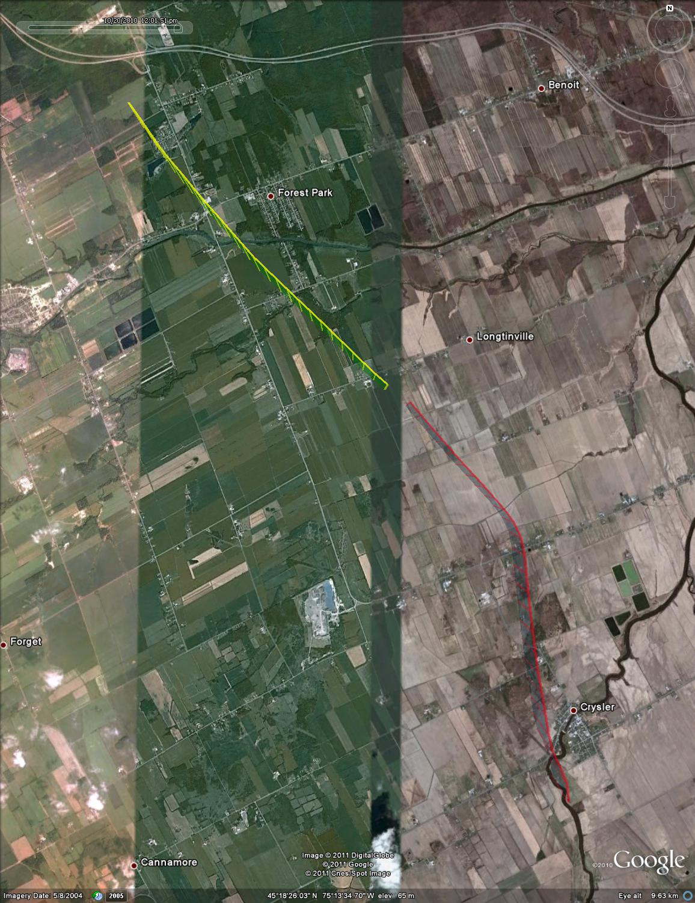

Figure : Test point #82, 0 deg azimuth, plan view (satellite overlay)

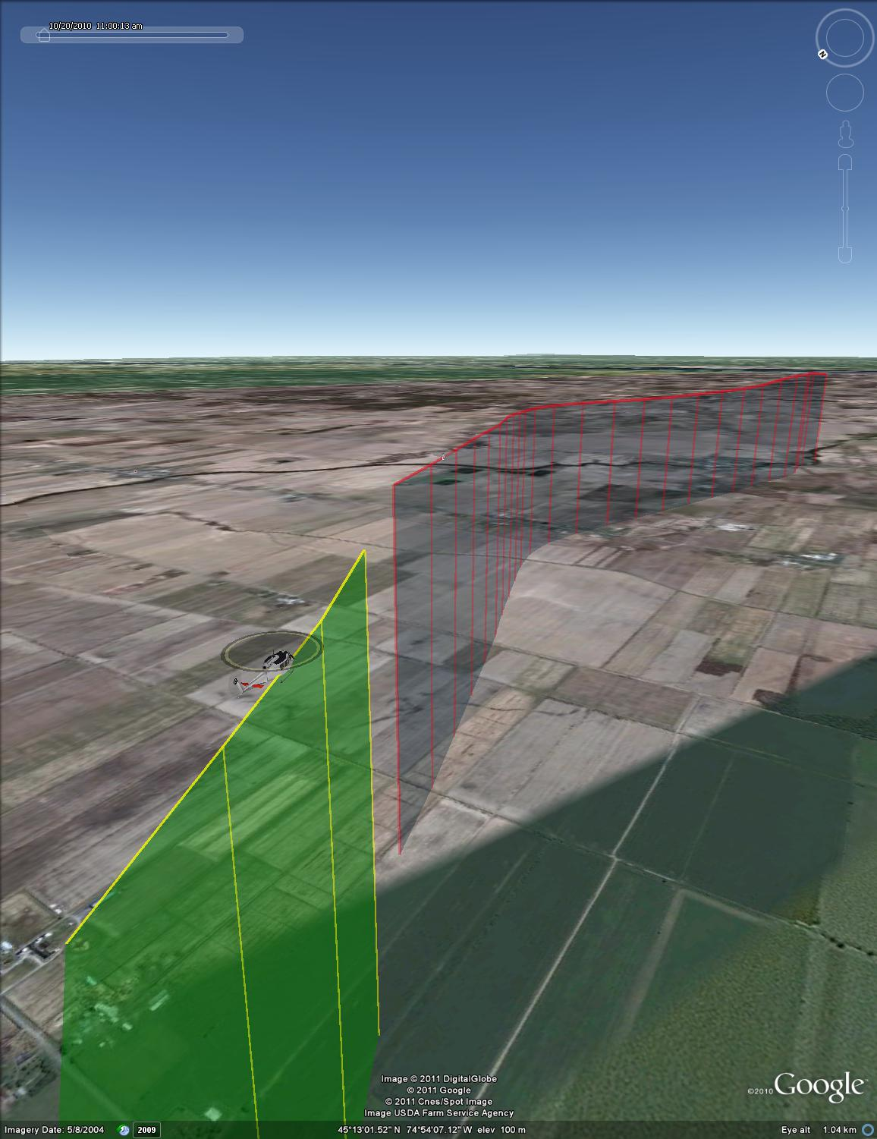

Figure : Test point #82, 0 deg azimuth, isometric view



Figure : Test point #83, -10 deg azimuth



Figure : Test point #83, -10 deg azimuth, final 30 seconds



Figure : Test point #83, -10 deg azimuth, plan view (UTM coordinates)

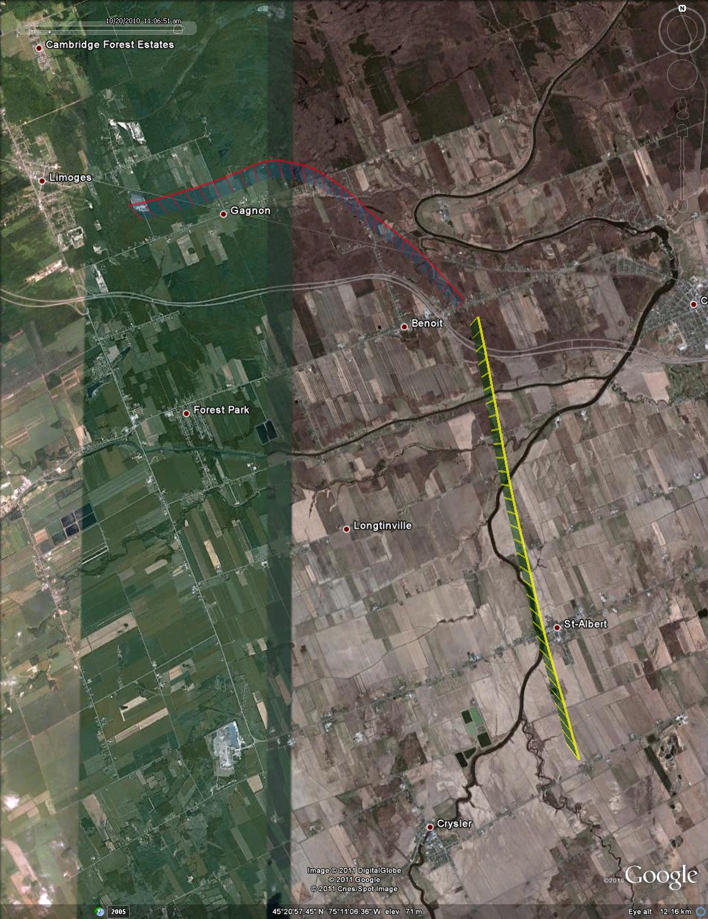

Figure : Test point #83, -10 deg azimuth, plan view (satellite overlay)

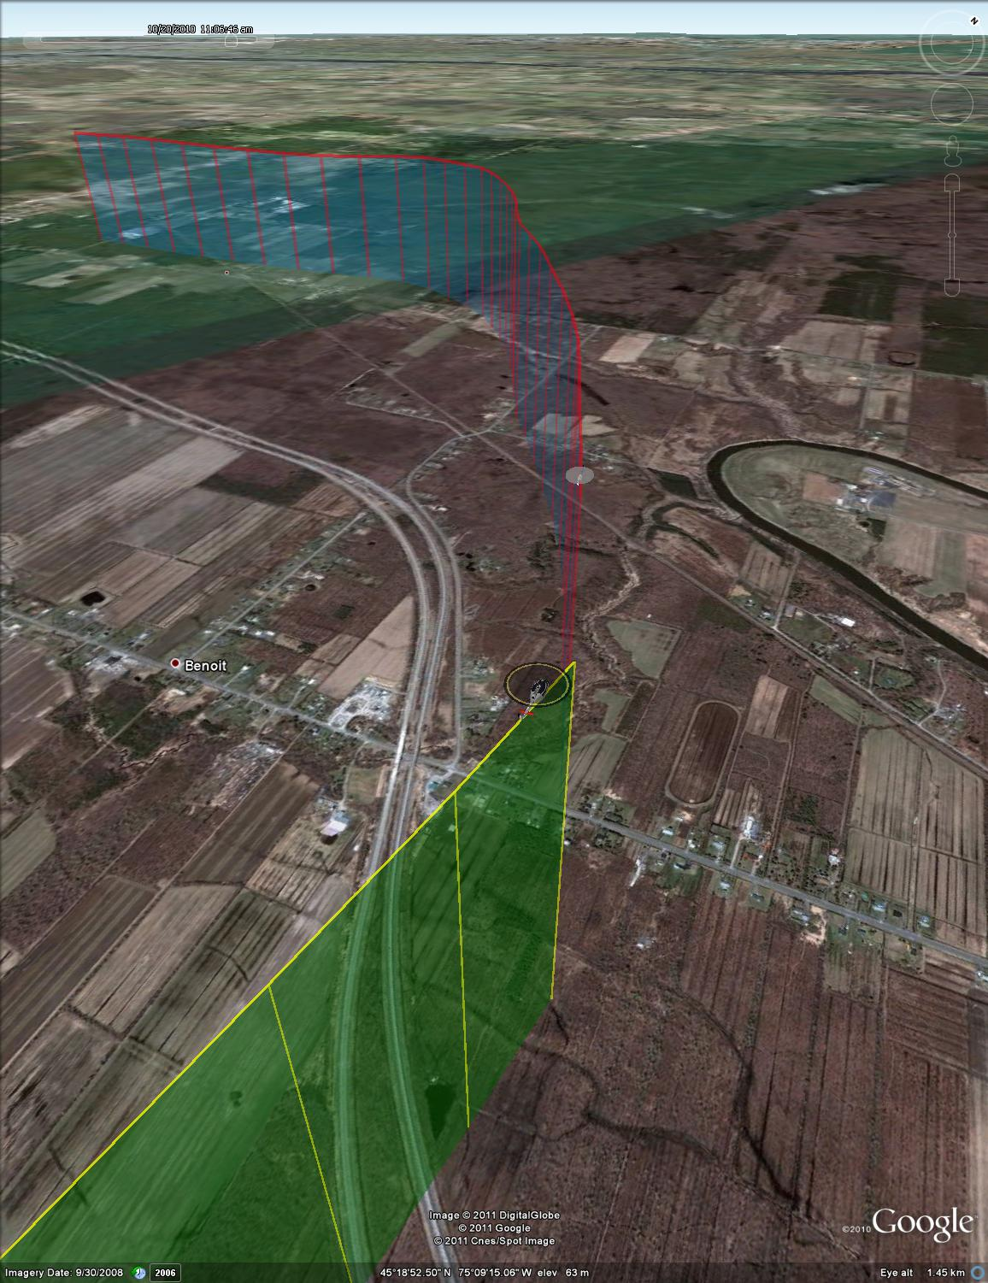

Figure : Test point #83, -10 deg azimuth, isometric view



Figure : Test point #84, -30 deg azimuth (aborted)



Figure : Test point #84, -30 deg azimuth (aborted), plan view (UTM coordinates)



Figure : Test point #85, -30 deg azimuth



Figure : Test point #85, -30 deg azimuth, final 30 seconds



Figure : Test point #85, -30 deg azimuth, plan view (UTM coordinates)

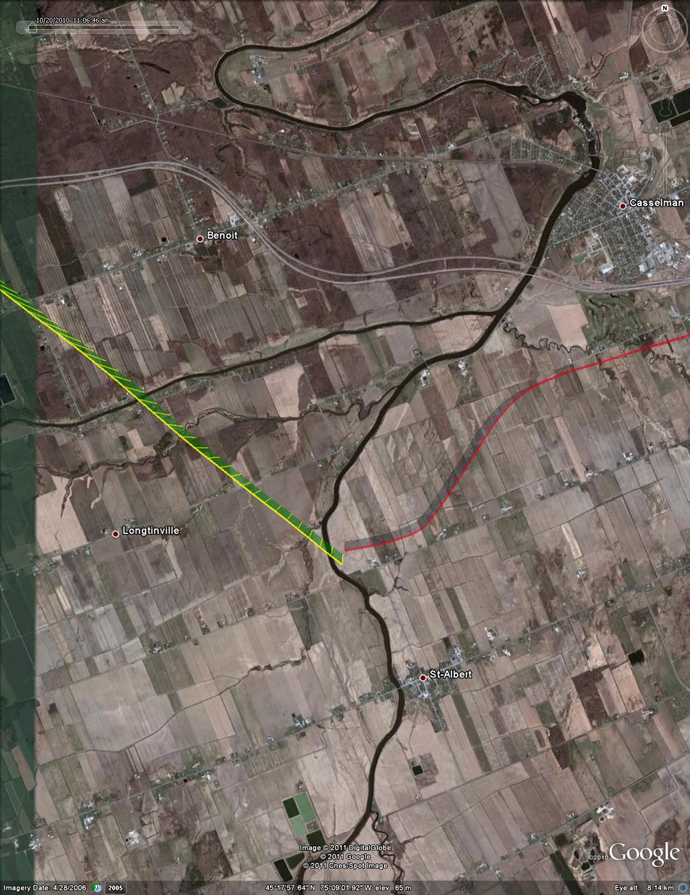

Figure : Test point #85, -30 deg azimuth, plan view (satellite overlay)

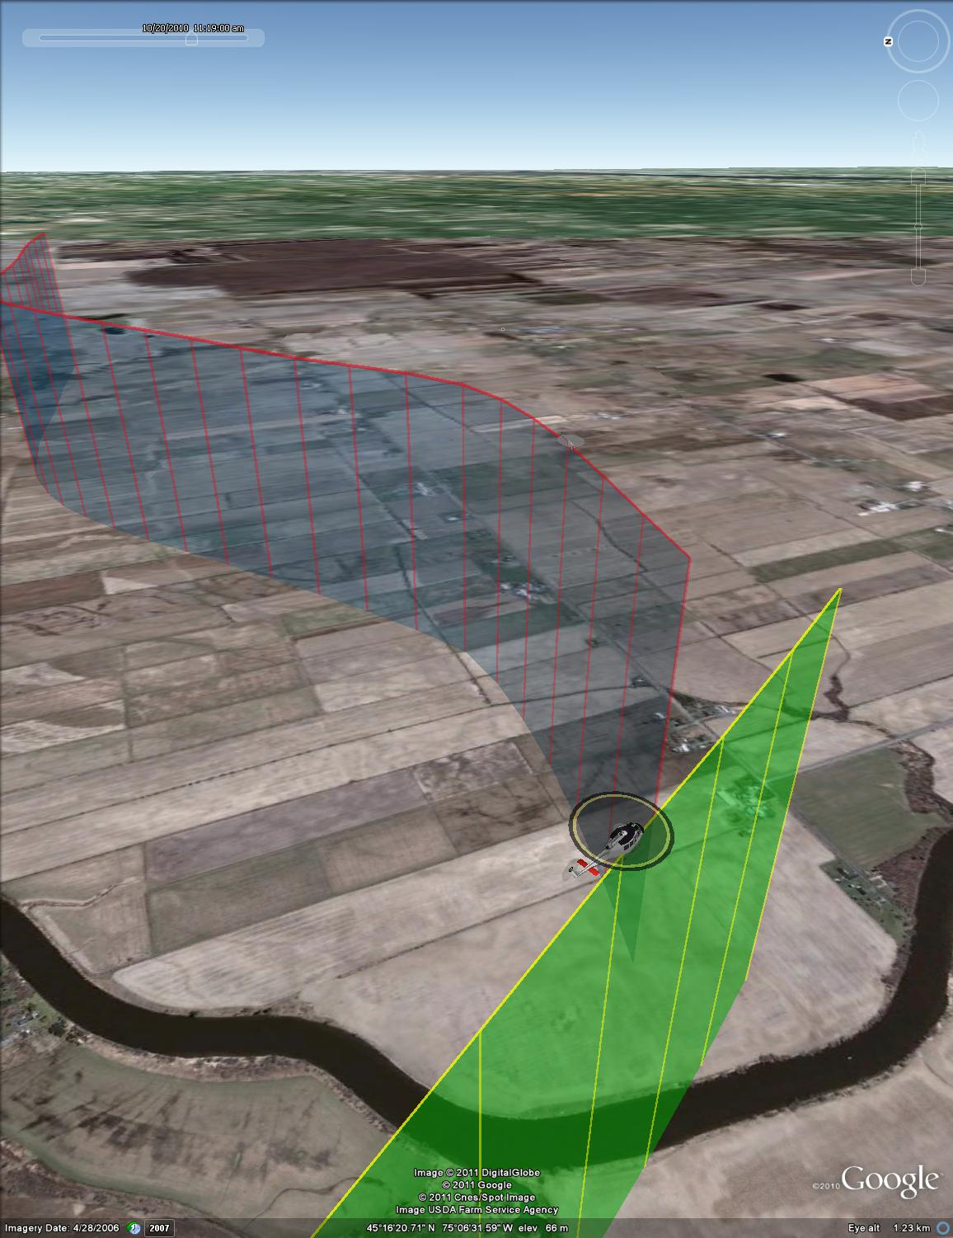

Figure : Test point #85, -30 deg azimuth, isometric view



Figure : Test point #86, -50 deg azimuth



Figure : Test point #86, -50 deg azimuth, final 30 seconds



Figure : Test point #86, -50 deg azimuth, plan view (UTM coordinates)

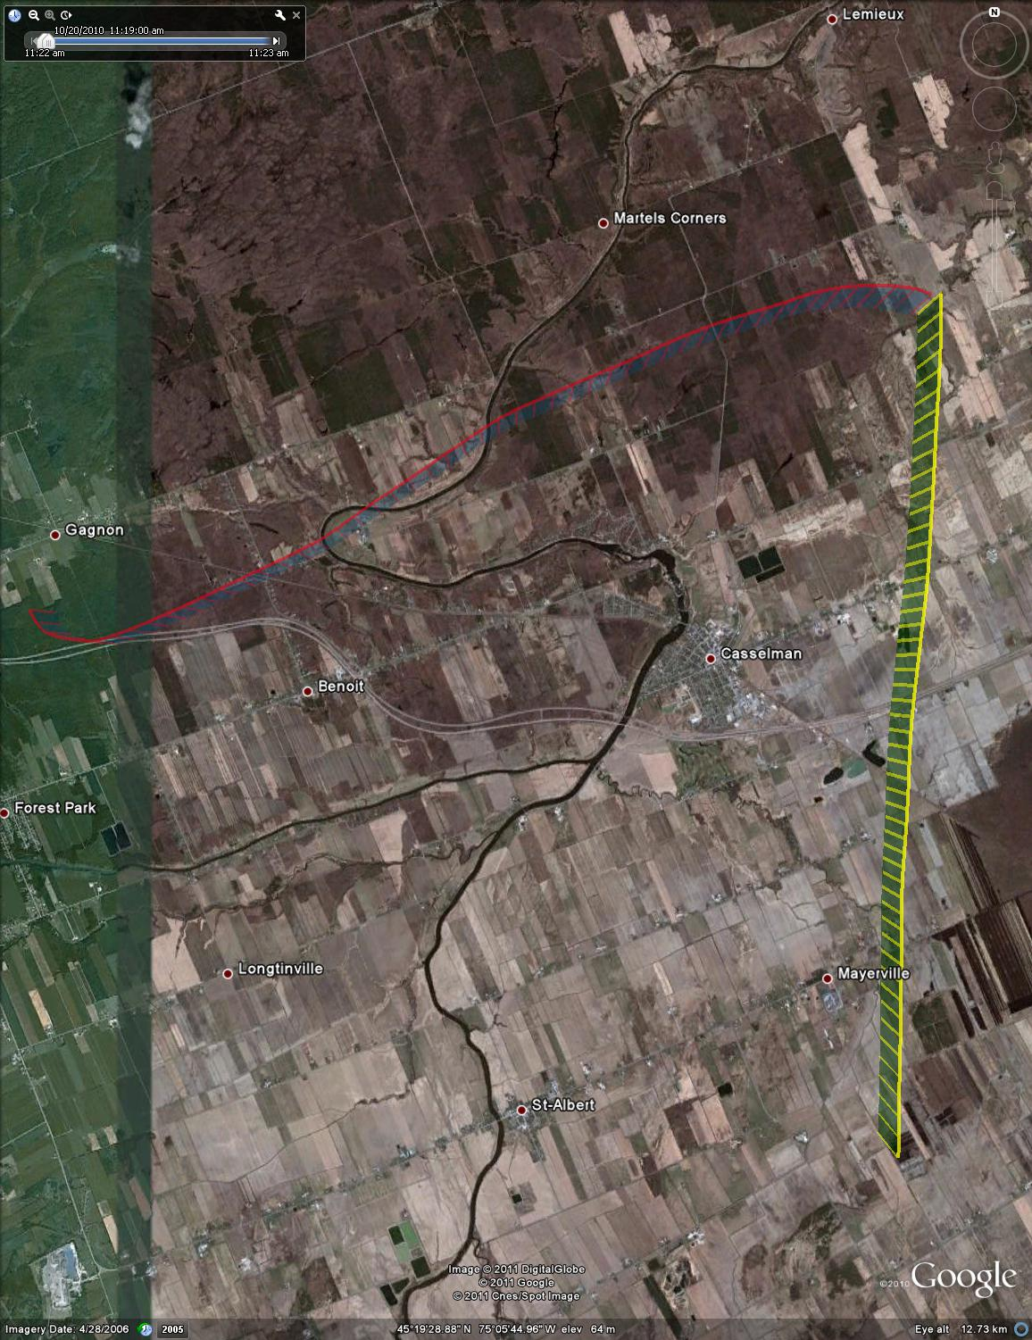

Figure : Test point #86, -50 deg azimuth, plan view (satellite overlay)

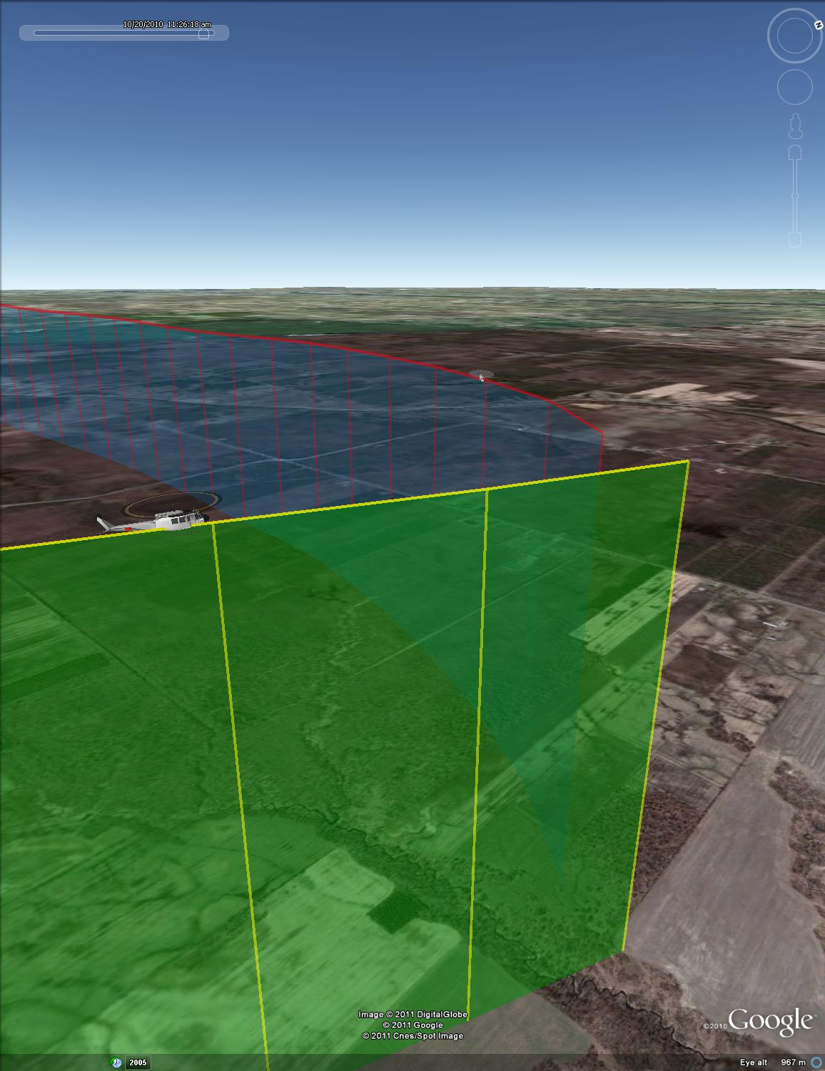

Figure : Test point #86, -50 deg azimuth, isometric view



Figure : Test point #87, -70 deg azimuth



Figure : Test point #87, -70 deg azimuth, final 30 seconds



Figure : Test point #87, -70 deg azimuth, plan view (UTM coordinates)

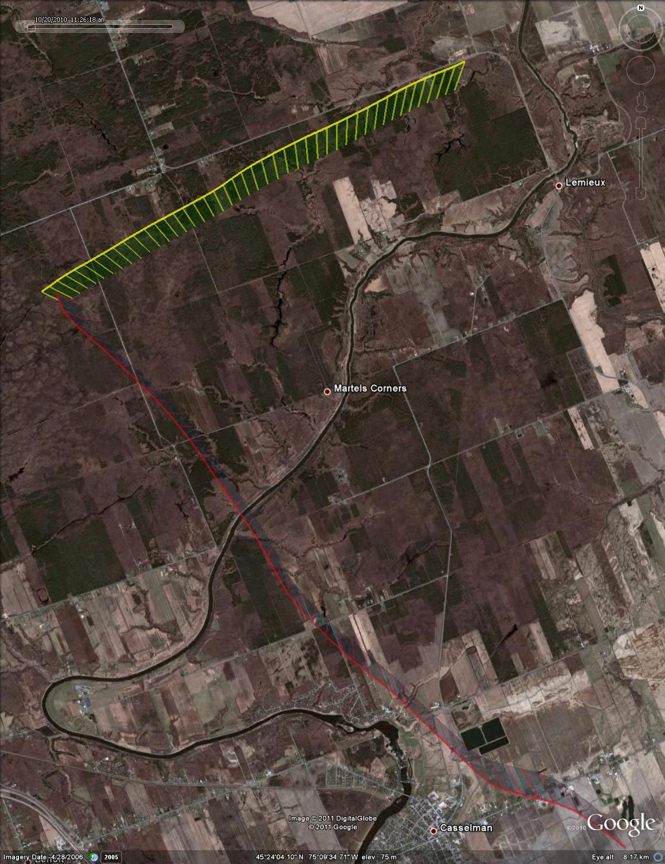

Figure : Test point #87, -70 deg azimuth, plan view (satellite overlay)

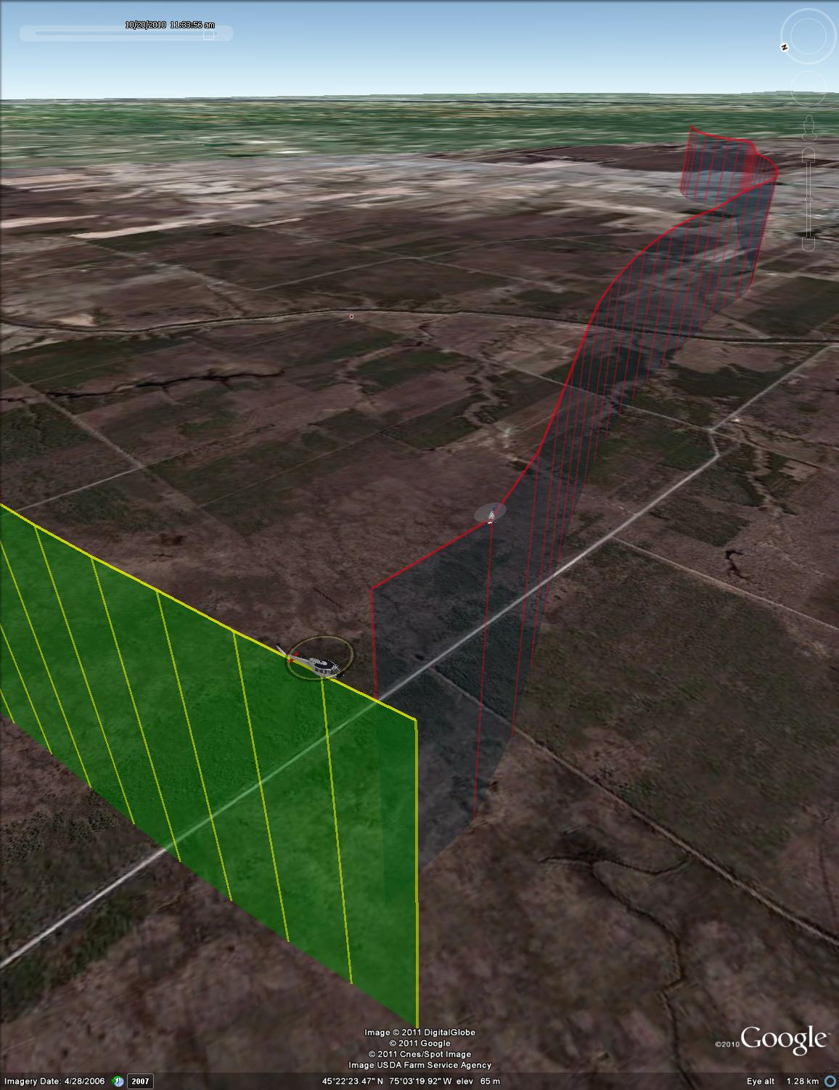

Figure : Test point #87, -70 deg azimuth, isometric view



Figure : Test point #88, -90 deg azimuth



Figure : Test point #88, -90 deg azimuth, final 30 seconds



Figure : Test point #88, -90 deg azimuth, plan view (UTM coordinates)

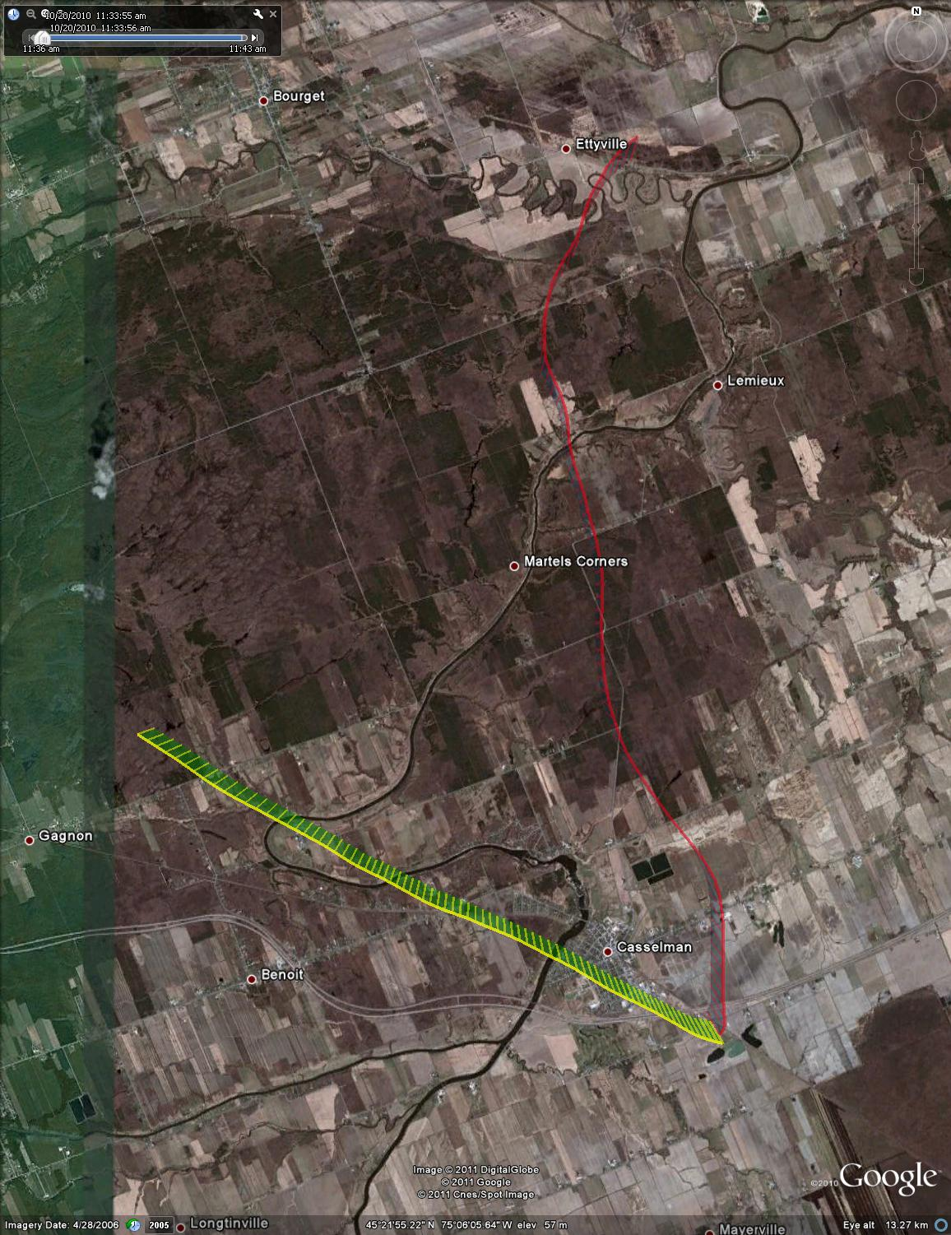

Figure : Test point #88, -90 deg azimuth, plan view (satellite overlay)

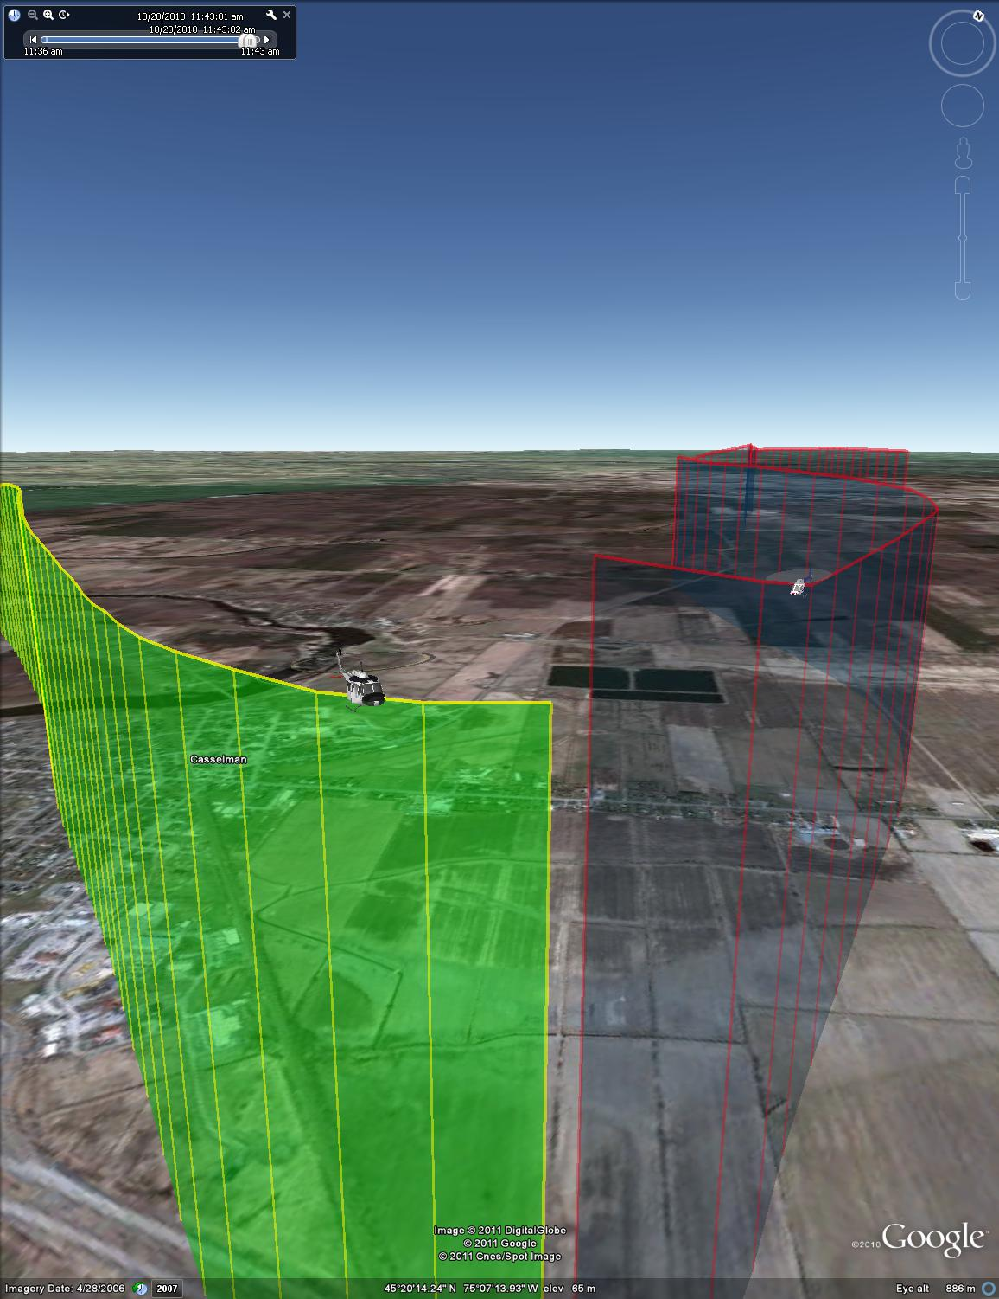

Figure : Test point #88, -90 deg azimuth, isometric view



Figure : Test point #89, 0 deg azimuth



Figure : Test point #89, 0 deg azimuth, final 30 seconds



Figure : Test point 89, 0 deg azimuth, plan view (UTM coordinates)

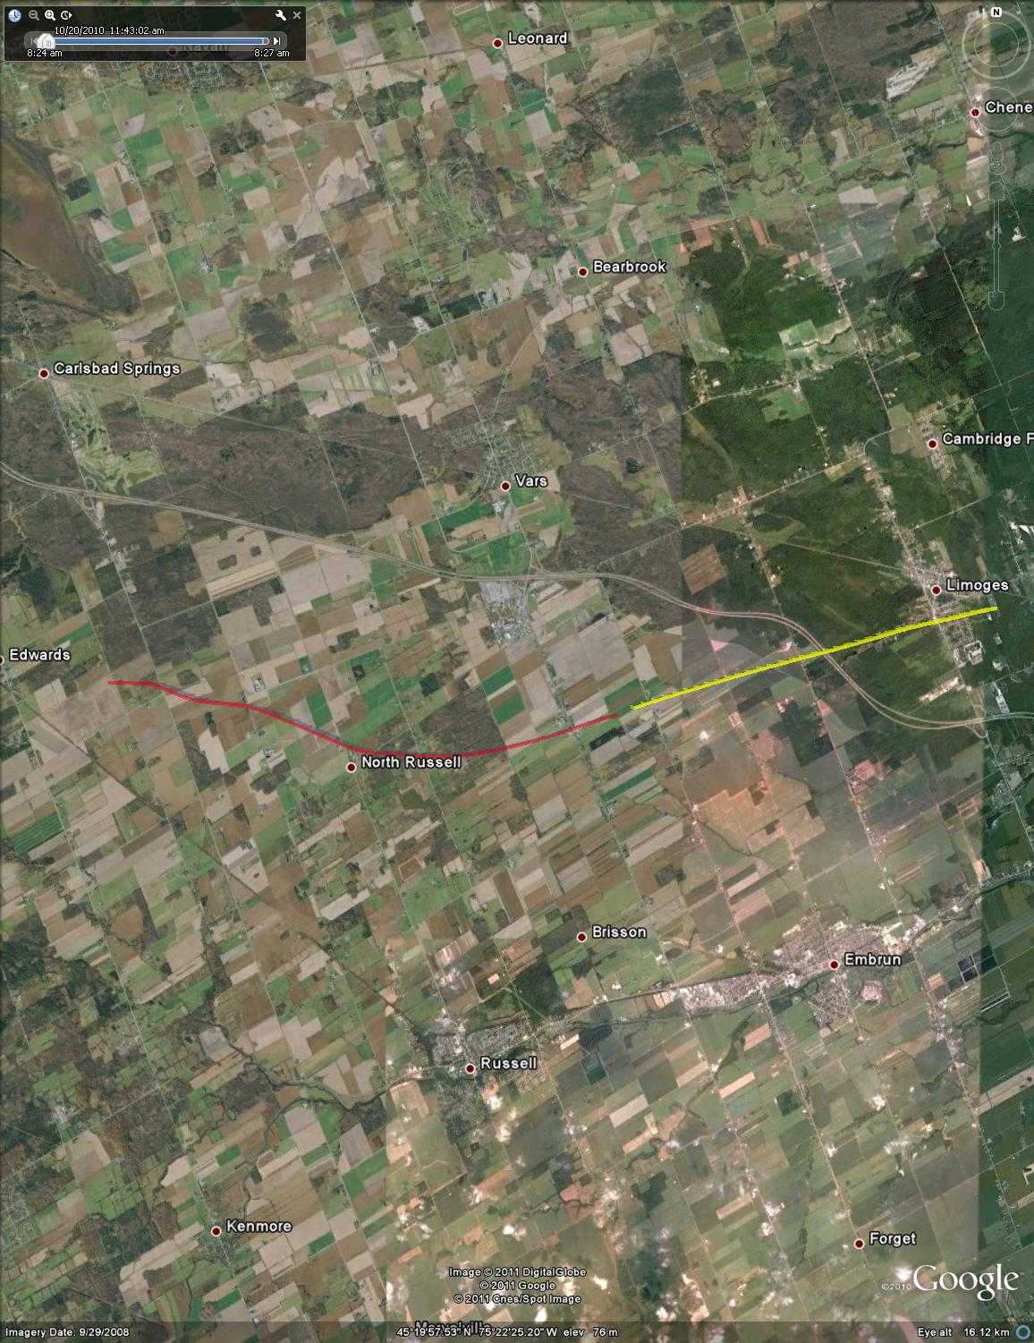

Figure : Test point #89, plan view (satellite overlay)

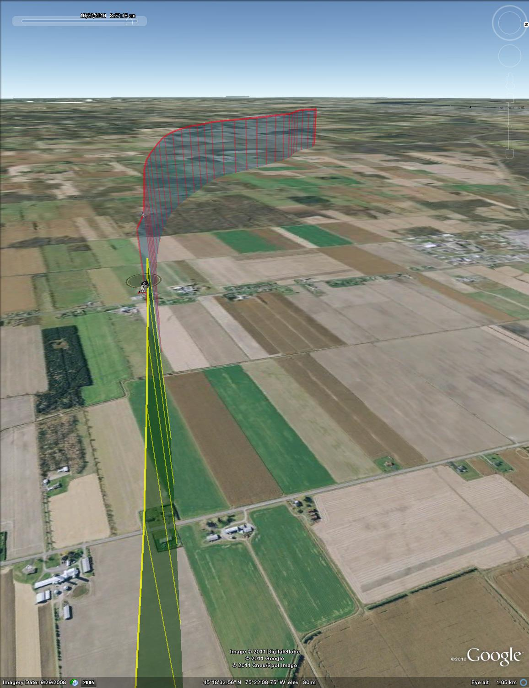

Figure : Test point #89, 0 deg azimuth, isometric view



Figure : Test point #90, -10 deg azimuth



Figure : Test point # 90, -10 deg azimuth, final 30 seconds



Figure : Test point #90, -10 deg azimuth, plan view (UTM coordinates)

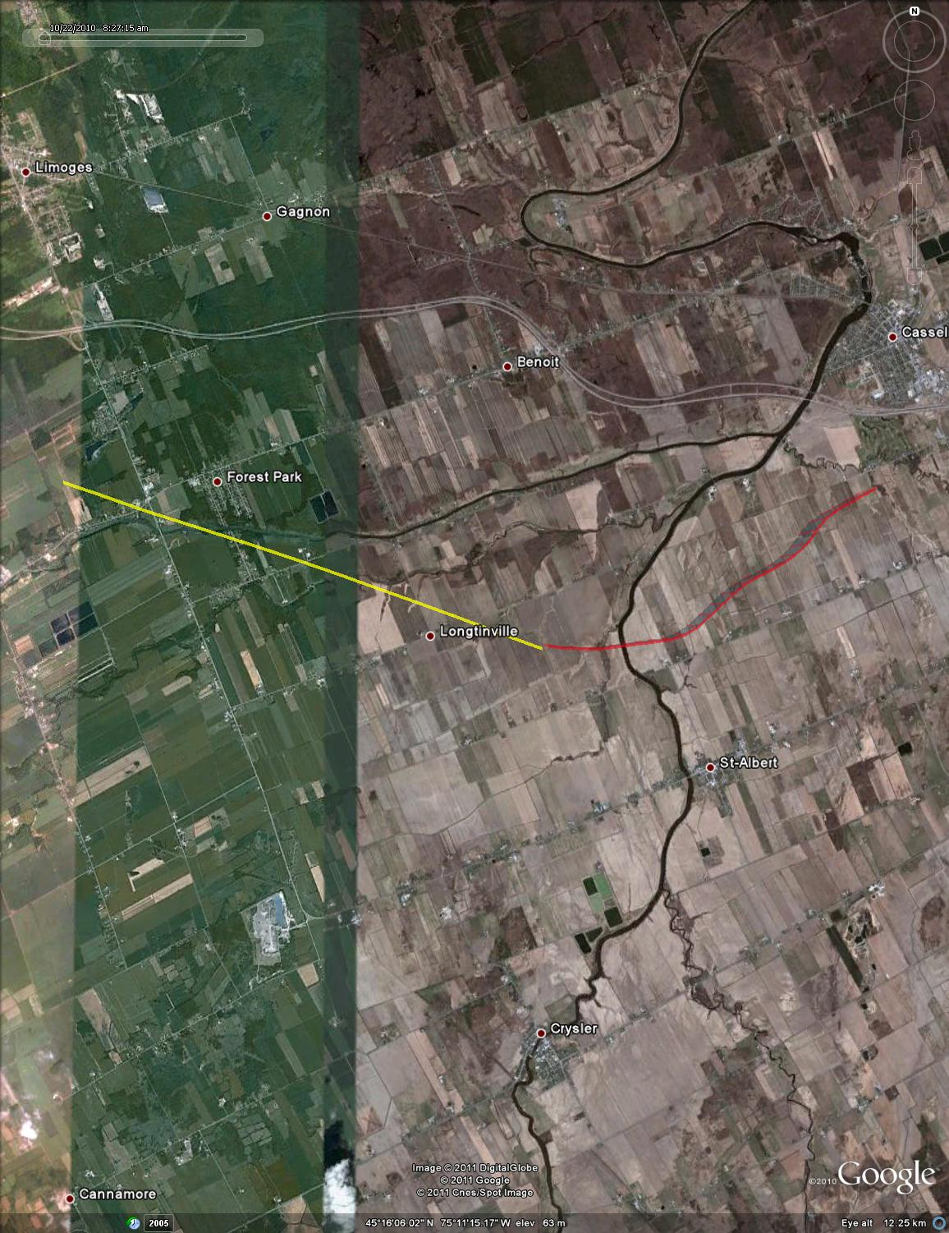

Figure : Test point #90, -10 deg azimuth, plan view (satellite overlay)

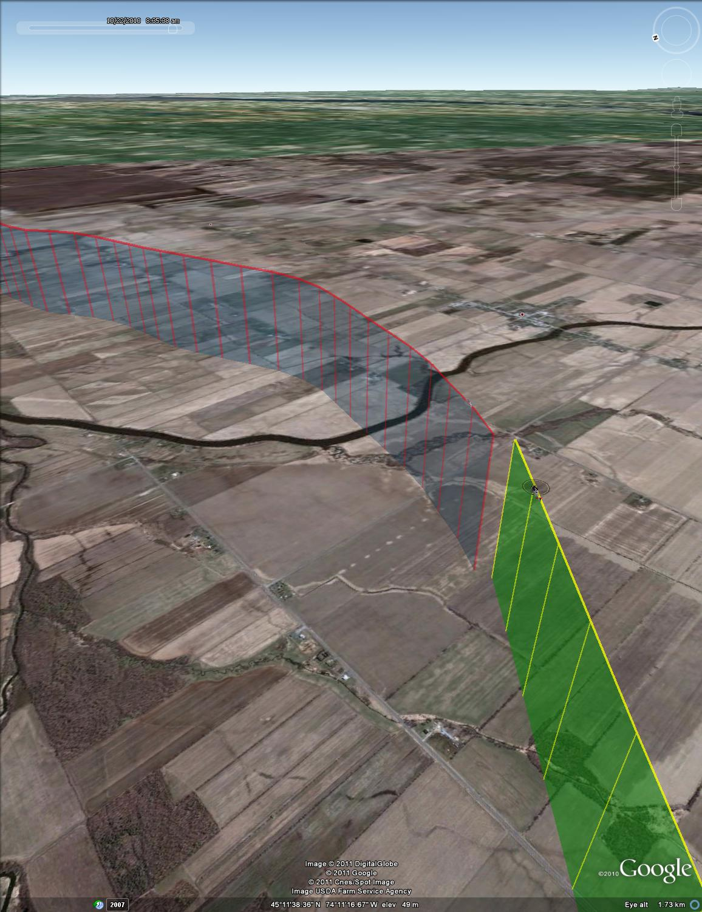

Figure : Test point #90, -10 deg azimuth, isometric view



Figure : Test point #91, -30 deg azimuth



Figure : Test point #91, -30 deg azimuth, final 30 seconds



Figure : Test point #91, -30 deg azimuth, plan view (UTM coordinates)

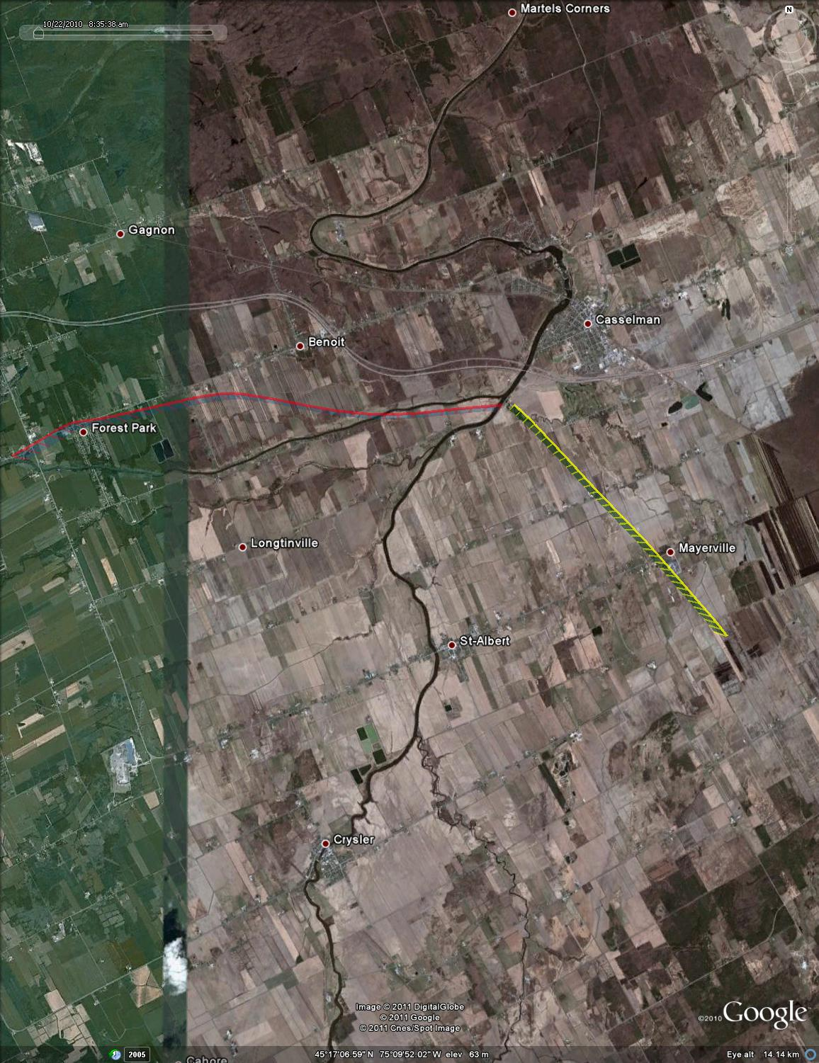

Figure : Test point #91, -30 deg azimuth, plan view (satellite overlay)

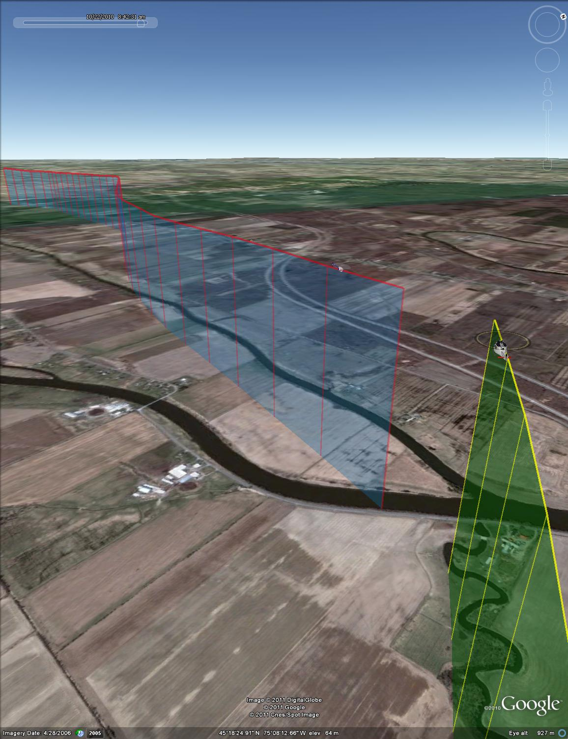

Figure : Test point #91, -30 deg azimuth, isometric view



Figure : Test point #92, -50 deg azimuth



Figure : Test point #92, -50 deg azimuth, final 30 seconds



Figure : Test point #92, -50 deg azimuth, plan view (UTM coordinates)

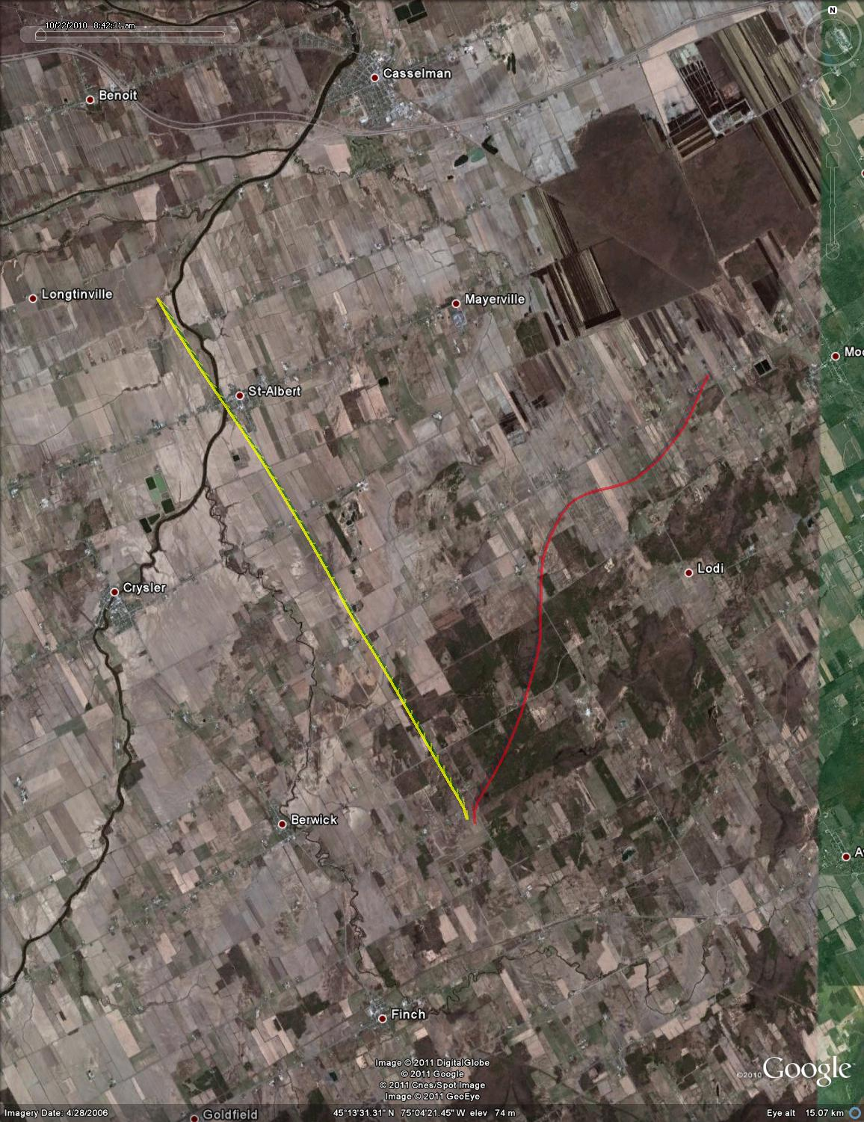

Figure : Test point #92, -50 deg azimuth, plan view (satellite overlay)

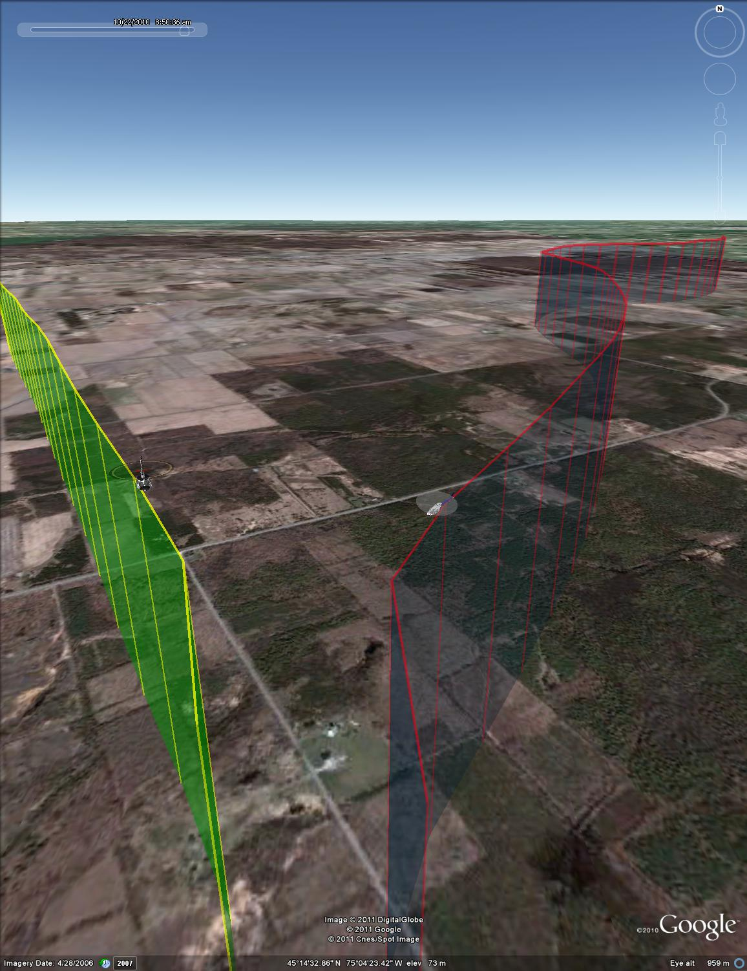

Figure : Test point #92, -50 deg azimuth, isometric view



Figure : Test point #93, -70 deg azmiuth



Figure : Test point #93, -70 deg azimuth, final 30 seconds



Figure : Test point #93, -70 deg azimuth, plan view (UTM coordinates)

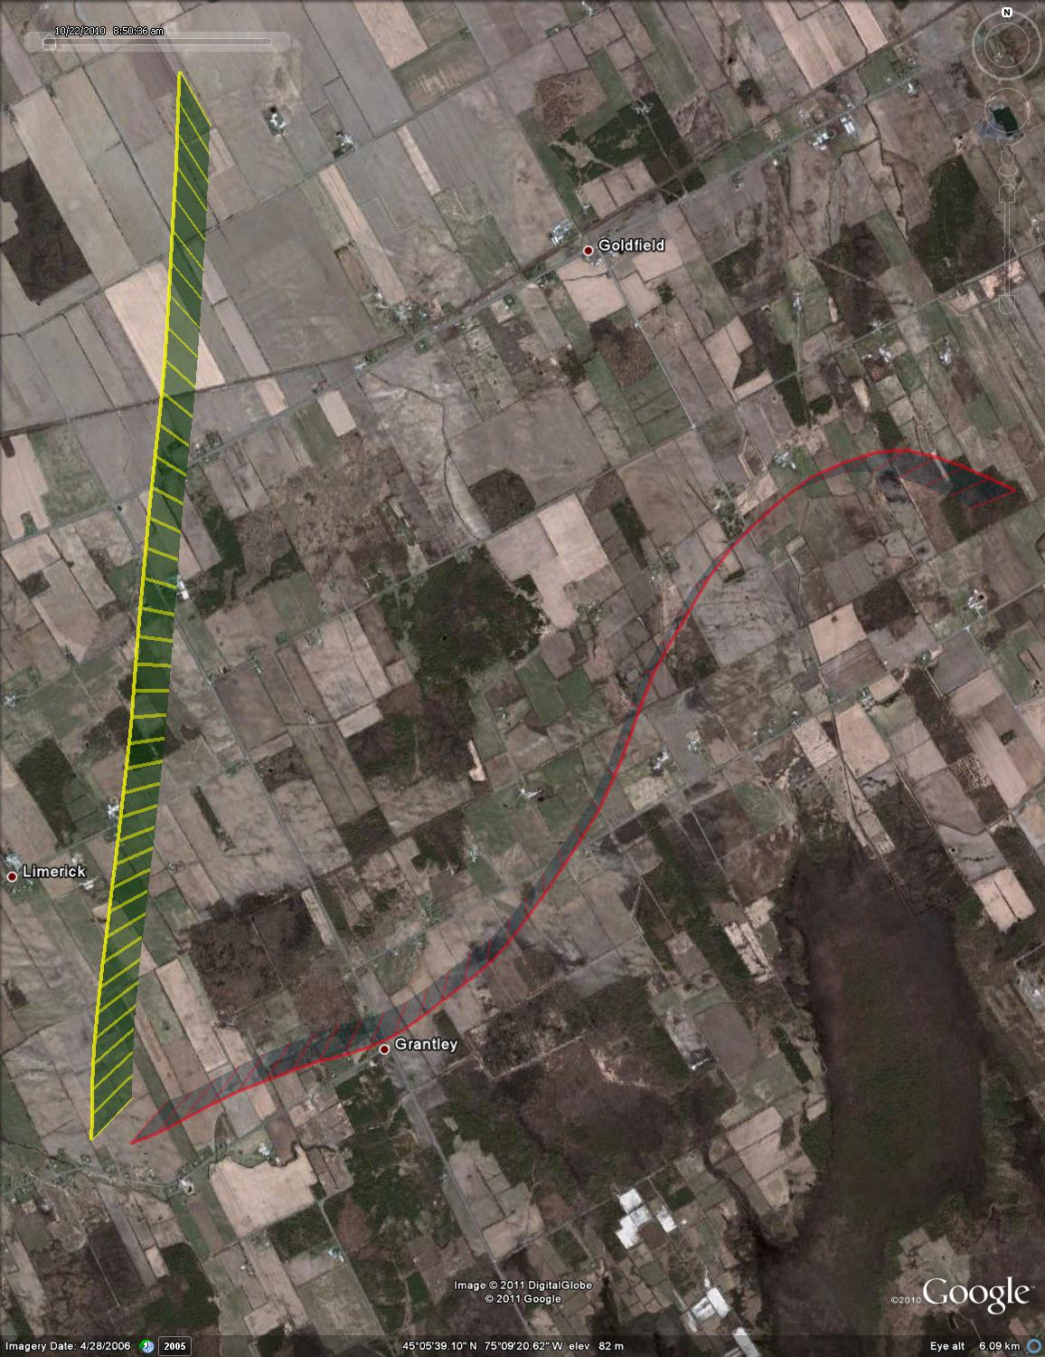

Figure : Test point #93, -70 deg azimuth, plan view (satellite overlay)

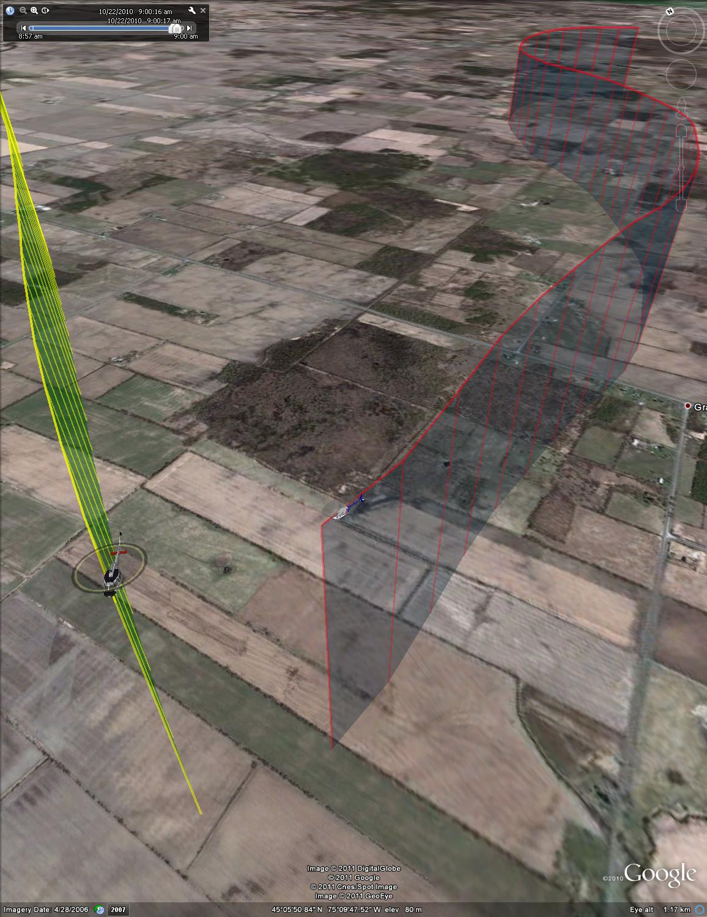

Figure : Test point #93, -70 deg azimuth, isometric view



Figure : Test point #94, - 90 deg azimuth (aborted)

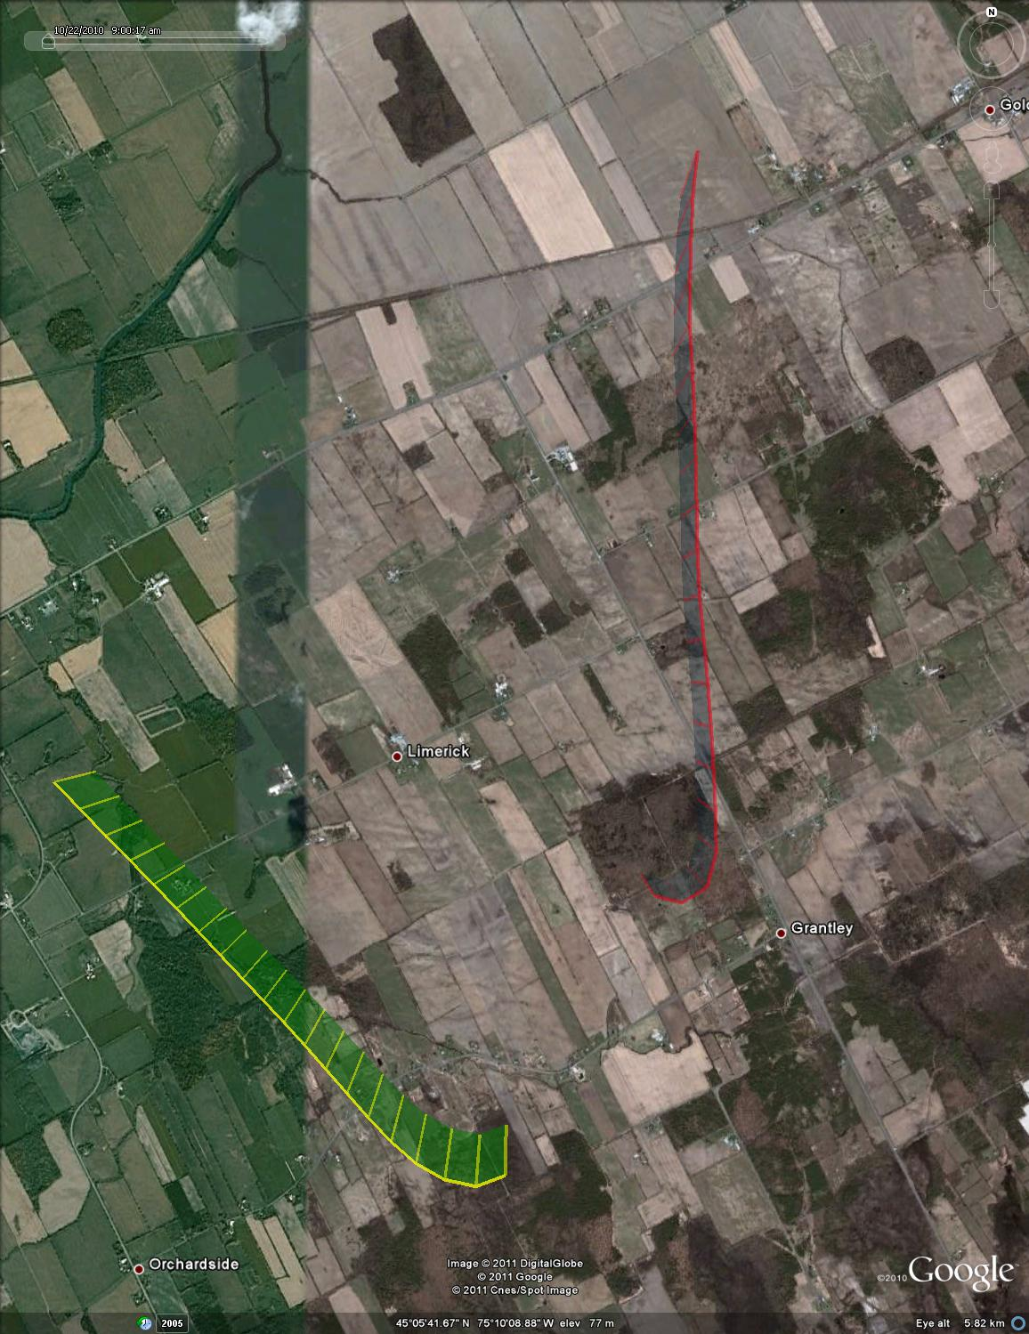

Figure : Test point #94, -90 deg azimuth (aborted), plan view (satelite overlay)



Figure : Test point #95, -30 deg azimuth



Figure : Test point #95, -30 deg azimuth, final 30 seconds



Figure : Test point #95, -30 deg azimuth, plan view (UTM coordinates)

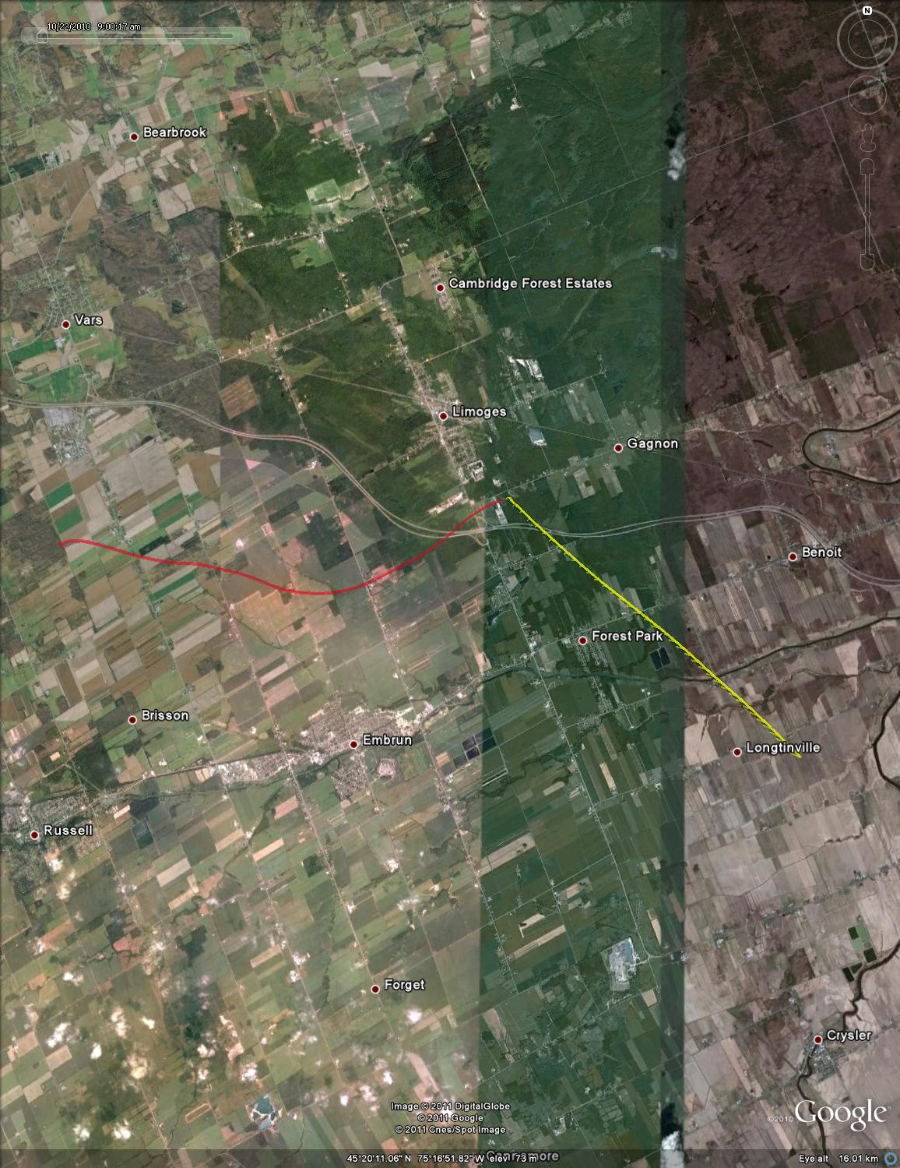

Figure : Test point #95, -30 deg azimuth, plan view (satellite overlay)

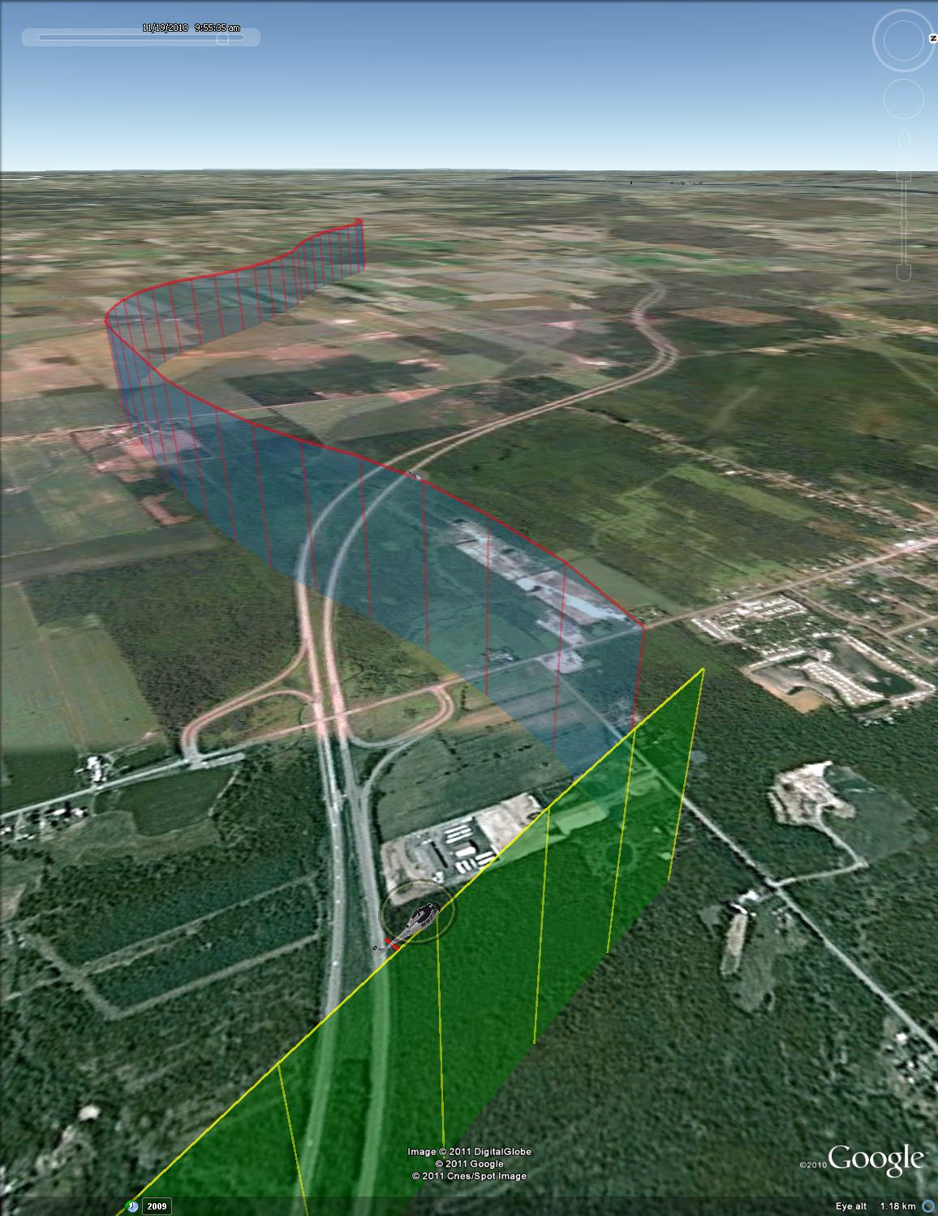

Figure : Test point #95, -30 deg azimuth, isometric view



Figure : Test point #96, -50 deg azimuth



Figure : Test point #96, -50 deg azimuth, final 30 seconds



Figure : Test point #96, -50 deg azimuth, plan view (UTM coordinates)

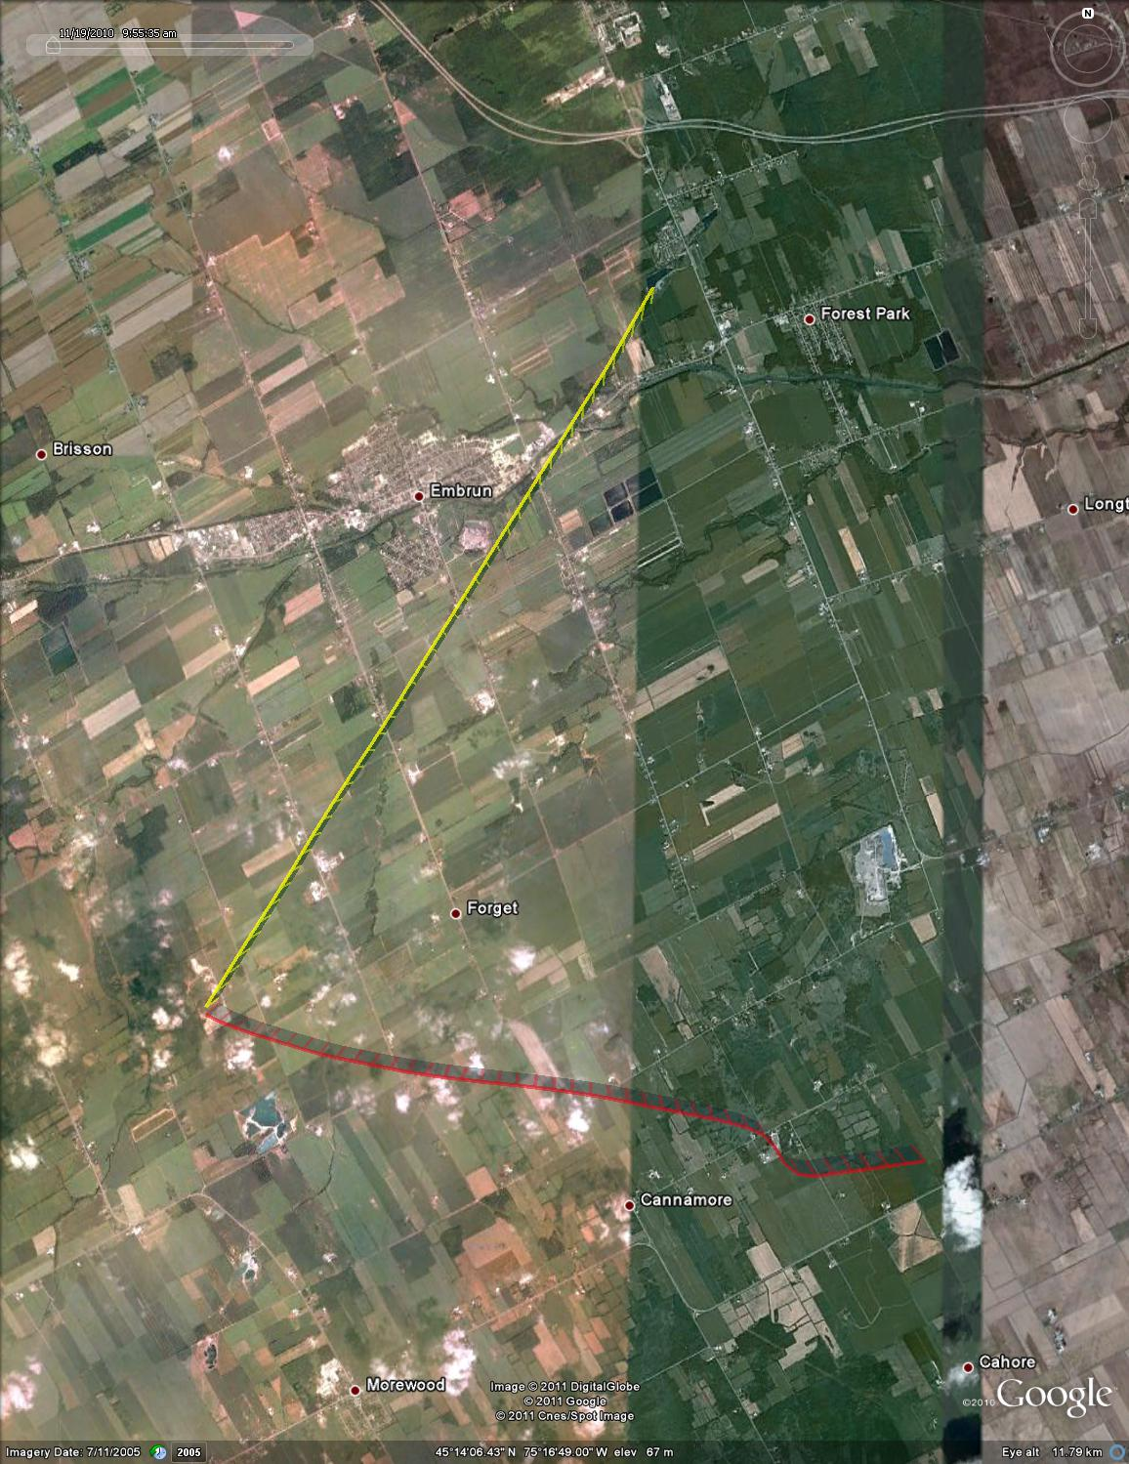

Figure : Test point #96, -50 deg azimuth, plan view (satellite overlay)

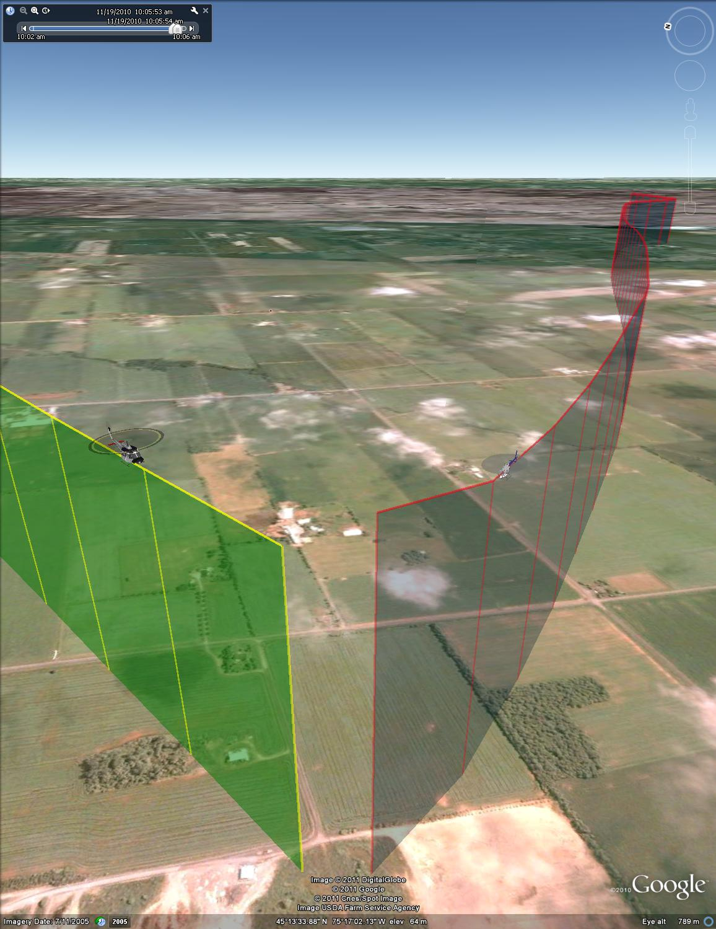

Figure : Test point #96, -50 deg azimuth, isometric view



Figure : Test point #97, -70 deg azimuth



Figure : Test point #97, -70 deg azimuth, final 30 seconds



Figure : Test point #97, -70 deg azimuth, plan view (UTM coordinates)

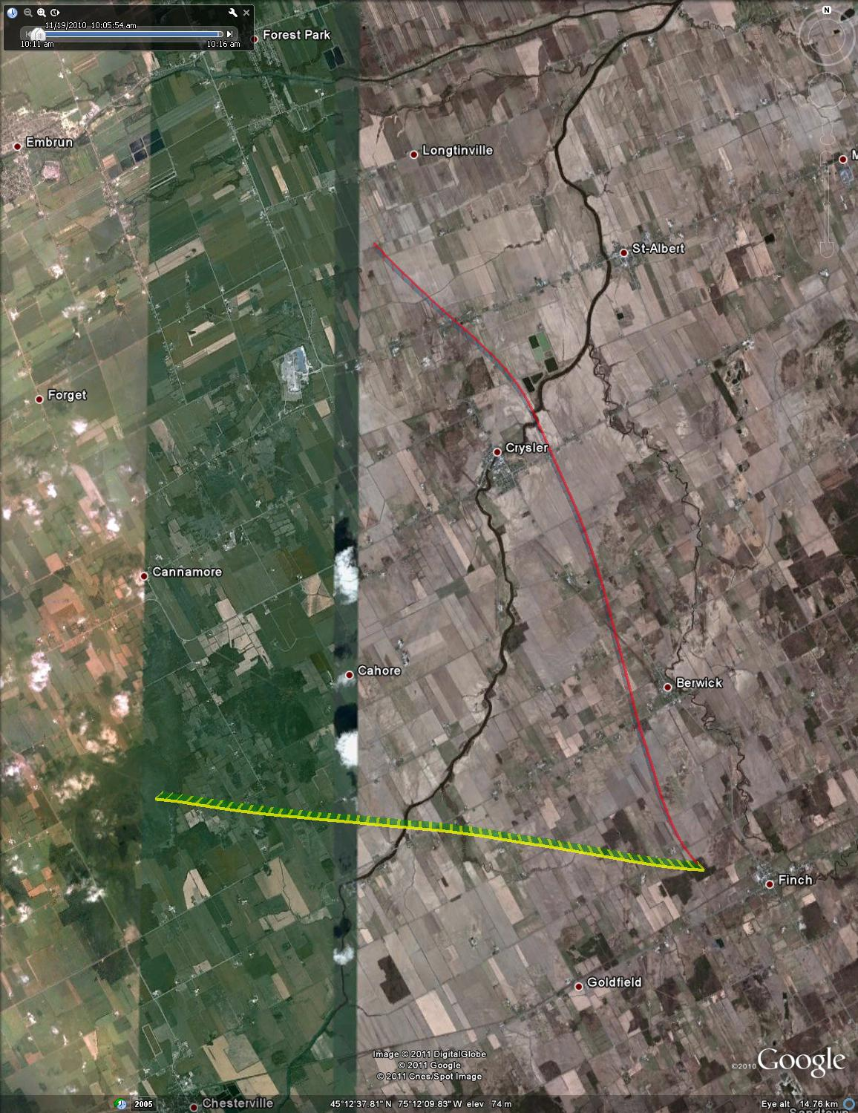

Figure : Test point #97, -70 deg azimuth, plan view (satellite overlay)

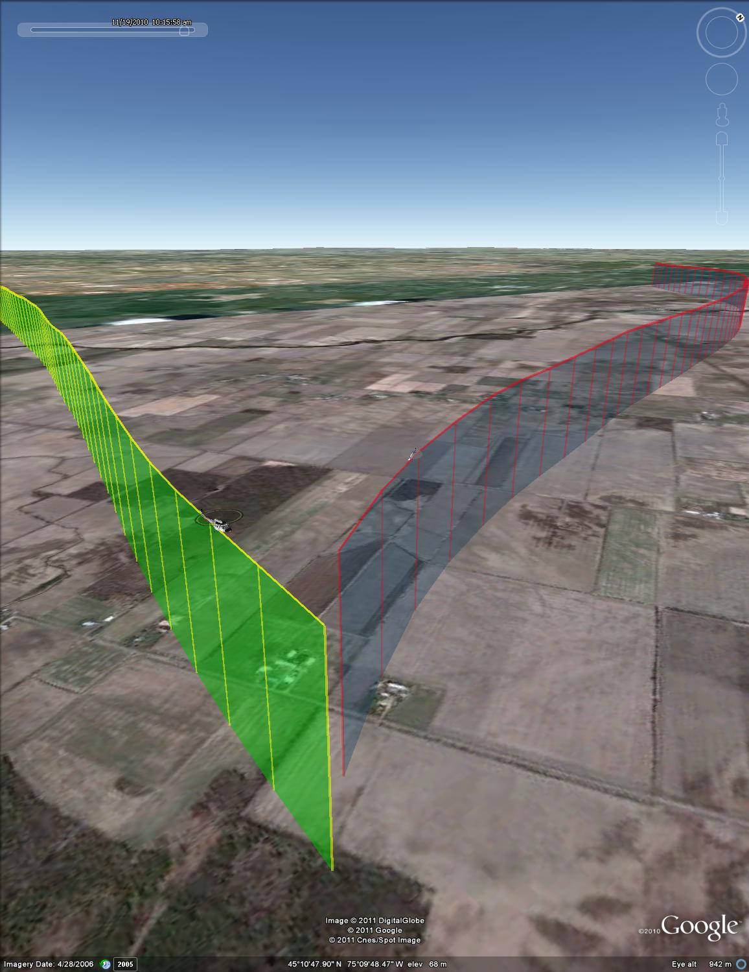

Figure : Test point #97, -70 deg azimuth, isometric view



Figure : Test point #98, -90 deg azimuth



Figure : Test point #98, -90 deg azimuth, final 30 seconds



Figure : Test point #98, -90 deg azimuth, plan view (UTM coordinates)

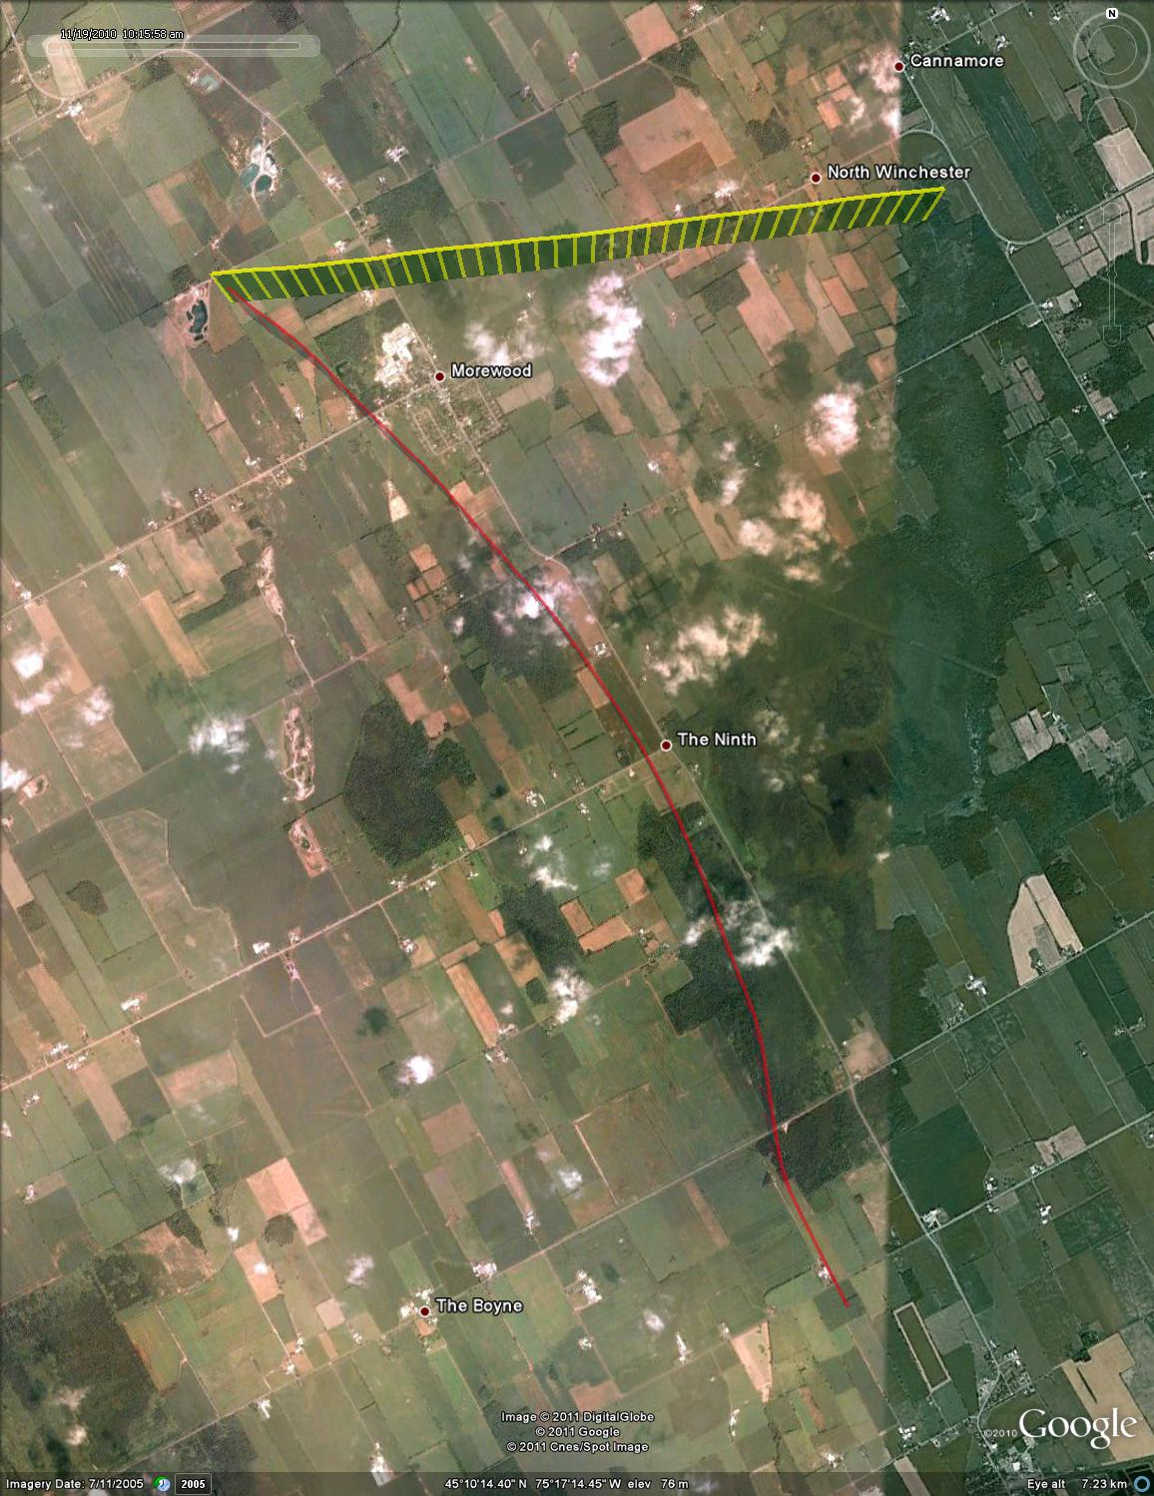

Figure : Test point #98, -90 deg azimuth, plan view (satellite overlay)

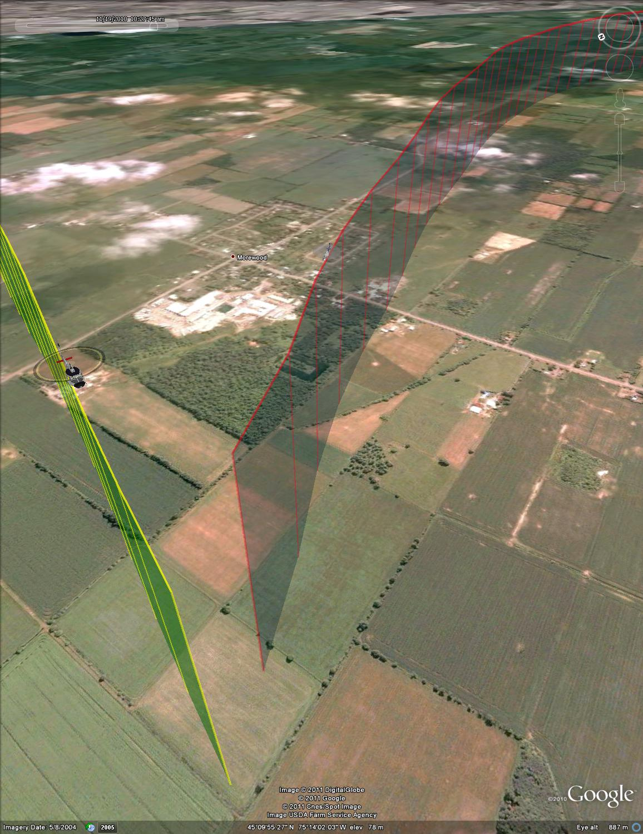

Figure : Test point #98, -90 deg azimuth, isometric view



Figure : Test point #100, 0 deg azimuth



Figure : Test point #100, 0 deg azimuth, final 30 seconds



Figure : Test point #100, 0 deg azimuth, plan view (UTM coordinates)

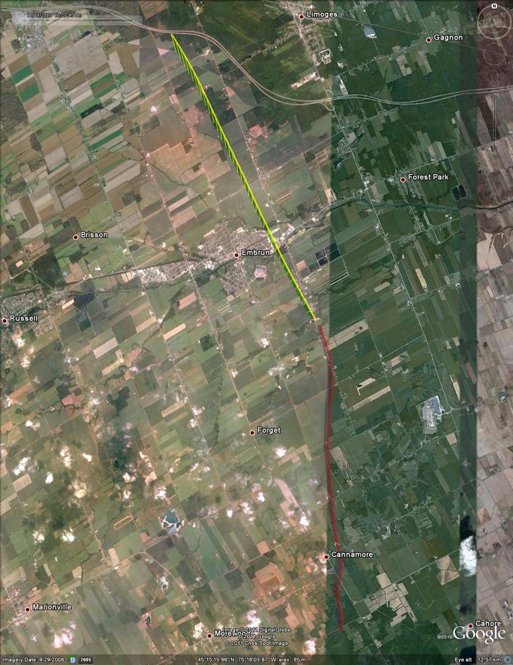

Figure : Test point #100, 0 deg azimuth, plan view (satellite overlay)

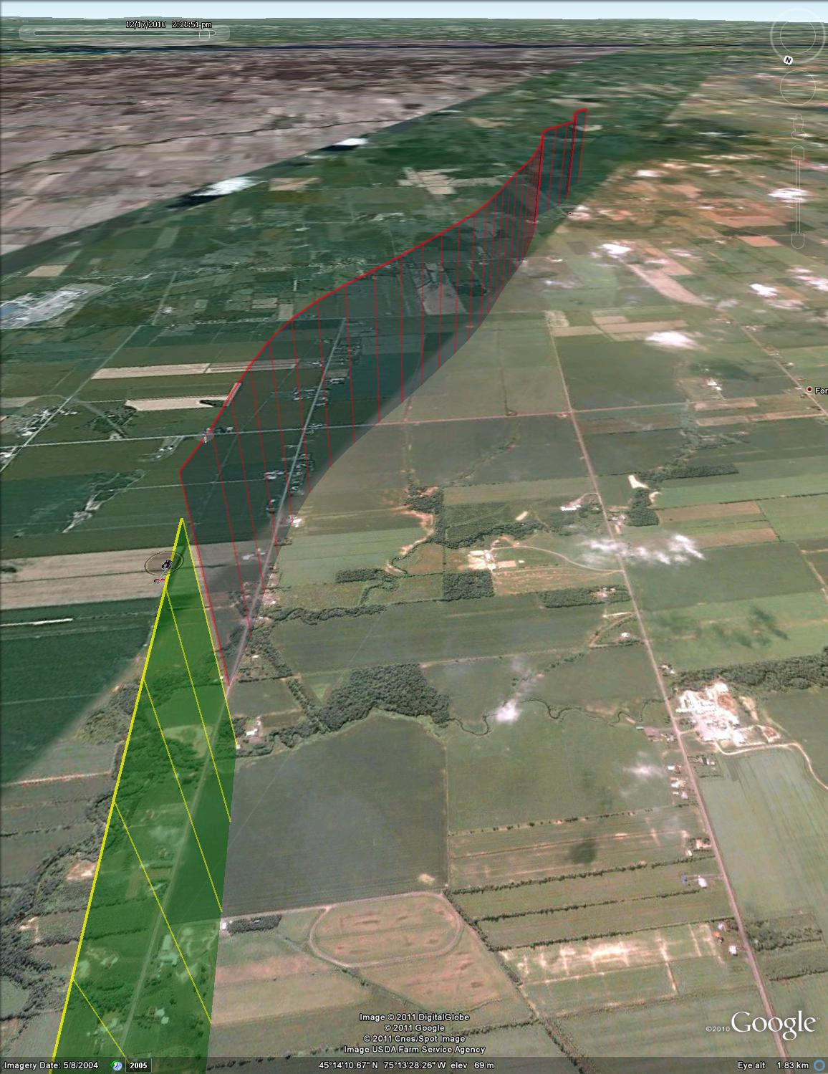

Figure : Test point #100, 0 deg azimuth, isometric view



Figure : Test point #101, -10 deg azimuth



Figure : Test point #101, -10 deg azimuth, final 30 seconds



Figure : Test point #101, -10 deg azimuth, plan view (UTM coordinates)

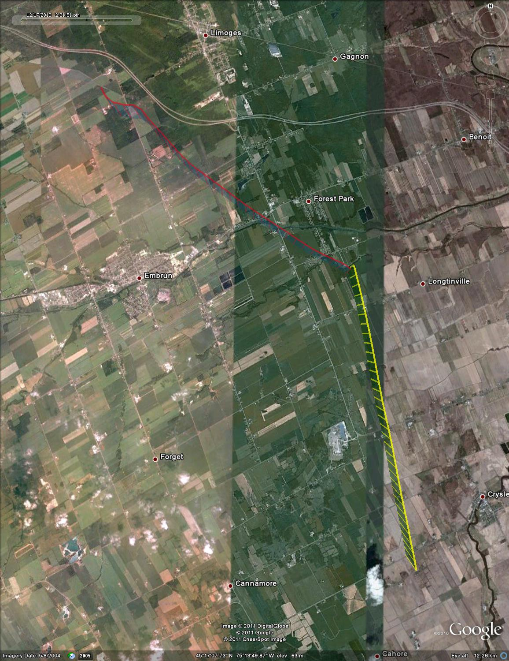

Figure : Test point #101, -10 deg azimuth, plan view (satelitte overlay)

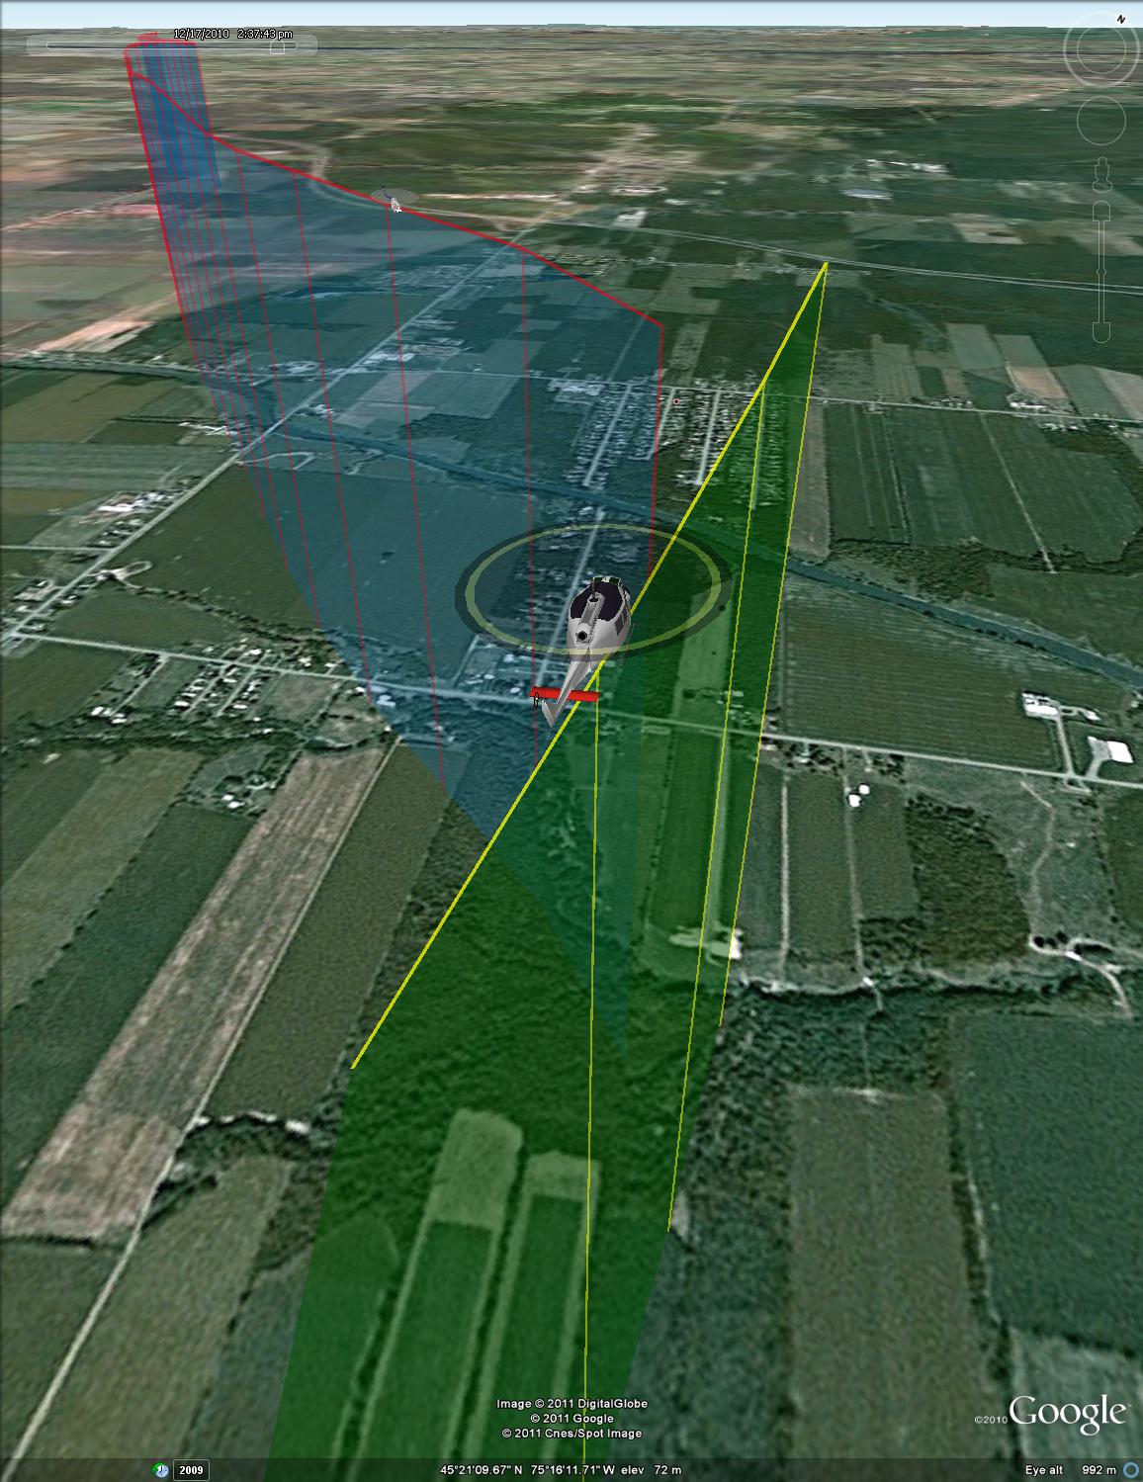

Figure : Test point #101, -10 deg azimuth, isometric view



Figure : Test point #102, -30 deg azimuth



Figure : Test point #102, -30 deg azimuth, final 30 seconds



Figure : Test point #102, -30 deg azimuth, plan view (UTM coordinates)

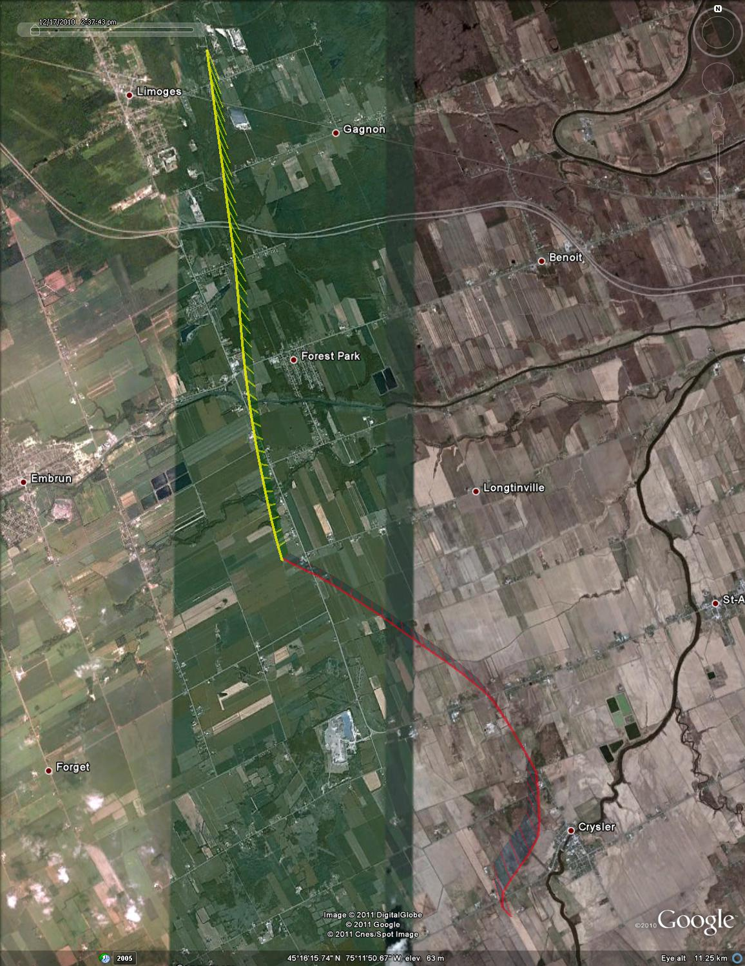

Figure : Test point #102, -30 deg azimuth, plan view (satellite overlay)

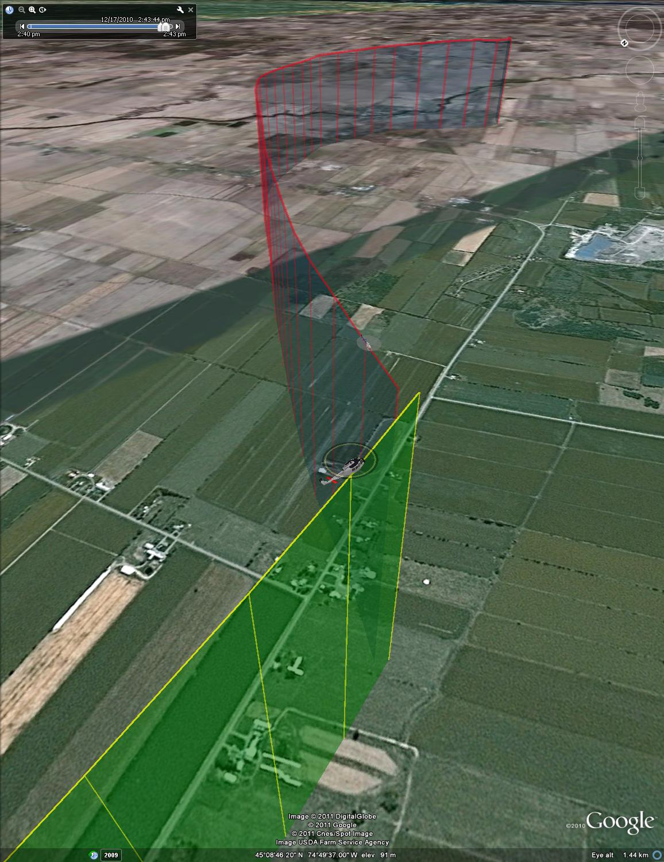

Figure : Test point #102, -30 deg azimuth, isometric view



Figure : Test point #103, -50 deg azimuth (aborted)



Figure : Test point #103, -50 deg azimuth (aborted), final 30 seconds



Figure : Test point #103, -50 deg azimuth (aborted), plan view (UTM coordinates)

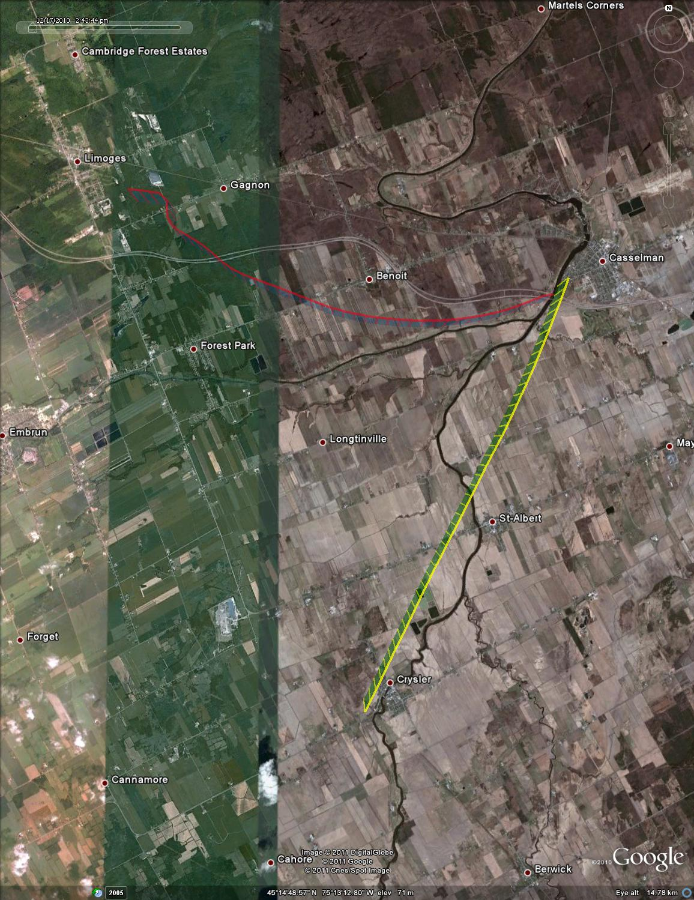

Figure : Test point #103, -50 deg azimuth (aborted), plan view (satellite overlay)

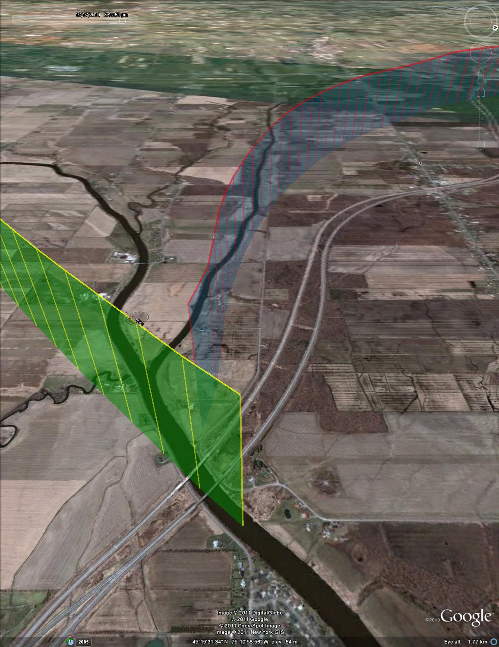

Figure : Test point #103, -50 deg azimuth (aborted), isometric view



Figure : Test point #104, -50 deg azimuth



Figure : Test point #104, -50 deg azimuth, final 30 seconds



Figure : Test point #104, -50 deg azimuth, plan view (UTM coordinates)

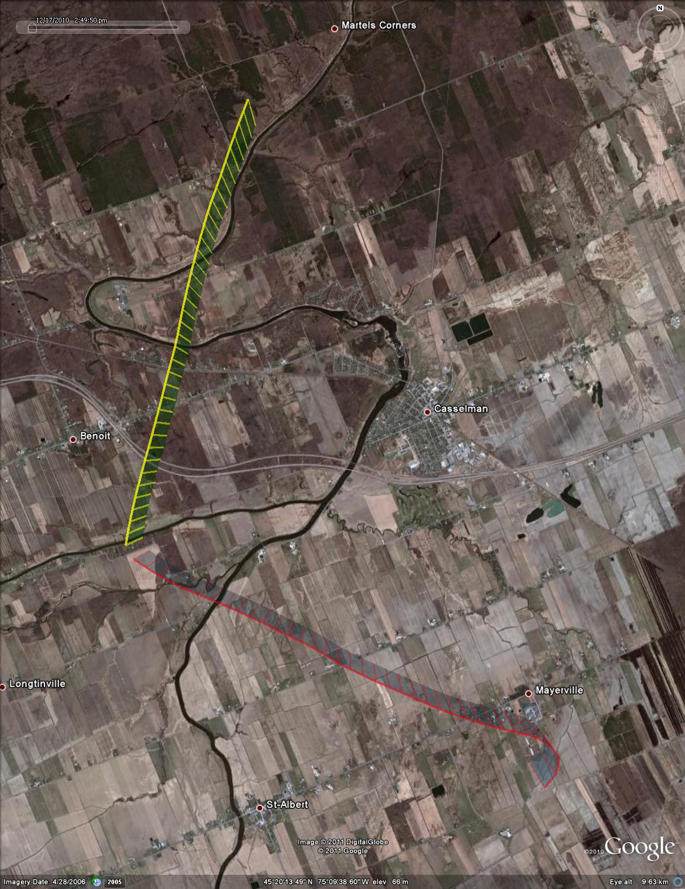

Figure : Test point #104, -50 deg azimuth, plam view (satellite overlay)

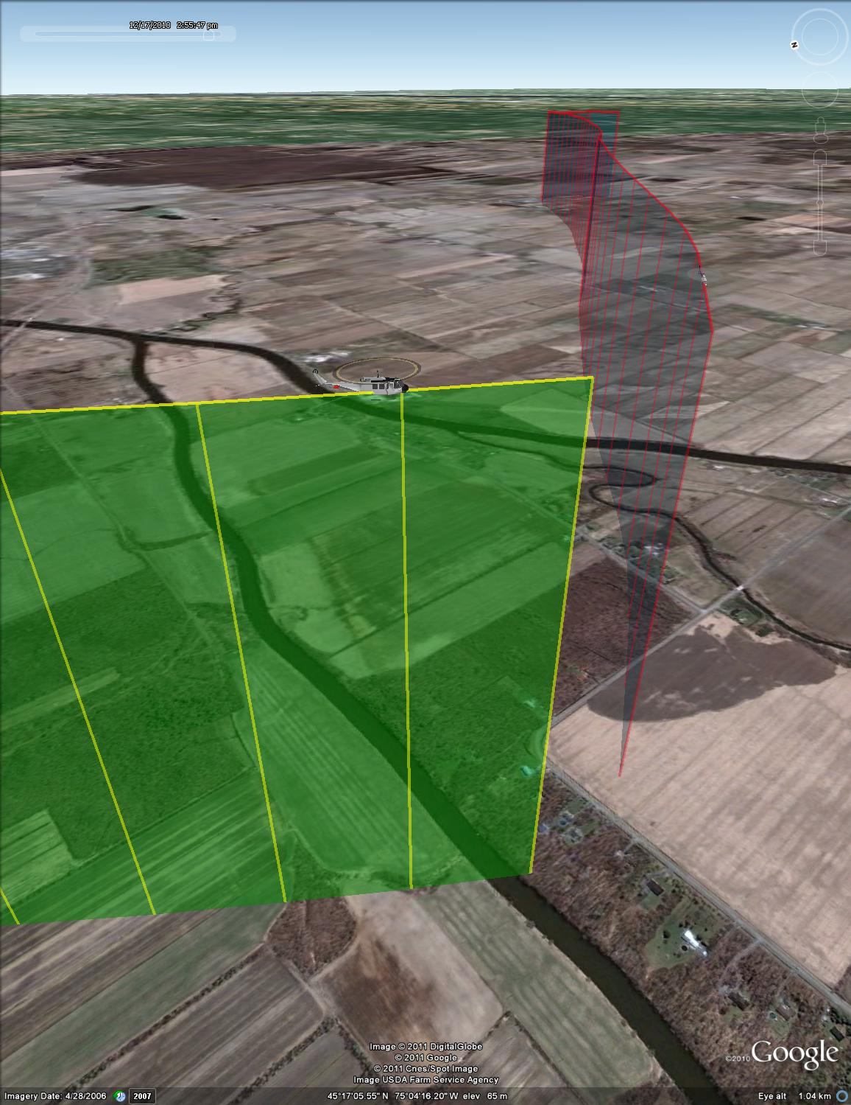

Figure : Test point #104, -50 deg azimuth, isometric view



Figure : Test point #105, -70 deg azimuth



Figure : Test point #105, -70 deg azimuth, final 30 seconds



Figure : Test point #105, -70 deg azimuth, plan view (UTM coordinates)

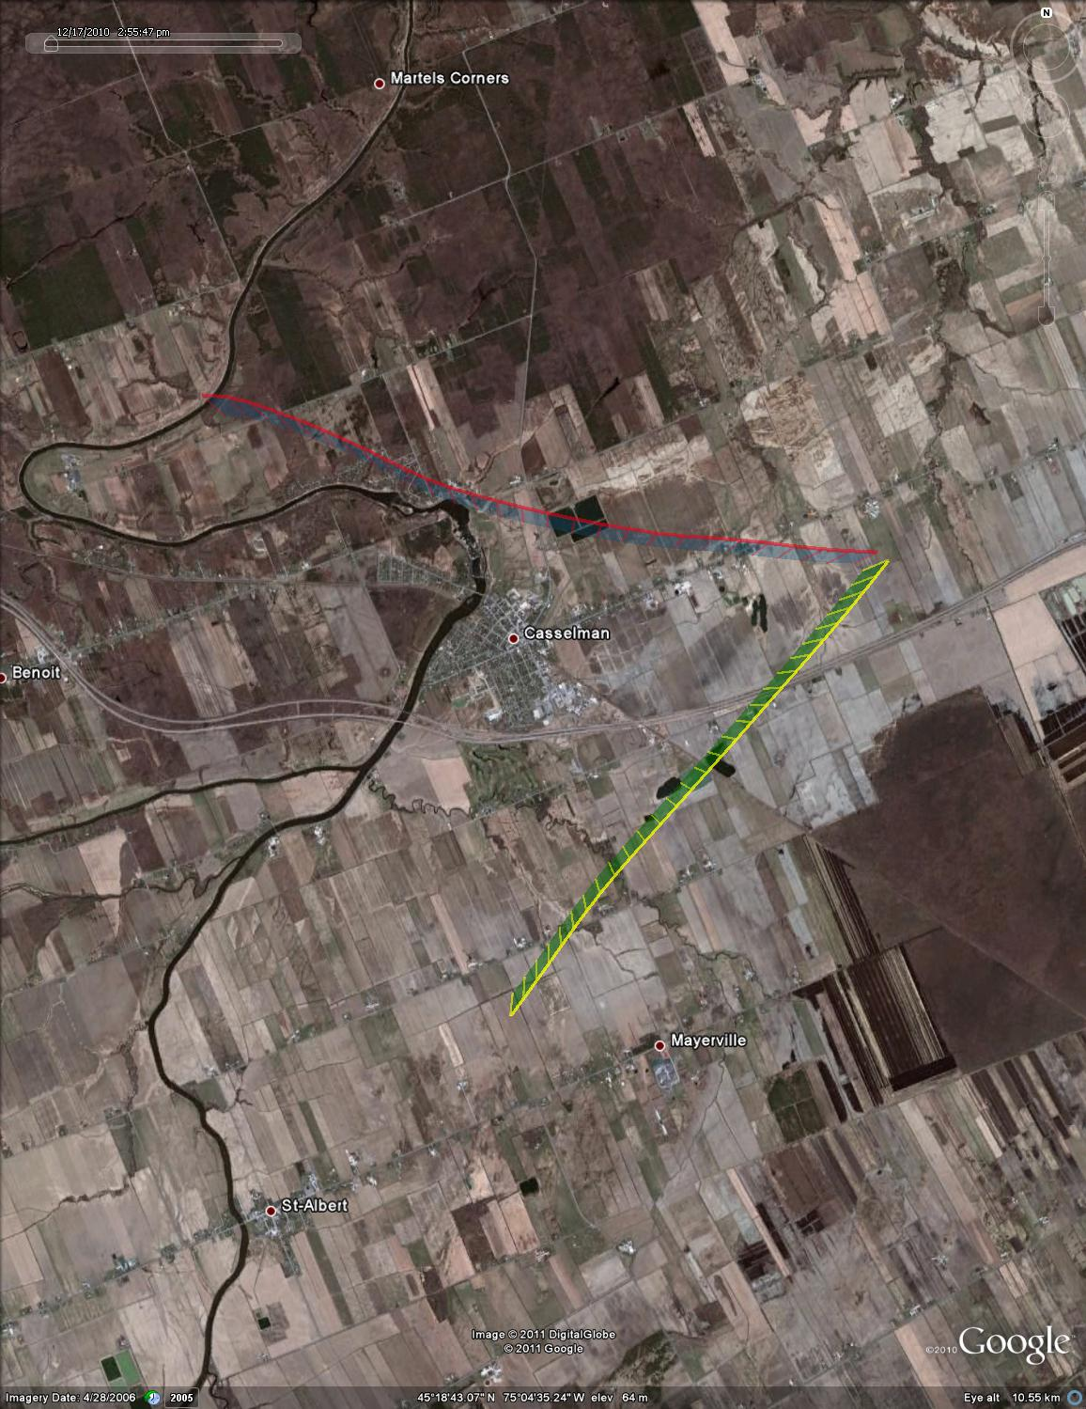

Figure : Test point #105, -70 deg azimuth, plan view (satellite overlay)

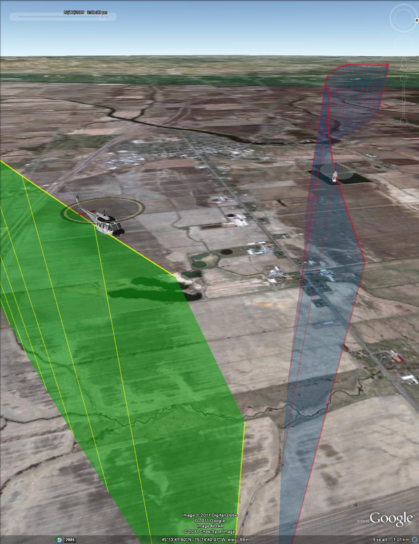

Figure : Test point #105, -70 deg azimuth, isometric view



Figure : Test point #106, -90 deg azimuth



Figure : Test point #106, -90 deg azimuth, final 30 seconds



Figure : Test point #106, -90 deg azimuth, plan view (UTM coordinates)

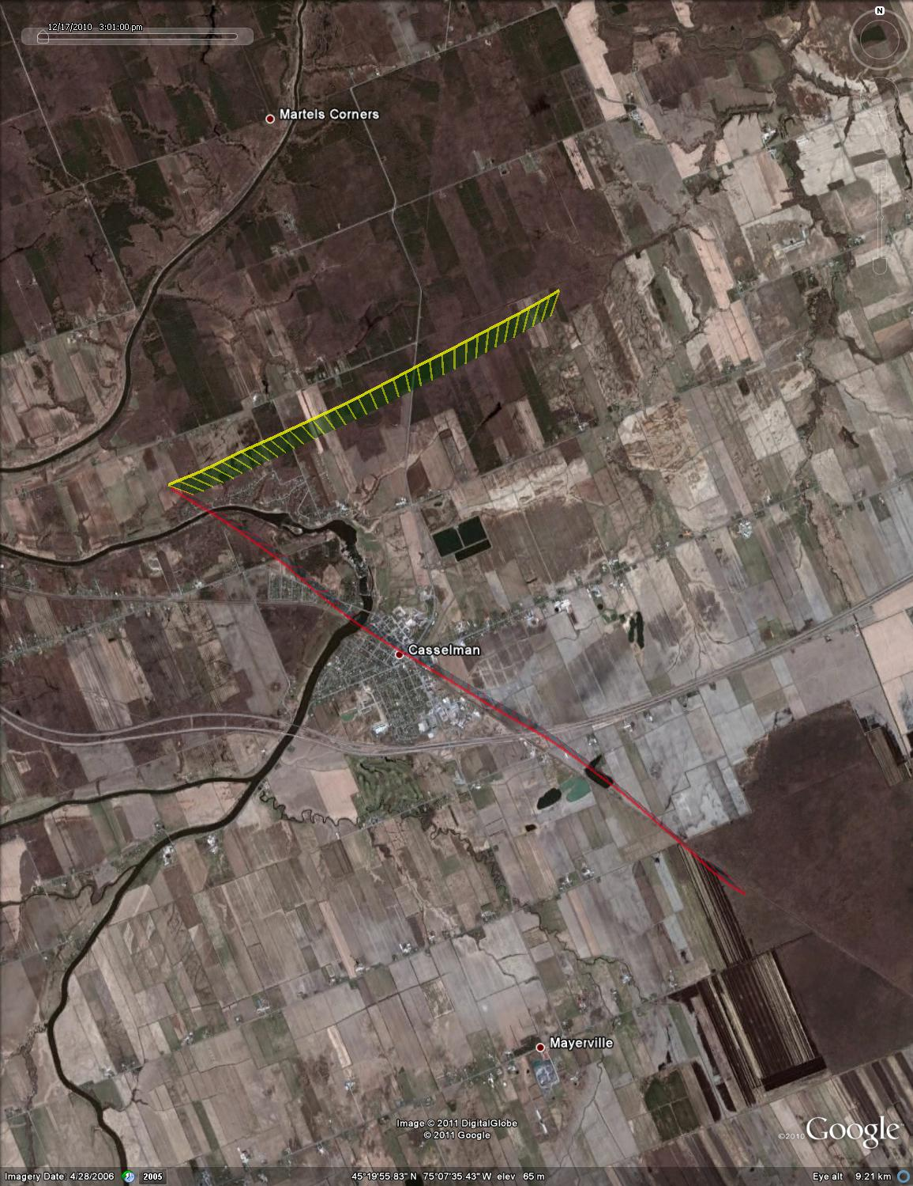

Figure : Test point #106, -90 deg azimuth, plan view (satellite overlay)

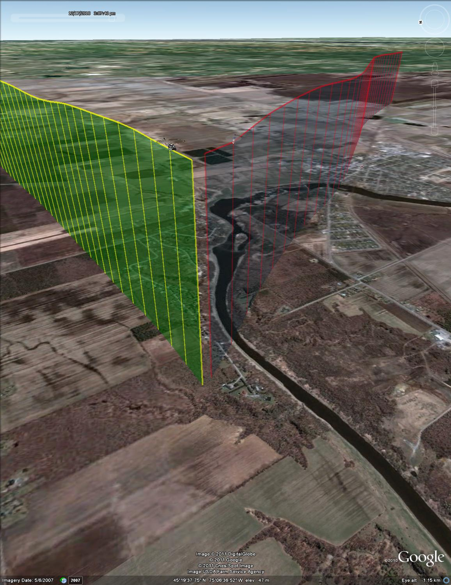

Figure : Test point #106, -90 deg azimuth, isometric view



Figure : Test point #107, 0 deg azimuth



Figure : Test point #107, 0 deg azimuth, final 30 seconds



Figure : Test point #107, 0 deg azimuth, plan view (UTM coordinates)

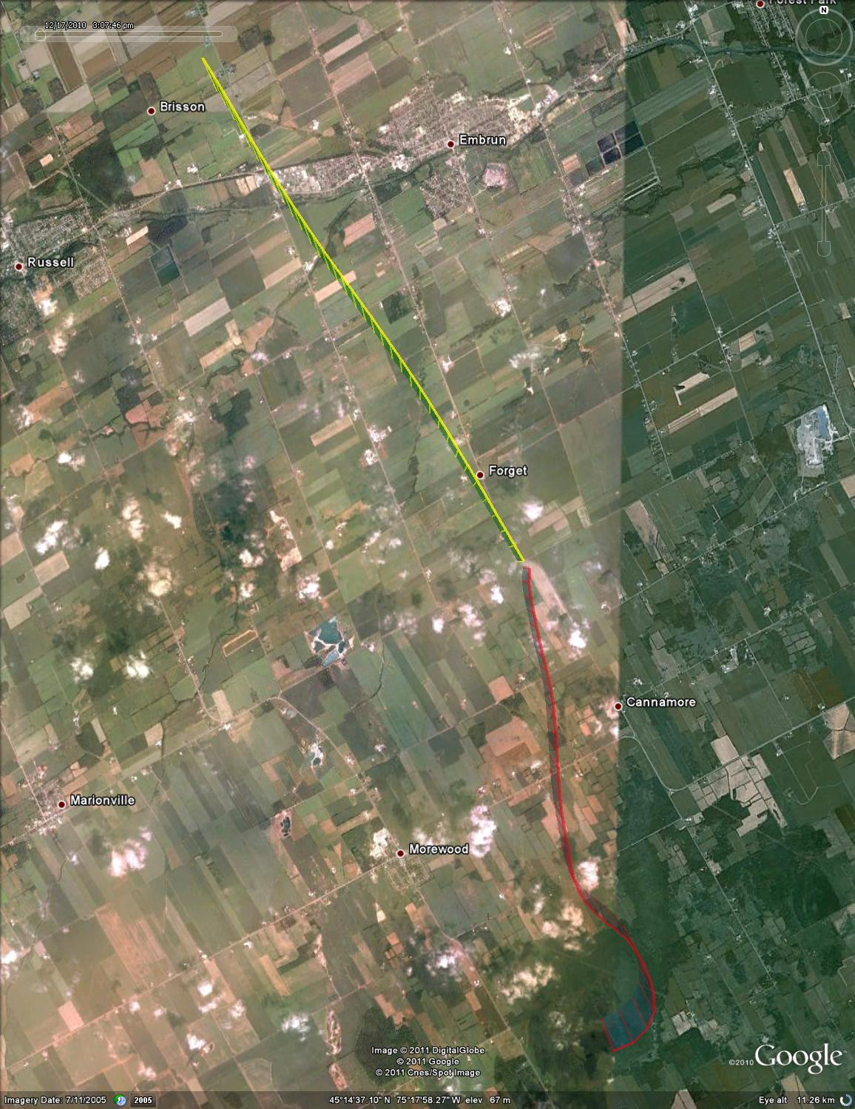

Figure : Test point #107, 0 deg azimuth, plan view (satellite overlay)

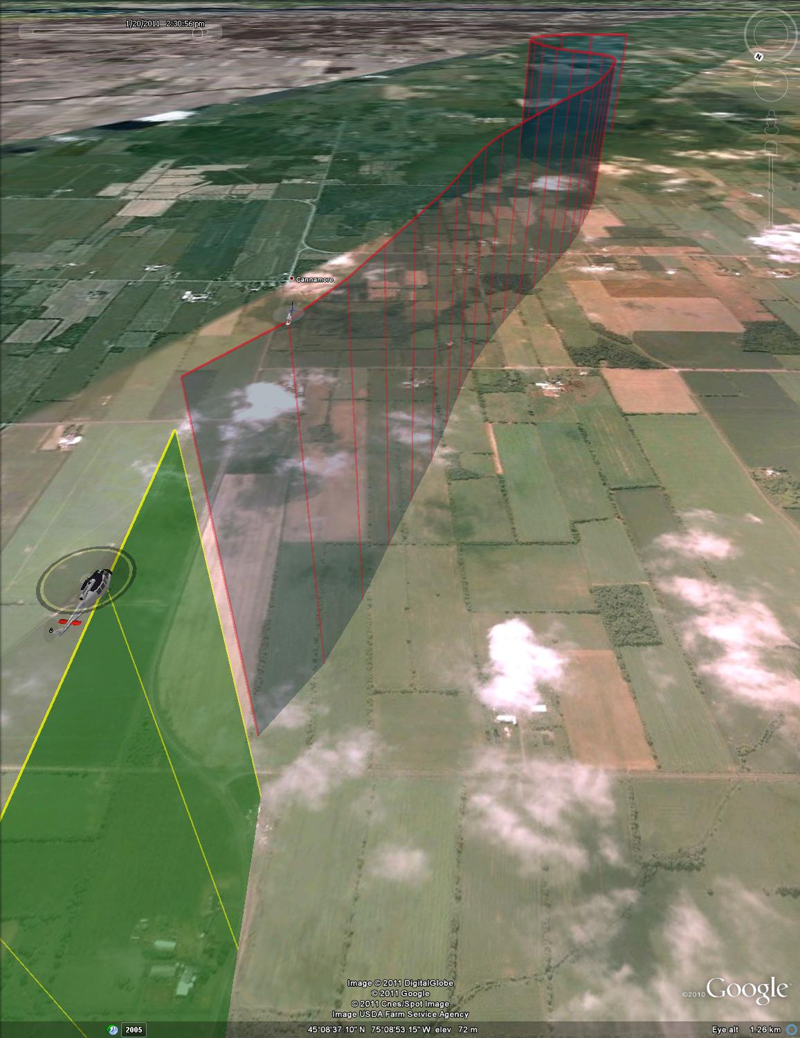

Figure : Test point #107, 0 deg azimuth, isometric view



Figure : Test point #108, -10 deg azimuth



Figure : Test point #108, -10 deg azimuth, final 30 seconds



Figure : Test point #108, -10 deg azimuth, plan view (UTM coordinates)

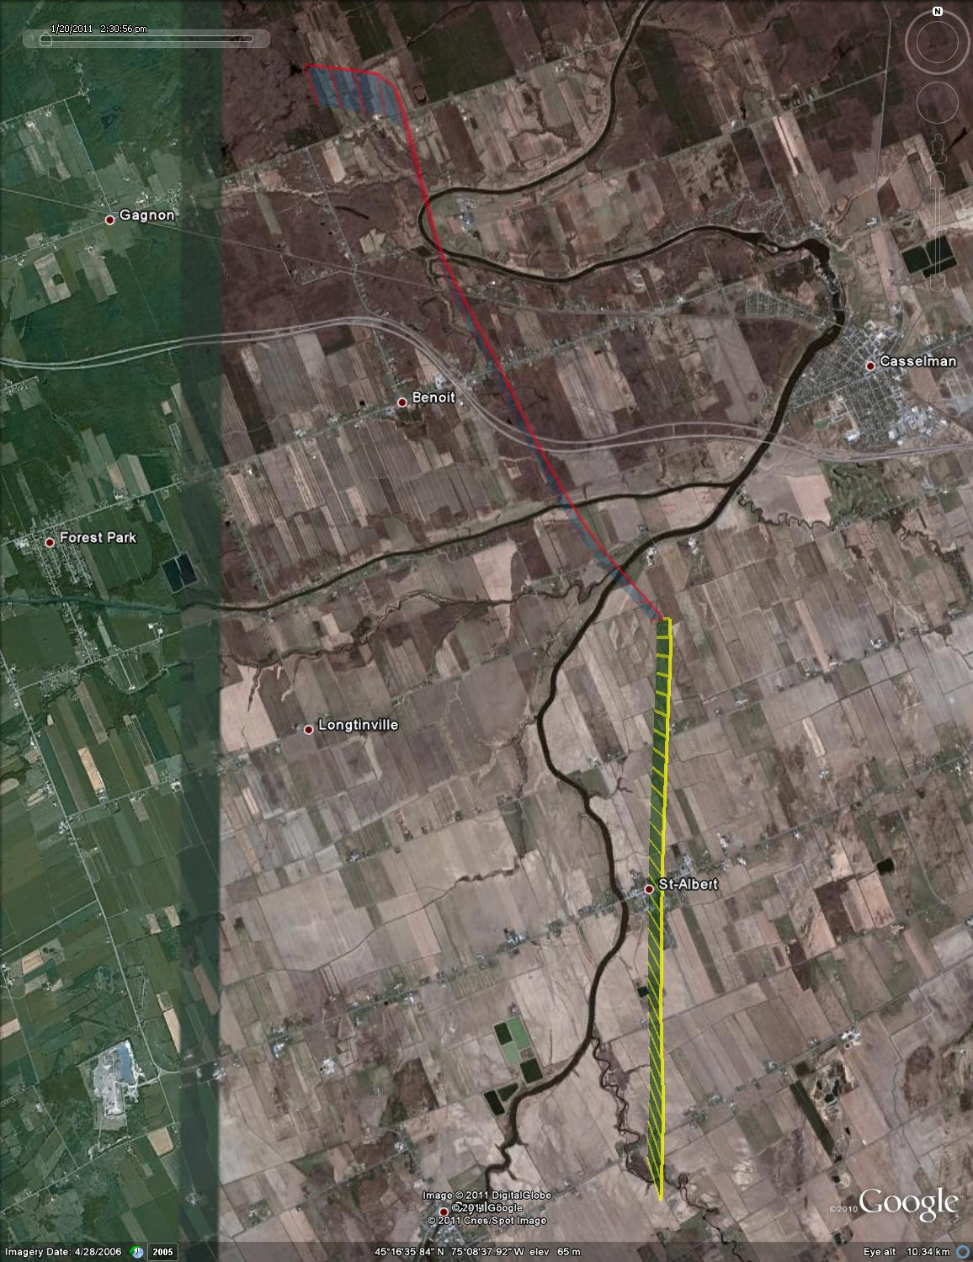

Figure : Test point #108, -10 deg azimuth, plan view (satellite overlay)

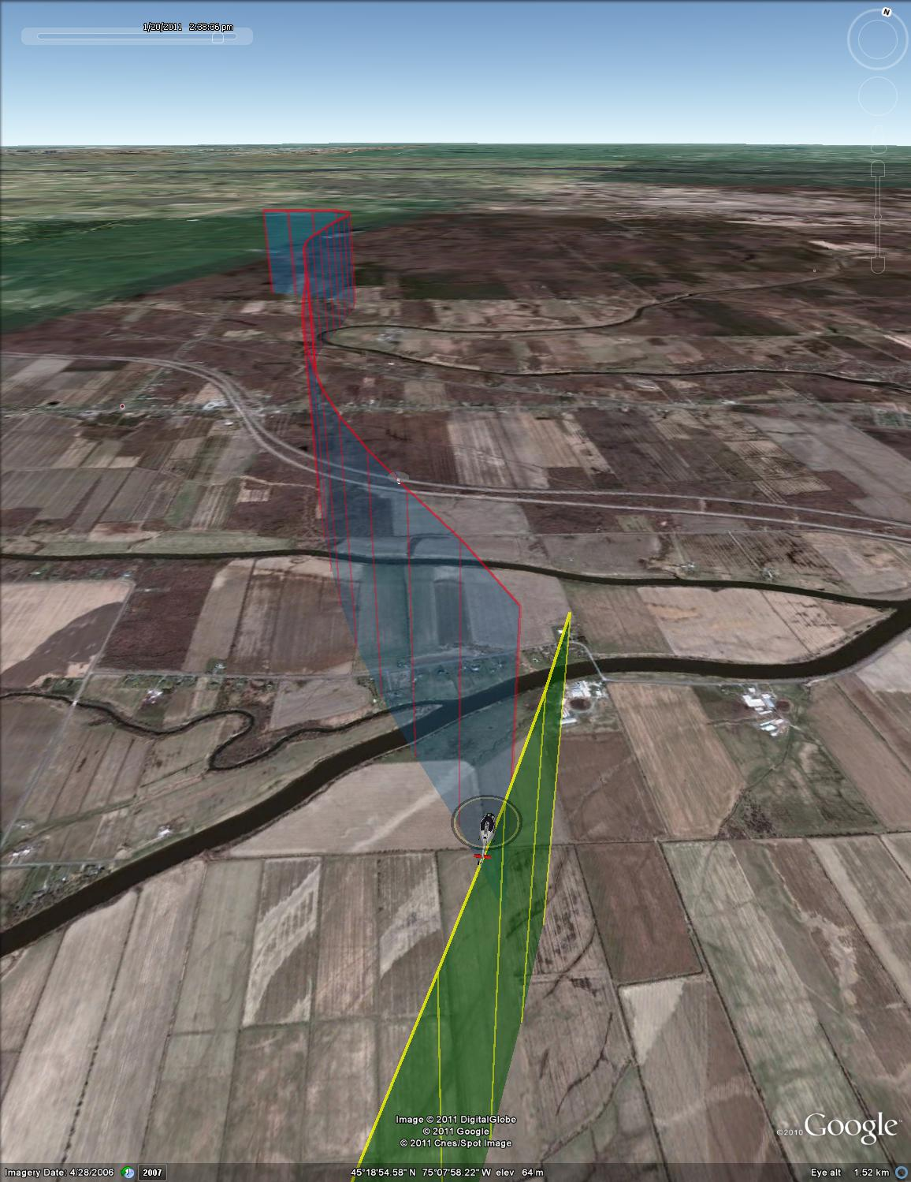

Figure : Test point #108, -10 deg azimuth, isometric view



Figure : Test point #109, -30 deg azimuth



Figure : Test point #109, -30 deg azimuth, final 30 seconds



Figure : Test point #109, -30 deg azimuth, plan view (UTM coordinates)

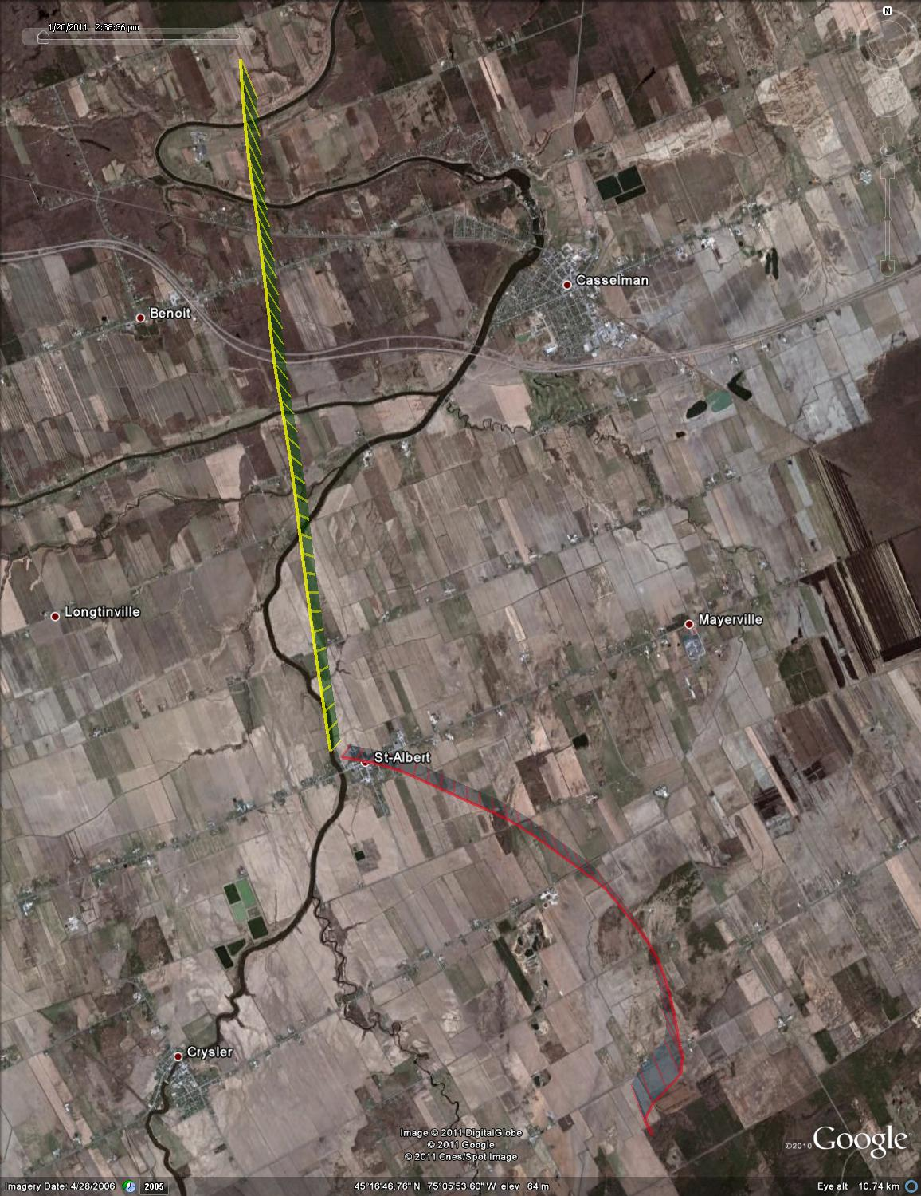

Figure : Test point #109, -30 deg azimuth, plan view (satellite overlay)

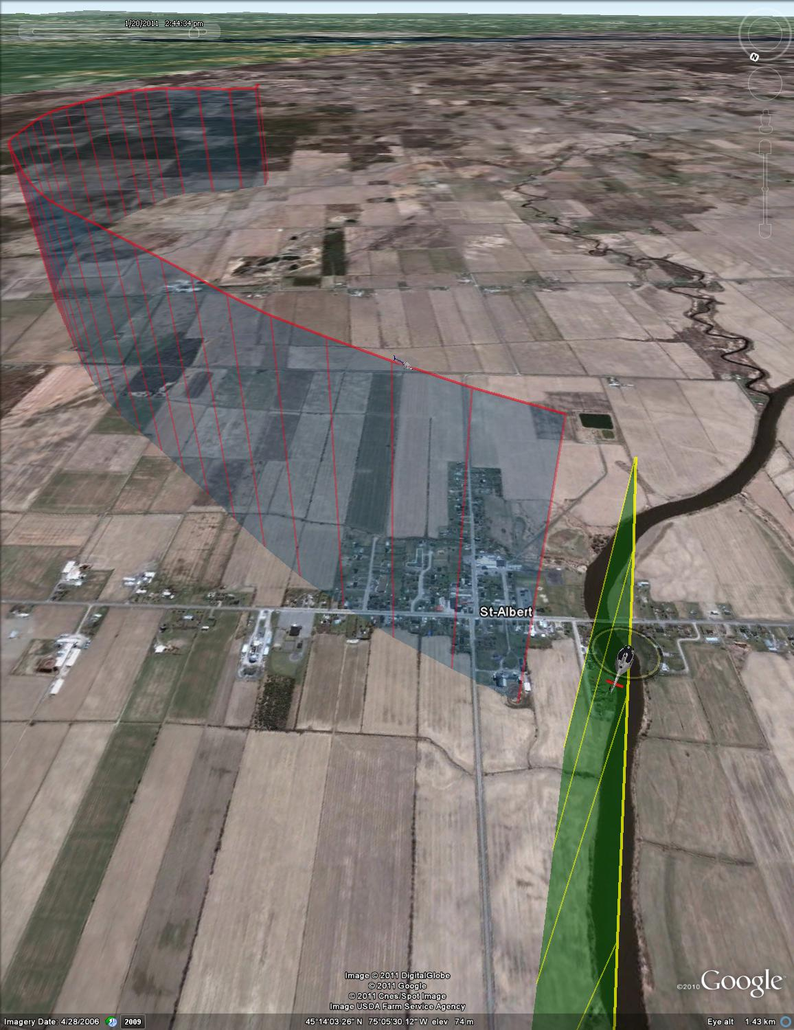

Figure : Test point #109, -30 deg azimuth, isometric view



Figure : Test point #110, -50 deg azimuth



Figure : Test point #110, -50 deg azimuth, final 30 seconds



Figure : Test point #110, -50 deg azimuth, plan view (UTM coordinates)

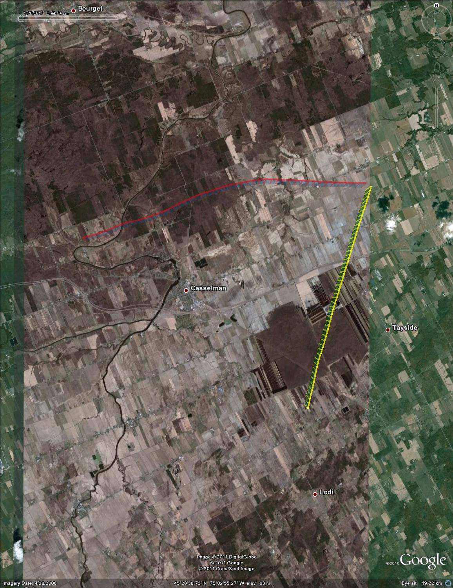

Figure : Test point #110, -50 deg azimuth, plan view (satellite overlay)

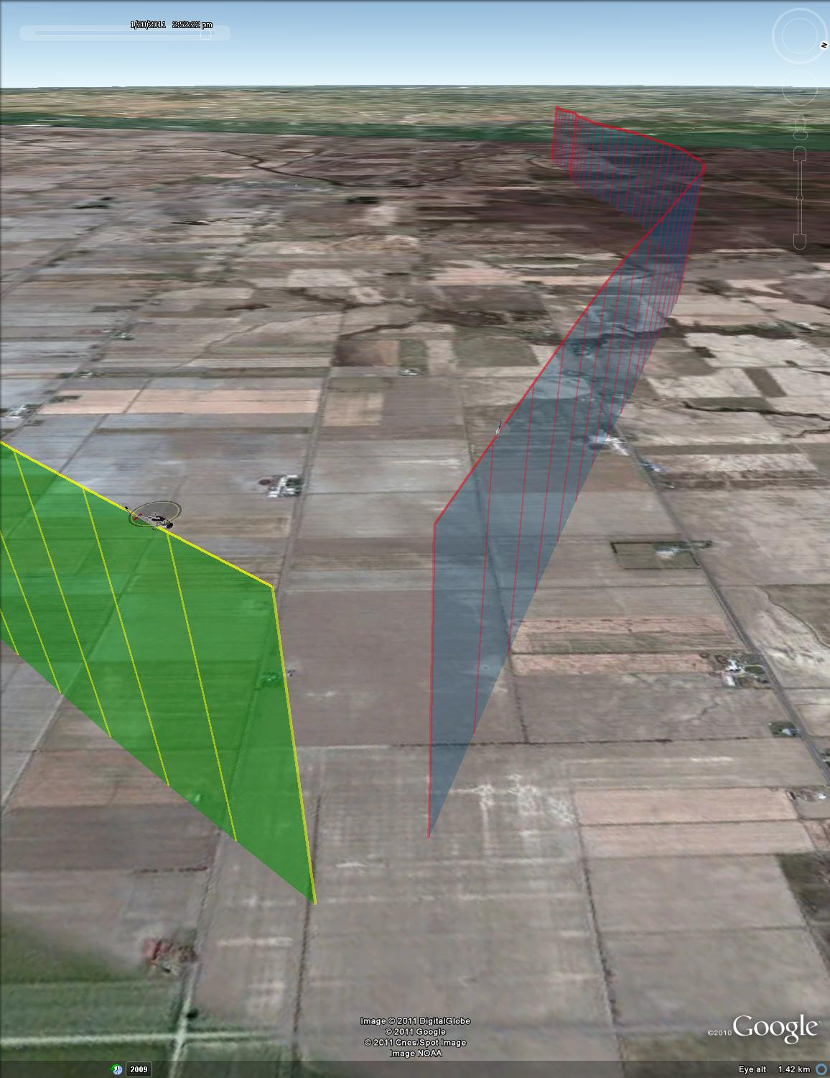

Figure : Test point #110, -50 deg azimuth, isometric view



Figure : Test point #111, -70 deg azimuth



Figure : Test point #111, -70 deg azimuth, final 30 seconds



Figure : Test point #111, -70 deg azimuth, plan view (UTM coordinates)

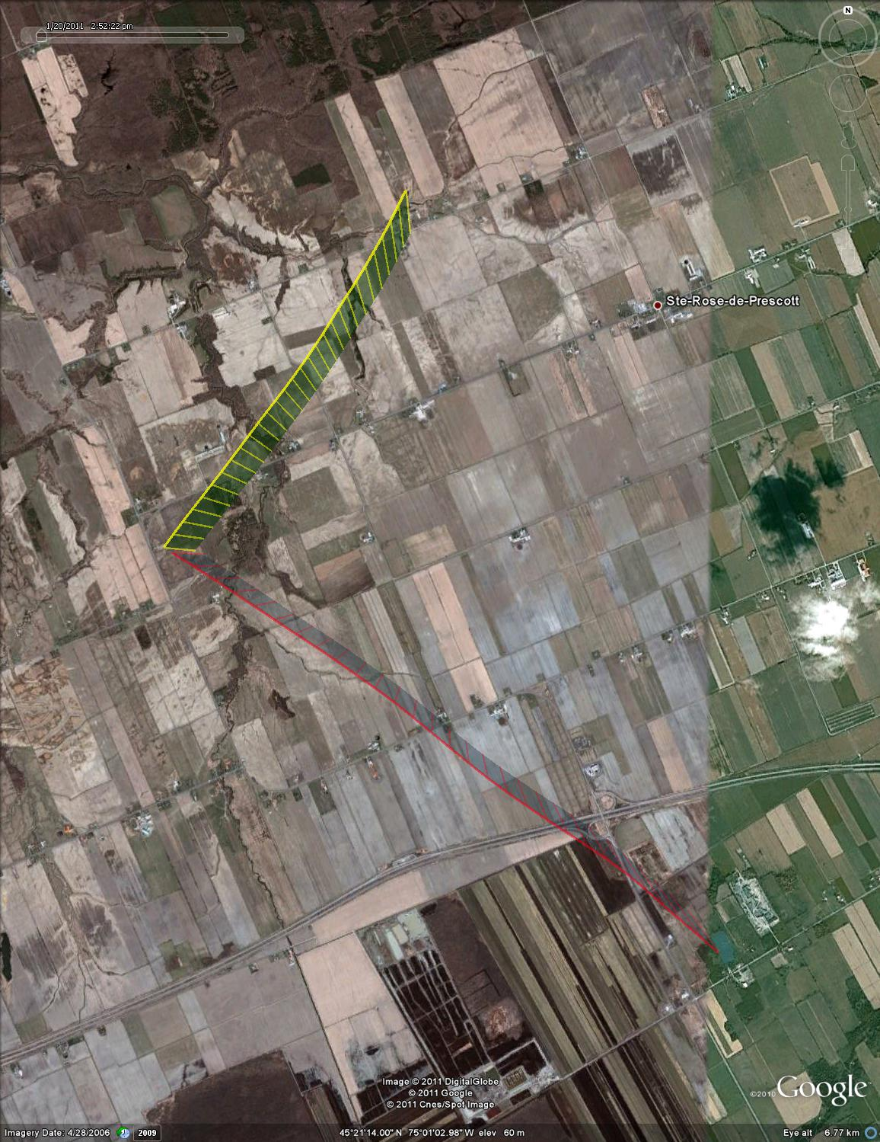

Figure : Test point #111, -70 deg azimuth, plan view (satellite overlay)

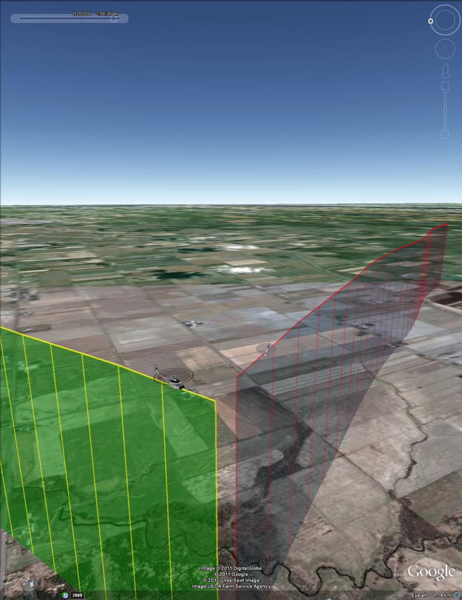

Figure : Test point #111, -70 deg azimuth, isometric view



Figure : Test point #112, -90 deg azimuth



Figure : Test point #112, -90 deg azimuth, final 30 seconds



Figure : Test point #112, -90 deg azimuth, plan view (UTM coordinates)

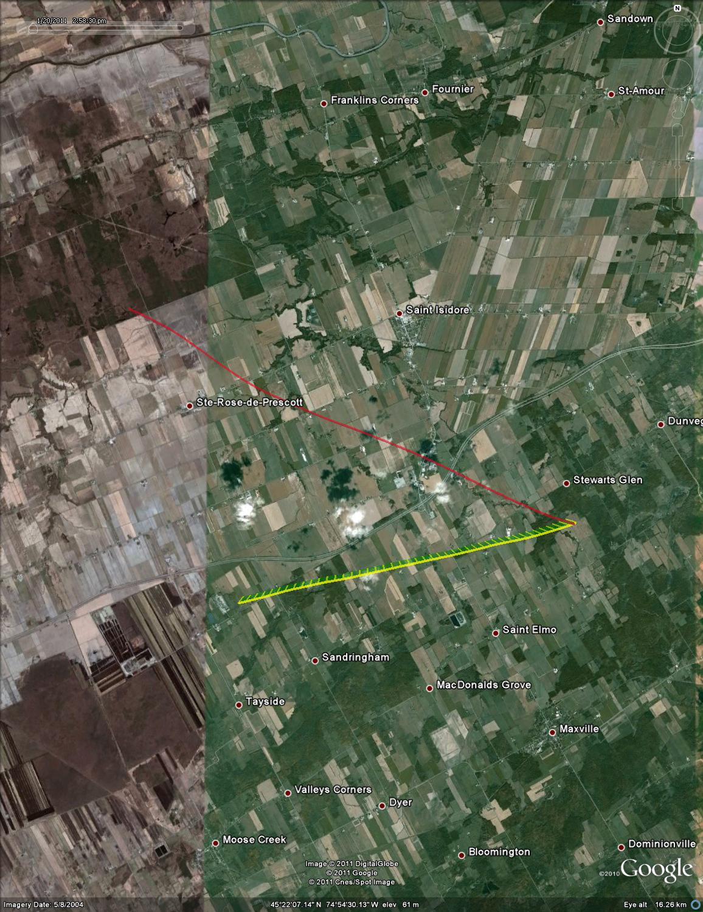

Figure : Test point #112, -90 deg azimuth, plan view (satellite overlay)